**I****AEA TECDOC**-#####

Safety and Performance Aspects in the Development and Qualification of High Burnup Nuclear Fuels for Water Cooled Reactors Report of a Technical Meeting

Foreword

Will be developed at a later stage

GUIDANCE FOR CONTRIBUTORS TO THE TECDOC

* Please use the current MS Word template:
  + - * + Please avoid plagiarism (including self-plagiarism) given that a detailed check will be carried out by the IAEA publications division
        + Ensure that copyright transfer to the IAEA will be made for any re-use of previously published material (including tables, figures, etc.) or that material already published will be duly quoted
        + Please conform to IAEA guidance for references, tables, figures
        + Please write the references into the related section, the IAEA will link them inserting necessary crossed references as necessary

Contents

1. INTRODUCTION 1

1.1. BACKGROUND 1

1.2. OBJECTIVES 1

1.3. SCOPE 2

1.4. STRUCTURE 2

2. Nuclear utilities’ perspective and expectations from HBU nuclear fuels 4

2.1. Overview 4

2.2. contributions provided at the technical meeting 4

2.2.1. The drive to license and deploy ATF and HBU fuels in the United States of America 4

2.2.2. Safety and performance of high burnup fuels: a utility’s perspective 5

2.2.3. Utility's experience with LTA irradiation in commercial reactors at Constellation 6

2.3. SUMMARY AND DISCUSSION 6

3. Phenomenological knowledge and insights from modelling AND simulation 7

3.1. Overview 7

3.2. contributions provided at the technical meeting 7

3.2.1. Current status and planned research activities for the TRANSURANUS code application to high burnup fuels 7

3.2.2. Consistent modeling of fuel fragmentation, grain-boundary fracture and fission gas release in LWR fuel rods during loss of coolant accident (LOCA) and reactivity insertion accident (RIA) 7

3.2.3. IRSN R&D activities on high burnup fuel behavior in RIA and LOCA accident conditions 8

3.2.4. Fuel Fragmentation Dispersal and Consequence Evaluation of Higher Burnup Fuel 8

3.2.5. Assess the impact of prototypic high burnup operating conditions on fuel fragmentation, relocation and dispersal 9

3.2.6. The SCIANTIX grain-scale code: recent developments for high burnup fuels 9

3.2.7. Review of high burnup fuel behaviour during normal operation and accidental transients 10

3.3. SUMMARY AND DISCUSSION 10

4. Experimental programs supporting the development of HBU nuclear fuels 12

4.1. Overview 12

4.2. Contributions provided at the technical meeting 12

4.2.1. Restructuring and fission gas bubbles in high burnup UO2 fuels 12

4.2.2. Experience with irradiation testing in relation to high burnup investigations at the OECD Halden Reactor Project 13

4.2.3. JAEA studies on high burnup LWR fuel behavior under Reactivity Initiated Accident conditions 13

4.2.4. Integral behavior of high burnup fuel rod under LOCA: effect on steam oxidation, integral FFRD experiment, and regulatory implications 14

4.2.5. HBU LOCA testing plan at INL 15

4.2.6. NEA activities supporting improved understanding of high burnup fuel behavior 16

4.2.7. Recent advanced post-irradiation examinations on HBU fuel at Idaho National Laboratory 17

4.3. SUMMARY AND DISCUSSION 17

5. Experience by fuel developers in development and qualification of fuel designs for high burnup 19

5.1. Overview 19

5.2. contributions provided at the technical meeting 19

5.2.1. Fuel management strategy and plan for increasing fuel burnup in China 19

5.2.2. ENUSA experience on high burnup demonstration programs 20

5.2.3. High burnup fuel development and implementation strategy at Westinghouse 20

5.2.4. Licensing Framatome’s fuel designs for higher burnup and low enriched uranium beyond 5% (LEU+) 21

5.2.5. Post irradiation characterization of high burnup oxide fuels 21

5.3. SUMMARY AND DISCUSSION 21

6. Licensing experience and regulatory perspective 23

6.1. Overview 23

6.2. contributions provided at the technical meeting 23

6.2.1. Safety implications of using high burnup fuel assemblies 23

6.2.2. Adequacy of safety design criteria at high burnup fuel type of unit 5&6 Kozloduy NPP 23

6.2.3. Approaches to safety regulation of high burnup nuclear fuel introduction in the Russian Federation 24

6.2.4. Elements on the research information letter on state-of-knowledge on Fuel Fragmentation Relocations and Dispersal 24

6.2.5. Assessment of the U.S. Nuclear Regulatory Commission’s regulatory framework for the licensing of high-burnup fuel 25

6.3. SUMMARY AND DISCUSSION 25

7. CONCLUSIONS AND PERSPECTIVES 28

7.1. Conclusions 28

7.2. Perspectives for future activities 29

REFERENCES 31

Annex I 33

Annex II 34

LIST OF ABBREVIATIONS 142

CONTRIBUTORS TO DRAFTING AND REVIEW 144

# INTRODUCTION

## BACKGROUND

An increasing maturity of nuclear technology and progress in knowledge of nuclear fuel behaviour, through operational experience (OPEX) of commercial nuclear power plants (NPP) operation, supported by experiments and numerical modelling and simulation, have driven efforts by the nuclear industry worldwide towards an increase in the discharge burnup of nuclear fuel in Water-Cooled Reactors (WCR).

Nuclear fuel vendors and NPP operators continue extending the discharge burnup of nuclear fuel assemblies within the operating envelope accepted by national regulators. The current operating limit slightly varies among licensee organizations, but in many Member States it corresponds to a rod average burnup of 62 gigawatt-day/tons of uranium (GWd/tU) (average fuel sub-assembly of 55 GWd/tU), or other equivalent criteria. Nuclear fuel vendors and NPP operators might obtain economic benefits from such high burnup operation via, for example, longer reactor cycle operation, as well as purchase, transport and handling of fewer fuel assemblies for the core reloading.

Currently, increased rates of the fuel discharge burnup (e.g., beyond 62 GWd/tU) are also being pursued by Member States in the framework of the development of advanced technology for nuclear fuel (which include so-called Accident Tolerant Fuels or Advanced Technology Fuels), particularly in association with advanced fuel and cladding materials, which might require higher fissile enrichment rates (in some cases exceeding 5%) in order to counterbalance increased parasitic neutron absorption in the cladding. Some nuclear fuel vendors and NPP operators are even exploring the possibility to increase the operating envelope up to 80 GWd/tU, which would imply the need to address considerable technical challenges, such as:

* Improvement of nuclear fuel analytical codes for the accurate prediction of fuel behaviour and performance at higher burnups;
* Update of source term calculations;
* Modifications for higher heat loads in the spent fuel pool;
* Deviations in refuelling mode;
* Fuel enthalpy increasing above acceptable value in deviations of normal operation modes;
* Direct contact between fuel and cladding;
* Primary coolant potential radioactivity increasing;
* Defence in depth criteria failure in case of LOCA;
* Performance of design and safety analyses at higher burnups addressing potentially new phenomena, including [Fuel Fragmentation Relocation and Dispersal](https://www.nrc.gov/reactors/atf/ffrd.html) (FFRD);
* Furthermore, it could lead to degradation of safety performance in normal operation and in accident conditions, posing considerable challenges for the development and qualification of high burnup nuclear fuels.

## OBJECTIVES

Several IAEA technical meetings have been held in the 2000’s to address the economic and safety aspects of high burnup fuels , . Since then, the utilities have been focusing on the safety improvements following the Fukushima accidents, development and qualification of the accident tolerant or advanced technology fuels (ATFs).

The status of knowledge in the development, qualification and licensing of advanced nuclear fuels for WCR is illustrated in a TECDOC (submitted to the Publications Committee) on the same topic, which addresses nuclear fuels within an envelope to a rod average burnup of 62 GWd/tU (average fuel sub-assembly of 55 GWd/tU). It is a general observation that the nuclear fuel community worldwide intends to pursue a synergy that fulfils two objectives at the same time, enhanced economic and safety, by employing both ATF and the higher burnup operation beyond 62 GWd/tU in water cooled reactors.

Under these circumstances, in November 2022, a Technical Meeting was jointly organized by the Department of Nuclear Safety and Security and the Department of Nuclear Energy, with the objective of providing a platform for Member States to exchange information on safety and performance of high burnup nuclear fuels (e.g., beyond 62 GWd/tU) for WCR, considering their development, qualification and licensing.

Considering the relevance of the technical contributions provided at this technical meeting (which had been attended by forty-three participants representing twenty-one Member States and two international organizations – the OECD Nuclear Energy Agency and the European Commission) the development of a TECDOC summarizing the material presented at this technical meeting was identified as being a highly beneficial follow-up action to this technical meeting.

The current TECDOC aims at illustrating the status (and in some cases the state-of-the-art, considering the attendance of several key players from technology developers, national regulators and technical support organizations, licensees, research and development (R&D) organizations, including both modelers of numerical codes and experimentalists) in addressing safety and technological challenges encountered in the development, qualification and licensing of high burnup nuclear fuels for WCR.

## SCOPE

The TECDOC encompasses design, qualification, licensing, and in-reactor operation of UO2-Zr-based alloys (including doped-UO2 and coated cladding), with discharge burnup exceeding 62 GWd/tU (fuel rod average) or 55 GWd/tU (fuel assembly average), or other equivalent criteria.

The TECDOC covers the following topics:

* Nuclear utilities’ perspective and expectations from high burnup (HBU) nuclear fuels;
* Experimental testing (in-pile and out-of-pile) and associated multiphysics and multiscale modelling and simulation of fuels at high burnup;
* Validation and application of computer codes and methods for design and safety analysis for high burnup fuels;
* Experience by fuel developers in development and qualification of fuel designs for high burnup;
* Practices by national regulators and technical support organizations in development or adaptation of licensing frameworks for nuclear fuels to address specific safety requirements and features of high burnup nuclear fuels, with focus on regulatory expectations from qualification process.

## STRUCTURE

The TECDOC consists of seven main sections and two Annexes:

* Section 1 describes the background, objectives, scope and structure of the publication;
* Section 2 describes the perspective and expectations from high burnup nuclear fuels from some nuclear utilities;
* Section 3 illustrates the state-of-the-art in the knowledge of physical phenomena occurring in the nuclear fuel at high burnup (including micro-structure and rim formation, FFRD, enhanced fission gas release), the associated multiphysics and multiscale modelling and simulation capabilities, as well as the identified challenges for safety (normal operation and accidental conditions);
* Section 4 presents insights from experimental testing (in-pile and out-of-pile), supporting the development and validation of numerical models in thermomechanical codes;
* Section 5 describes the experience of fuel developers in development and qualification of fuel designs for high burnup, including advanced fuel and cladding designs, irradiation of test fuel rods beyond 62 GWd/tU, pool-site inspections and post-irradiation examinations;
* Section 6 illustrates the experience by national regulators and technical support organizations in development or adaptation of licensing frameworks for nuclear fuels to address specific safety features of high burnup nuclear fuels;
* Section 7 presents the conclusions and highlight gaps which might be the subject of future activities.

The Annex I provides a link to the electronic version of the presentations provided at the technical meeting, while the Annex II contains the extended abstracts associated to such presentations.

# Nuclear utilities’ perspective and expectations from HBU nuclear fuels

## Overview

Most current commercial light water reactors around the world use low‐enriched uranium (LEU) fuel. In general, fuel costs comprise approximately 20% of nuclear power plants’ total generating costs. Fuel costs are driven like most commodities by supply and demand with the costs for the uranium feedstock and conversion, enrichment, and fuel assembly fabrication processes. Fuel efficiency of a core design determines the quantity of nuclear material needed to meet a plant’s energy objectives. While a utility can improve the efficiency of the core design, this efficiency is ultimately limited by the specific design constraints of the core design. Two of several constraints that have been shown to directly impact the core design efficiency are the uranium enrichment level and discharge burnup achieved by the core and/or fuel design.

A review of the current fuel management practices, based on equilibrium cycle designs, has shown that 99% of the variation in fuel cycle efficiency is attributable to variations in enrichment and burnup. Many sites are currently constrained by the existing regulatory limits on one or both of these parameters.

In the U.S., utilities have leveraged recent activities associated with the development and deployment of Accident Tolerant Fuels to revisit core design efficiencies that optimize batch reload quantities of fuel to reduce generation costs. With the increased interest in higher burnup cores, it is likely that within the next decade, both operating and advanced reactors will see a demand for fuel enriched greater than 5 weight percent (wt%) U‐235.

A study conducted by EPRI included assumptions, economic projections, inflation and financial methodologies—that evaluates the technical, financial and regulatory issues associated with increasing the limits on uranium enrichment and on fuel burnup for current uranium dioxide (UO2) fuel types. Revising these limits impacts a large portion of the nuclear fuel cycle as well as the licensing bases for both plant operators and fuel suppliers. While there are economic advantages to making these changes, they also require long‐term capital investment and regulatory changes. Revising these limits will provide savings through additional cycle length flexibility, reduced high level waste storage and disposal requirements, and a positive benefit on the environmental impact of the fuel cycle. The final decision to pursue new limits must consider not only the expected benefits but the business risks associated with such an undertaking.

This section was prepared by Mr. Jinzhao Zhang (Tractebel-ENGIE, Belgium) and Mr. Al Csontos (Nuclear Energy Institute, United States of America) and, and Mr. Al Csontos chaired the session of the technical meeting.

## contributions provided at the technical meeting

### The drive to license and deploy ATF and HBU fuels in the United States of America

Mr. Al Csontos (Nuclear Energy Institute, United States of America) introduced a nuclear operator perspective from the United States of America, to develop and deploy fuel technologies that enhance accident tolerance as well as fuel reliability and operational margins while enabling sustained economic performance through minimizing cost and improving efficiency.

The objective is to safely and economically enable 24-month cycle operation for the entire fleet of existing light water reactors, with burnups up to ~75 GWd/MTU, associated to enrichment extensions towards Low Enriched Uranium from 5% to 10% (LEU+) beyond legacy limits in the mid-2020s.

The presentation also covered major milestones along this path, including on-going experimental programs of irradiations of LTR/LTA in commercial reactors, as well as regulatory and R&D activities underway.

### Safety and performance of high burnup fuels: a utility’s perspective

Mr. Jinzhao Zhang (Tractebel-ENGIE, Belgium) presented the feasibility study performed by in 2007-2009 to assess the HBU safety and performance issues for Belgian nuclear power plants that are owned and operated by Electrabel , , , . The feasibility in safety and performance with limited burnup increase was confirmed for some Belgian NPPs:

* Up to fuel assembly average burnup of 58 GWd/t with existing fuel designs, adapted codes and methods for fuel design and safety analyses;
* Up to fuel assembly average burnup of 62 GWd/t or higher with advanced fuel designs, improved codes and methods for fuel design and safety analyses.

The licensing effort was the most important economic constraint without possible plant life extension. Therefore, a burnup extension may not be profitable for all Belgian NPPs, and hence was not implemented.

This paper then presented the progress made since the last IAEA Technical Meetings on HBU fuels on high burnup fuel performance, safety and licensing aspects. It was concluded that significant progresses have been made since 2009:

* Better understanding of the fuel behaviors at high burnups;
* Development and qualification of improved fuel designs for high burnups;
* Revision of the Loss of Coolant Accident (LOCA) and Reactivity Insertion Accident (RIA) safety criteria, based on tests of fuels at high burnups;
* Improvement and validation of fuel codes for modelling and simulations of fuel behaviors at high burnups;
* Development and licensing of advanced fuel design and safety analysis methodologies.

However, there is a lack of consistent high burnup fuel licensing process, which prevents the Utilities from requesting and implementing the burnup extension.

It was thus proposed to enhance international co-operation on safety and performance of high burnup fuels and to ensure the consistency of the licensing framework to simplify or accelerate the licensing process.

### Utility's experience with LTA irradiation in commercial reactors at Constellation

Mr. William Gassmann (Constellation, United States of America) highlighted the leading role of Constellation in supporting the development/deployment of ATF/HBU. Four ATF/HBU LTA campaigns are currently in progress at Constellation (at Byron-2, Limerick-2, Clinton and Calvert Cliffs-2 units), and an explicit HBU application is in progress or under consideration for all of these LTA campaigns.

The presentation also introduced additional post-irradiation examinations (PIE) required for a complete characterization of all HBU and ATF phenomena (including gamma scan measurements for fission gas pressure and pellet integrity, detailed corrosion examination for cladding integrity, and destructive and non-destructive examination in hot cell).

## SUMMARY AND DISCUSSION

From the round table discussions, it appears that the current nuclear fuels have been developed, qualified, licensed, and operated within the existing WCRs up to the approved burnup limits in most member states. In certain member states, significantly high burnups have been reached (e.g., up to rod average burnup of 70 GWd/t in Sweden and Switzerland).

There is an economic incentive to improve the efficiency of fuel use by increasing fuel enrichment and burnup. This fuel burnup increase is possible with the existing advanced fuels (e.g., PRIME, GAIA) and in particular the recently developed ATFs (e.g., ENCORE, EATF).

Lead test ATF rods or assemblies (LTRs and LTAs) are being irradiated in several nuclear power plants in the USA and in Europe, and pool-side inspections or PIEs are being performed to qualify these fuels.

However, implementation of HBU needs considerable efforts to resolve certain safety issues such as the FFRD. In addition, the consistency in licensing process would be helpful to speed up the licensing of HBU in different member states.

# Phenomenological knowledge and insights from modelling AND simulation

## Overview

The burnup increase leads to significant modifications of the fuel rods during irradiation. These changes may have a major impact on the fuel behavior in normal and accidental conditions (in particular RIA or LOCA transients).

The objective of this session was to share the last development of multiphysics and multiscale modelling and simulation of fuels with focus on high burnup phenomena characterization, including micro-structure, rim, FFRD, enhanced fission gas release, source term, etc.;

This Chapter was prepared by Mr. Vincent Georgenthum (IRSN, France) and Mr. Nathan Capps (Oak Ridge National Laboratory, United States of America), and Mr. Vincent Georgenthum also chaired the session of the technical meeting.

## contributions provided at the technical meeting

A total of seven presentations were made in this session, covering high burnup fuel restructuring, fission gas release, FFRD, fuel rod model and code development and validation, etc..

### Current status and planned research activities for the TRANSURANUS code application to high burnup fuels

Mr. Paul Van Uffelen (European Commission, Karlsruhe) summarised the efforts made over the past decade for application of the TRANSURANUS fuel rod performance platform for high burnup fuels.

Specific developments were made to develop in a more mechanistic manner the high burnup structure (HBS) formation in the SCIANTIX and MFPR-F codes that are coupled with TRANSURANUS. A benchmark of these codes is planned in the frame of the R2CA project. Further developments aim at the simulation of design basis accidents (DBA) such as LOCA and RIA. The important role of international benchmarks organised by the IAEA and NEA were thereby underlined, along with the role of creating an international reference database for code development and validation.

In parallel with the further refinement of the HBS modelling, also the code developments for hydrogen uptake and its consequences on the cladding behaviour during operation as well as subsequent storage were outlined.

Finally, the current application of the best estimate plus uncertainty methods and the potential of machine learning were contemplated.

### Consistent modeling of fuel fragmentation, grain-boundary fracture and fission gas release in LWR fuel rods during loss of coolant accident (LOCA) and reactivity insertion accident (RIA)

Mr. Grigori Khvostov (Paul Sherrer Institute, Switzerland) presented several amendments made in the FALCON code coupled with the GRSW-A model, as well as in the FRELAX code, aiming at improvement of calculation for specific types of thermal transients, such as RIA and LOCA.

A model was developed and integrated into GRSW-A for trapping of the released fission gases by the specific closed voids ( ‘pockets’), during base irradiation.

Transient analysis with the GRSW-A model of the FALCON code was extended to simulate the processes of fuel fragmentation and concomitant FGR due to grain-boundary fracture.

A fuel fragmentation dependent analytical criterion for the on-set of grain-boundary fracture and transient FGR was proposed.

The FRELAX code was extended for simulation of bulk flow and diffusion of the gases in the rod free volume during thermal transients.

After a calibration of the model parameters using data of a selected NSRR RIA test, and a Halden LOCA test, the updated codes and models were applied to extended sets of RIA- (NSRR and CABRI-SL) and LOCA- (Halden) tests, assuming the same set of best-estimate parameters.

### IRSN R&D activities on high burnup fuel behavior in RIA and LOCA accident conditions

Mr. Vincent Georgenthum (Institut de Radioprotection et de Sûreté Nucléaire, France) presented the current IRSN R&D activities related to the study and modelling of the fuel behavior in RIA and LOCA accident conditions.

The remaining questions related to high burnup fuel during RIA transient mainly concern the transient fission gas behaviour and its impact on clad loading during the entire transient, the rod behaviour with high clad temperature and internal pressure and the post-failure phenomena (fuel ejection, fuel-coolant interaction with finely fragmented solid fuel). CIP (Cabri International project) investigates the behavior of fuel rods in PWR conditions during RIA transients in particular for high burn-up fuels and advanced fuels and claddings. Models, concerning the fission gas behavior and fuel coolant interaction are currently under development to be introduced in the SCANAIR and CIGALON code.

With regards to the study of fuel behavior under LOCA, the pending questions are the fuel fragmentation, relocation and dispersal after cladding burst. In this frame, specific modelling is under development in the DRACCAR code to simulate the 3D thermo-mechanical behavior and reflooding of a fuel rod assembly during a LOCA transient taking into account fuel fragmentation, relocation and flow blockage. These models are based on academic studies and results of separate effect tests (as COAL experiments, part of PERFROI project).

### Fuel Fragmentation Dispersal and Consequence Evaluation of Higher Burnup Fuel

Mr. Ken Yueh (Electric Power Research Institute, United States of America) presented a study on the fuel fragmentation dispersal and the consequence evaluation for high burnup fuel.

To this aim, it is necessary to determine the number of burst rods, extent of fuel release from each rod, and under high steam flow conditions, how the fuel disperses in the fuel assembly, the reactor coolant system (RCS) and containment.

An EPRI developed thermal-hydraulic code, GOTHIC, was used to evaluate fuel fragments dispersal within the RCS and containment.

Model calculations show fuel fragments carried by steam could impact a grid at significant velocities and recent drop tests of post-LOCA fuel fragments showed sub-fragmentation is likely.

To evaluate possible blockage at the grid, a flow experiment with a 3x3 fuel bundle with two spacer grids will be conducted. The experiment will use crushed non-irradiated UO2 fuel fragments.

### Assess the impact of prototypic high burnup operating conditions on fuel fragmentation, relocation and dispersal

Mr. Nathan Capps (Oak Ridge National Laboratory, United States of America) first presented an historical overview of the research, development and demonstration process that has accompanied the increase of fuel-to-rod average burnups from approximately 30 GWd/tU (for the very first NPP licensed in the USA) up to the current licensed limit of 62 GWd/tU peak rod average for UO2/Zr alloy-based fuels.

Subsequently, he introduced a best-estimate-plus-uncertainty pin-by-pin high-burnup loss-of-coolant accident (LOCA) analysis technique developed at ORNL to assess full-core high-burnup FFRD and to identify approaches for minimizing or potentially mitigating FFRD through core design optimizations.

Results obtained on a four-loop Westinghouse commercial pressurized water reactor (PWR) plant were illustrated. A statistical analysis of the finite element method (FEM)-based fuel performance code BISON results was performed to predict the full-core susceptibility to FFRD during an LBLOCA event.

### The SCIANTIX grain-scale code: recent developments for high burnup fuels

Mr. Davide Pizzocri (Politecnico di Milano, Italy) present the last development of SCIANTIX code for high burnup fuels. SCIANTIX operates at the scale of fuel grains.

Several developments have been made to improve the semi-empirical description of high burnup structure formation and porosity evolution at high burnup:

* A fuel material representing the high burnup structure, incorporating the properties of the restructured fuel (e.g., grain size, lattice parameter).
* The formation of the high burnup structure.
* The high burnup structure porosity predicted based on the local burnup.
* A physics-based model for the evolution of the porosity distribution in terms of pore number density, average number of gas atoms per pore, and variance of the number of gas atoms per pore.
* The size of the high burnup structure pores as a function of the porosity and the number density of pores.

SCIANTIX includes all the capabilities required for a semi-empirical description of high burnup structure formation and porosity evolution at high burnup.

These modelling capabilities are suitable for direct coupling within fuel performance codes, in terms of numerical robustness, computational time, verification, and validation.

### Review of high burnup fuel behaviour during normal operation and accidental transients

Mr. Ioan Arimescu (Consultant, Nufology Plus LLC, United States of America) presented a critical review of the high burnup fuel behaviour.

The nuclear industry has initiated activities to further extend the operational burnup range, beyond the currently approved limit. This entails research and testing of fuel behavior at extended high burnup to confirm adequate fuel performance. This means the same level of fuel reliability as for the current burnup range and no new phenomena triggered by higher than current burnup, which would require more research to understand the phenomenology and quantify the potential new processes. This requirement is due to the necessity of performing design analyses to demonstrate adequate fuel behavior during normal operation as well as during anticipated abnormal occurrences and accidental situations.

The following new or enhanced-effects phenomena have been identified in high burnup fuels, some of which may need further studies through international co-operation:

* Decreasing fuel thermal conductivity, a.k.a. burnup degradation of fuel thermal conductivity (TCD)
* Enhanced fission gas release (FGR) during normal operation and thermal transients
* High burnup structure (HBS) formation
* Fuel-Cladding bonding
* Cladding corrosion and hydrogen uptake
* Zirconium alloys irradiation stress-free growth
* Fuel fragmentation, relocation and dispersal (FFRD)

Fuel behavior research is a complex process involving both out-of-pile as well as in-pile experiments and tests. When a new phenomenon or process is identified, separate-effects tests are devised to focus on the specific process in question, to understand the phenomenology and provide data for its quantification by models. However, integral tests are also required to verify that the inter-relations of the given process with all other phenomena occurring in the fuel are adequately captured.

The result of high burnup fuel experimental and theoretical studies is the demonstrated capability to predict fuel performance for fuel design confirmation and licensing analyses to assure safe and reliable fuel operation to the desired maximum burnup.

## SUMMARY AND DISCUSSION

The modelling of high burnup fuel behavior during normal and accidental conditions needs improvement due to the significant evolution of the fuel rods during base irradiation.

There is first a need of fine description of the fuel modifications for rods with average burnup higher than 60 GWd/t. In particular, the properties (e.g., grain size, pores size and shape and lattice parameter) of the restructured fuel and the gas distribution in intra and intergranular bubbles and the associated radial profiles should be better characterized.

Some modern mechanistic models and codes are under development to better evaluate the complex high burnup structure state of the fuel (SCIANTIX, MFPR-F, GRSW-A/FALCON..). Some questions on the fuel restructuring mechanism remain. These codes have to be coupled with fuel performance code (TRANSURANUS, BISON, FIRST, …)

Concerning the high burnup fuel behavior modelling during transient conditions (RIA and LOCA) challenges remain and work are under progress regarding:

* The transient fission gas release mechanism and criteria. Depending on the thermomechanical conditions and the transient kinetics, gas release can occur after grain boundary saturation with thermal diffusion or grain boundary opening due to pore overpressurization.
* The radial and axial gas flow in the fuel and the gap. The fuel permeability and the fuel-clad bonding are key parameters.
* The clad mechanical behavior at high temperature: clad constitutive laws and failure criteria have to take into account the transient conditions (temperature, kinetics) cladding type and fuel burnup.
* The fuel cracking and fragmentation, the associated fuel relocation and the impact on clad temperature and the coolability of ballooned cladding.
* The fuel fragmentation dispersal and the consequence after clad failure in LOCA transient
* The fuel coolant interaction after clad failure (RIA transient) in particular the size and the kinetic of fuel ejected and the evaluation of the mechanical energy.

Fuel performance codes integrate progressively both new high burnup models and best-estimate-plus-uncertainty methodology to assess single rod or full-core behavior in accidental conditions.

# Experimental programs supporting the development of HBU nuclear fuels

## Overview

To support the understanding of phenomena particularly important to high burnup, the collection of, and availability of, experimental data on irradiated fuel are important. Activities in this regard include both irradiation testing in test reactors, as well as hot-cell studies on irradiated fuel. In addition, studies on un-irradiated material can also be of value to supplement hot-cell studies, as well as also contributing to extending current testing capabilities.

The objectives of this session were to invite participants to present recent activities in their organizations in experimental activities and programs of particular relevance to high burnup. Also important for the session was to provide information of available data that could be of valuable use in activities in fuel modelling development as well as evaluating current fuel safety criteria and safety margins.

This Chapter was prepared by Mr. Terje Tverberg (Institute for Energy Technology, Norway), who also chaired the session of the technical meeting.

## Contributions provided at the technical meeting

A total of seven presentations were made in this session, covering the last techniques available at CEA, the Halden high burnup fuel research, JAEA high burnup fuel RIA testing, high burnup fuel LOCA testing, PIEs, etc.

### Restructuring and fission gas bubbles in high burnup UO2 fuels

Mr. Jean Noirot (Commissariat à l'Energie Atomique et aux Energies Alternatives, France) presented the last techniques available in the CEA/LECA facility to characterize the restructuring occurring in the fuel pellets and on the associated micrometric fission gas bubbles at high burnup fuel.

Recent progress was allowed by the increasing use of improved micro-examination techniques, in particular EBSD (electron back-scattered diffraction) and FIB-SEM 3D examinations (focused ion beam, scanning electron microscope). These techniques provide local crystal orientation maps that can be used to quantify the restructuring progress and 3D geometrical information on the bubbles.

Results obtained on a set of PWR UO2 samples at various burn-ups, including Cr doped UO2 fuels with large grains, showed:

* On the pellet's periphery: the HBS (high burn-up structure) restructuring starts first by the formation of sub-grains with orientations close to that of the original grains followed by the formation of randomly oriented sub-grains; the complexity of the HBS bubble surfaces, with the emerging small grain boundaries on these surfaces
* In the central volumes: restructuring with sub-grains orientation spreading around that of their original grain was detected by EBSD for all the fuels with an average burn-up higher than 60 GWd/tU; with the restructuring progress, the local porosity and the fraction of complex bubbles tend to increase without forming long distance networks.

The local temperatures and local burn-up are certainly major parameters in the restructuring process, but they are probably not the only ones.

The central restructuring, characterized in this work, certainly plays a role on the general increase in the fission gas release at high burn-up. This increase without clear bubble interconnected networks rises the need for low scale studies on the grain-boundaries and low-angle-grain-boundaries relatively to fission gases under irradiation.

Fission gas density in bubbles, measured by combining EPMA, SIMS and FIB-SEM characterizations were provided.

Ongoing works: -  
on FIB-SEM cantilever micro-mechanical testing, providing micro-scale fracture properties of irradiated fuels, in particular in restructured zones, and - on TEM works on thin foils cut in irradiated fuels using FIB/SEM were mentioned.

### Experience with irradiation testing in relation to high burnup investigations at the OECD Halden Reactor Project

Mr. Terje Tverberg (Institute for Energy Technology, Norway) presented experience with high burnup fuels testing from various OECD Halden Reactor Project research programs:

The presentation gave an overview of different irradiation types and experimental setups utilized in the Halden reactor relevant for studies of high burnup fuel, also providing examples of data and results obtained from the various testing setups. While in the later years the high burnup fuels tests would preferably be done using re-instrumented commercially irradiated LWR fuel, irradiations were4 also done starting from fresh fuel and over several year while collecting relevant data on fuel temperature, rod pressure, as well as pellet-cladding interaction. Of particular note, such HBU tests starting from fresh fuel were often done on fuel with enrichment of 10% or higher, which could have some relevance to the current industry efforts to move to LEU+ enrichment.

Fig. 1. Fission gas release data from collected in the IFA-519.9 experiment together with modelling predictions.

Activities towards the latter stages of operation of the Halden Reactor were largely focused on in-pile LOCA testing of high burnup UO2 fuel in the IFA-650 test-series. The 13 tests conducted in this program on re-instrumented LWR fuel ranging from medium to very high burnup have provided valuable data on LOCA behavior, in particular as regards FFRD. The IFA-650 LOCA test program was also aiming at supplementing ongoing hot-cell LOCA activities at other facilities, in particular the SCIP program at Studsvik.

Also provided in the presentation was a listing of available data sets to support modelling of HBU fuel in the IFPE database at NEA as well as data used in the various FUMEX and FUMAC modelling exercises organized by the IAEA.

### JAEA studies on high burnup LWR fuel behavior under Reactivity Initiated Accident conditions

Mr. Yoshinori Taniguchi (Japan Atomic Energy Agency, Japan) presented data collected from research programs on RIA at high burnup:

Several fuel safety research activities are ongoing at JAEA related to high burnup aiming to provide an enhanced database for future regulations in high burnup fuels, and to evaluate the adequacy of current safety criteria and limits. Studies related to LOCA, code development and RIA are actively pursued. The presentation gave a summary of extensive data collected at JAEA on RIA studies in the NSRR reactor. Over the years a database of more than 1000 unirradiated test segments and around 100 irradiated segments has been developed. Studies have been conducted on both UO2 fuel and MOX fuel.

Key findings from extensive high burnup fuel test campaigns in the ALPS and ALPS-II programs, were that extension of burnup significantly affects the PCMI failure limit, heat transfer and transient FGR. Of particular importance to PCMI failure limit in RIA conditions are hydrogen content and hydride distribution in the irradiated cladding. Planned new studies aim will in particular aim at filling in the existing knowledge gap on burnup effect on transient FGR in RIA conditions.

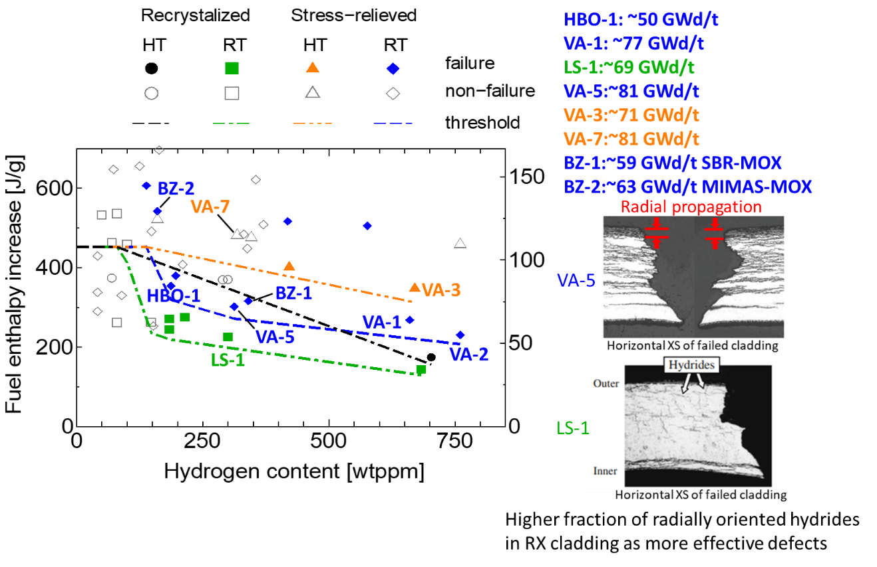

*Fig. 2: PCMI failure thresholds: fuel enthalpy increase at PCMI failure expressed as a function of cladding hydrogen content.(Courtesy of Yoshinori TANIGUCHI, JAEA).*

### Integral behavior of high burnup fuel rod under LOCA: effect on steam oxidation, integral FFRD experiment, and regulatory implications

Mr. Youho Lee (Seoul National University, South Korea) presented results from studies on LOCA and FFRD at the Department of Nuclear Engineering at Seoul National University (SNU).

The design and capabilities of integral LOCA experiment equipment at SNU (i-LOCA facility) were presented, The test facility uses induction heating for pressurized fuel rods containing surrogate pellets (i.e., whole pellet or crushed powder form) that undergo the entire process of ballooning, burst, steam oxidation, and reflood quenching Both single rod and multiple (4) rod arrangements can be applied, with heating rates up to 10°C/s. Ballooning burst and oxidation behavior are documented with high speed digital camera as well as IR camera recordings during test.

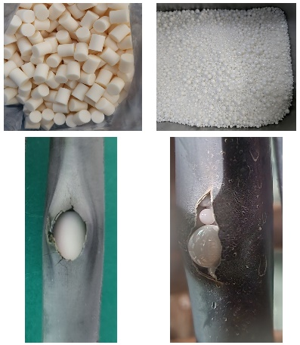Tests results from comparative tests of Zry and Cr-coated Zry using surrogate ZrO2 powder / powder mixture to simulate fragmented fuel pellets, showed similar burst temperature, balloon and burst opening for the two claddings.

In a test comparing the effect of single powder size (simulating >80 GWd/tU and mixed powder size, the mixed powder size test showed less ballooning and smaller burst opening as well as significantly less dispersal (100% dispersal vs. 31% dispersal).

Capabilities of, and results from, the TRANOX Zircaloy steam oxidation model for mechanistic modelling of Zircaloy oxidation in LOCA transients were also presented.

*Fig.3. Whole pellet or crushed powder form loaded in cladding.*

### HBU LOCA testing plan at INL

Mr. Robert Armstrong (Idaho National Laboratory, United States of America) presented the status and plans for LOCA testing studies in the TREAT / SATS facilities at INL (TREAT) and ORNL (SATS):

Research programs at INL and ORNL aimed at supporting industry’s investigations to extend burnup and enrichment limits. Key area for the presented program to study high burnup fuel during LOCA, specifically FFRD. Development include in-situ instrumentation for monitoring fuel motion, transient FGR, balloon extent, and improved surface temperature measurements. SATS facility at ORNL operational, with upgrades being implemented. Commissioning tests for TREAT LOCA facilities during 2023-224, with aim to start tests with HBU fuel in 2024.

Presentation showed the proposed test matrix under discussion, which aims to tie back to Halden/Studsvik tests and build on and add to investigations there. Coordination with ongoing activities at Studsvik in the SCIP program there. Specific studies aimed at looking at decay energy heating (DEH) vs. stored energy heating (SEH).



*Fig. 4. Examples of relevant LOCA heat up conditions, illustrating SEH vs. DEH. (Top) Fuel and cladding temperatures as a function of time for Scenario A, with a strong SEH effect, and for Scenario B, with no observed SEH contribution. (Bottom left and right) Radial temperature profiles in the fuel at different points in time during the transient progression for Scenarios A and B, respectively.*

### NEA activities supporting improved understanding of high burnup fuel behavior

Ms. Michelle Bales (OECD/Nuclear Energy Agency) presented current NEA activities related to understanding of HBU fuel behaviour:

Several of NEA’s working groups and expert groups have ongoing activities relevant to high burnup in the Working Group on Fuel Safety (WGFS), the Expert Group on Reactor Fuel Performance (EGRFP), as well as in joint projects like the HRP, FIDES-II and SCIP.

Completed WGFS studies include a SAR on nuclear fuel behavior under RIA; a Status Report on fuel safety implications of extended enrichment and high reactivity/high suppression core designs. Ongoing WGFS activities are on a Status Report on good practices for analyses of design condition as well as a Report on development of validation matrix and database for RIA related experiments.

EGFRP activities include benchmark exercises on PCMI and on burst fission as release utilizing two IFPE cases (REGATE and HATAC-C2).

Regarding new and ongoing experimental programs in the OECD NEA framework, the second Framework for Irradiation Experiments (FIDES-II) program will include a Joint Experimental Project (JEEP) on high burnup experiments in RIA (HERAD) using the TREAT facility in USA and the NSRR reactor in Japan. Also the current SCIP-IV program hosted at Studsvik in Sweden includes studies related to high burnup, notably continued LOCA testing as well as on dry storage.

### Recent advanced post-irradiation examinations on HBU fuel at Idaho National Laboratory

Ms. Fabiola Cappia (Idaho National Laboratory, United States of America) presented recent developments in PIE capabilities at INL.

The presentation focused on recent developments at INL’s hot-cell facilities to extend the range of advanced techniques available there for characterization of HBU fuel. The new developments in hot cell techniques at INL are largely aimed at supporting the LOCA test programs introduced in presentation 2 in this session, with the integral tests at INL’s TREAT facility and the separate effects tests in the SATS facility at ORNL.

In this respect, it is recognized that detailed information and characterization of irradiated fuel samples prior to such tests planned in the programs mentioned above, will be of high importance. To that end, the existing techniques aim at producing detailed information on porosity distribution, distribution of Cs and fission gas bubbles, as well as detailed characterization of grain structure and grain subdivision using a combination of SEM/TEM, EBSD and EPMA. Recent additions to existing capabilities also include techniques for detailed (local) characterization of elastic properties and fracture strength as well as local thermal conductivity measurements. Examples of results from characterization of a sample taken from a rod with burnup 75 GWd/tU that had been tested at in SATS were also presented.

## SUMMARY AND DISCUSSION

From the presenters in this session we saw that many aspects regarding high burnup fuel behavior in transient conditions have been studied in large detail, and burnup effects on e.g. cladding failure limit and fuel dispersal in RIA and LOCA conditions have been identified and to a certain extent also quantified. Advanced PIE techniques are also available to provide insights into the details and formation of HBS, and also on the distribution of fission gases in the high burnup fuel.

Nevertheless, the discussion in this session centered largely on the topic of transient FGR, and the role of gas release resulting from fuel (micro) cracking vs. diffusion in the time frame of a transient like LOCA. In this context, good pre-and post-test characterization data are important to help understand the phenomenon was again underlined. The question was also raised on which kind of data (specifically with respect to EPMA both pre- and post a transient test) – if any – is available in the open literature.

As we saw from discussions in several of the sessions at the meeting, it was also in this session mentioned as important that there are still questions to be further addressed regarding FFRD. There is still a need for more research and data to fill in existing knowledge gaps when understanding this phenomenon, e.g. detailed mapping of the pre-transient microstructure and improve the understanding of how the distribution of fission gas bubbles and transient FGR may affect the extent of fuel fragmentation during the LOCA.

The importance of assessing and documenting associated uncertainties when reporting experimental results was also underlined during the discussion.

# Experience by fuel developers in development and qualification of fuel designs for high burnup

## Overview

Reliable and high-performance fuels are needed to support the licensing and target operation at high burnup in nuclear power plants.

Therefore, it is necessary to review the current status of high burnup fuel development, qualification, licensing and operation from the technology developer’s perspectives.

The objective is to share experience of fuel developers in:

* Development and qualification of fuel designs,
* Irradiation of ‘lead test’ or ‘lead use’ fuel rods and PIE,
* Validation and application of computer codes and methods for fuel design and safety analysis,
* Plan for licensing of fuel designs and codes ,models and methods for implementation of high burnup fuels beyond 62 GWd/tU (fuel rod average burnup).

This section summarizes the main outcomes of the presentations, the conclusions and discussions.

This section was prepared by Mr. Jinzhao Zhang (Tractebel-ENGIE, Belgium) and Ms. Nuria Doncel (ENUSA, Spain), and Mr. Jinzhao Zhang also chaired the session of the technical meeting.

## contributions provided at the technical meeting

A total of five presentations were made in this session, covering fuel management strategy, fuel product development and qualification, testing, licensing and implementation plan.

### Fuel management strategy and plan for increasing fuel burnup in China

Mr. Yongjun Jiao (Nuclear Power Institute of China, China) presented the current fuel management status together with the strategy and plan for increasing the fuel burnup in China.

The major refueling cycle length of nuclear power plant in China is around 18 months and fuel assembly (FA) burnup limit is around 52 GWd/tU (except for AP1000 and VVER with higher FR and FA burnup limit).

To further improve fuel economy, some nuclear power units are considering adopting 24-months refueling strategy with increased enrichment (5-6%) and increased fuel assembly burnup limit (57 GWd/tU).

The plan for increasing FA burnup is:

* CF3AA will increase FA burnup to 55 GWd/tU, and LFA in-pile irradiation test will be carried out by 2025.
* AFA3GAA will increase FA burnup to 57 GWd/tU based on international experience and hot cell inspection.
* ATF with Cr-coated cladding will increase FA burnup to 62 GWd/tU, by 2030.

The Chinese nuclear safety authority (NNSA) has strict safety supervision, which brings challenges to increase fuel burnup limit. The irradiation test plan is being designed to progressively increase fuel burnup limit.

### ENUSA experience on high burnup demonstration programs

Ms. Nuria Doncel (ENUSA, Spain) presented the ENUSA experience in high burnup fuel demonstration programs design, irradiation and inspection.

ENUSA promoted several HBU fuel irradiation programs, some of them with standard fuel features and some others with characteristics under investigation as demonstration programs in Spanish PWRs, with extensive PIE including hot cell exams during the last two decades:

* Vandellós segmented fuel rods program (1991-2002) and burnup extension program (1991-2003): Rod average burnup up to 67 to 75 GWd/tU
* Vandellós high burnup program (1998-2009): Rod average burnup up to 74 GWd/tU
* Almaraz new cladding alloy program (2006-2014): Rod average burnup up to 68 GWd/tU.

The data obtained from those HBU programs (such as fission gas release or mechanical responses) has been used in the improvement of models and methods. However, nowadays there is not any strategy for increasing the current licensed burnup limit (62 GWd/tU rod average burnup) in Spanish NPPs due to the planned phaseout between 2027 and 2035.

ENUSA is working with Westinghouse and utilities on the irradiation of LTRs/LTAs with ATF features (e.g., Cr-coated Optimized ZIRLO, etc.).

### High burnup fuel development and implementation strategy at Westinghouse

Mr. Kevin Barber (Westinghouse, United States of America) presented Westinghouse’s high burnup fuel development:

* Westinghouse has developed and qualified the PRIME fuel with ADOPT® pellets and AXIOM® cladding for HBU applications.
* Westinghouse is developing and qualifying the ENCORE® fuel with ADOPT pellets and Cr-coated Optimized ZIRLO cladding (near term), as well as Uranium Nitride (UN) Pellets and Silicon Carbide Cladding (long term) for HBU applications.

Westinghouse has adopted a two-step process for licensing of burnup extension program:

* An incremental fuel burnup limit increase to 68 GWd/tU (rod average burnup) by putting rods in peripheral assemblies (topical report submitted in December 2021), and
* An increment on the fuel burnup limits up to 75 GWd/tU (rod average burnup) with an enrichment increase above 5%.

Westinghouse is supporting the EPRI Alternate Licensing Strategy (ALS) for FFRD by accounting for the extremely low likelihood of occurrence for a postulated large break LOCA (LBLOCA), and justifying non-burst for SBLOCAs, and in parallel developing licensing basis analysis capabilities for FFRD.

Data gaps to support FFRD analysis capabilities are being addressed via industry collaboration and Westinghouse testing.

### Licensing Framatome’s fuel designs for higher burnup and low enriched uranium beyond 5% (LEU+)

Mr. Brian Friend (Framatome, United States of America) presented Framatome’s fuel and licensing plan for high burnup and high enrichment (LEU+: 5% < U-235 enrichments <10%).

Framatome is developing Advanced Fuel Management (AFM), which is built on a design using innovative fuel material able to implement advanced codes and methods (C&M) capable of supporting burnups up to 75 GWd/tU (rod average burnup) utilizing LEU+ enrichments.

* Increasing enrichment and burnup enables the transition of PWR reactors from 18-Month to 24-Month with advanced fuel designs (e.g., GAIA);
* The use of LEU+ enables high power density reactors to realize benefits from transitioning;
* Advanced C&M along with LEU+ and BU > 62 GWd/tU allow for economical batch sizes.

Framatome is adopting a two-step approach for HBU applications:

* Increased Enrichment Topical Report for PWRs (topical report submitted to NRC in 2021).
* Increased burnup licensing approval for UO2, M5 Framatome, PROtect® Cr-doped pellets and Cr-coated cladding by 2027.

Framatome intends to use the following licensing strategy for increased burnup:

* Applicability of advanced C&Ms at rod average burnup > 62 GWd/tU.
* ARCADIA code system (including COBRA-FLX) plus mechanical codes will be validated.
* The applicability of safety analysis C&M at high burnup will be validated (including impact of FFRD).

Framatome will also use a similar licensing process to apply LEU+ enrichments and increased burnup to BWR reactor methods.

### Post irradiation characterization of high burnup oxide fuels

Ms. Prerna Mishra (Bhabha Atomic Research Centre, India) presented the post-irradiation examinations of the pressurized heavy water reactor (PHWR) fuels.

India’s PHWRs are using low-enriched U or Th fuels that have relatively low burnups. PIEs have been performed to better understand the phenomena.

## SUMMARY AND DISCUSSION

The 5 presentations have shown that:

* The fuel vendors have developed and qualified fuel products that have demonstrated a safe and reliable operation up to the licensed burnup limits (e.g., PRIME and GAIA);
* The existing operation experiences with most of the fuel products as lead test rods or lead test assemblies, or lead use fuel assemblies slightly beyond those licensed burnup limits is also satisfactory (e.g., GAIA for fuel rod burnup up to 70 GWd/t);
* Accident tolerant or advanced technology fuels (ATFs) opens the door for potential increase of burnup limits, for example:
  + ENCORE® fuel with ADOPT pellets and Cr-coated Optimized ZIRLO cladding (near term), as well as Uranium Nitride (UN) Pellets and Silicon Carbide Cladding (long term) for rod average burnups up to 75 GWd/t;
  + PROtect® fuel with Cr-doped pellets and Cr-coated cladding utilizing LEU+ enrichments (5-10%) for rod average burnups up to 75 GWd/tU.
* The vendors are adapting the safety analysis codes and methods (C&M) at high burnups, which will be validated against existing or new test data, including impact of FFRD.
* There are some gaps in the validation and licensing of the codes and methods for extended burnup increase (>68-70 GWd/t), in particular for the FFRD related phenomena which are being addressed via industry collaboration and internal testing.
* EPRI has proposed an Alternate Licensing Strategy (ALS) for assessing FFRD by accounting for the extremely low likelihood of occurrence for a postulated large break LOCA (LBLOCA), and justifying non-burst for SBLOCAs, and in parallel developing licensing basis analysis capabilities for FFRD.
* There are also differences in the licensing framework and requirements on high burnup in different member states.

# Licensing experience and regulatory perspective

## Overview

Regulatory bodies worldwide are preparing to perform safety reviews to support licensing activities associated with high-burnup fuel. In certain countries, some licensing activities associated with high-burnup fuel are already underway or have been completed.

The objective of this session was to share relevant knowledge and experiences associated with licensing (or preparing to license) high-burnup fuel to promote regulatory cooperation and consistency. The presentations in this session described both (1) technical issues that may be relevant to safety reviews and (2) regulatory considerations and process issues that may need to be addressed in safety reviews associated with high-burnup fuel.

This Chapter was prepared by Mr. John Lehning (USNRC, United States of America), while the session of the technical meeting was chaired by Mr. Salvador Goranov (Bulgarian Nuclear Regulatory Agency, Bulgaria).

## contributions provided at the technical meeting

A total of six presentations were made in this session, covering safety implications, safety design criteria, FFRD, licensing framework and practices for high burnup fuel.

### Safety implications of using high burnup fuel assemblies

Mr. Surik Bznuni (Nuclear and Radiation Safety Center, Armenia) provided an overview of anticipated impacts of high burnup nuclear fuels on the fuel cycle back-end, first introducing implications in terms of additional needs of validation of numerical tools (used for modelling of reactor physics, criticality safety, source term, decay heat and shielding effects) and related input data libraries in the range of uranium enrichment beyond 5 weight% and discharge burnup beyond 62 GWd/tU.

The transport and storage of HBU SNF are likely to be impacted by increased values of thermal load, decay heat as well as neutron and gamma dose rates, which may require either longer cooling times prior to transport or a design modifications of transport casks and configurations for SNF storage, and which will inevitably require adaptations of licensing processes.

### Adequacy of safety design criteria at high burnup fuel type of unit 5&6 Kozloduy NPP

Mr. Salvador Goranov (Bulgarian Nuclear Regulatory Agency, Bulgaria) presented the results of an analysis demonstrating how relevant safety design criteria were met for a fuel transition involving high-burnup fuel (up to 65 GWd/tU rod average) for the Kozloduy NPP unit 5&6 (VVER-1000/320).

The presentation also covered the necessary updates to the relevant chapters (including chapters 1 and 15) of the Safety Analysis Report, carried out in conjunction with the periodic safety review of these two units.

### Approaches to safety regulation of high burnup nuclear fuel introduction in the Russian Federation

Mr. Sergey Makovskiy (Scientific and Engineering Centre for Nuclear and Radiation Safety, Russian Federation) presented an overview of the nuclear program of the Russian Federation and discussed how relevant regulations ensure safe operation with high-burnup fuel.

The presentation focused upon fuel designed for VVER reactors, and discussed how, under the current enrichment limit of 4.95 percent, the fuel cycle has gradually been lengthened to 18 months.

The presentation identified several key considerations associated with increased fuel burnup, including the following:

* Changes in strength of fuel assembly components
* Structural changes of the nuclear fuel
* Dimensional changes in the fuel assembly geometry
* Increased fuel swelling and consequent pressure increases on fuel cladding
* Increased decay heat of spent fuel
* Increased radioactivity and dose rates from spent fuel

The presentation provided an overview of rules and regulations applicable to nuclear fuel and discussed requirements for adequate strength and acceptable thermomechanical behavior of fuel assemblies, requirements for bench tests and in-reactor tests of new nuclear fuel to confirm satisfaction of safety criteria, and requirements for maximum fuel burnup.

The presentation further discussed the validation and certification of codes for performing safety analyses for nuclear fuel, noting that a key criterion for code certification is that sufficient experimental data must be considered in the code validation process. The presentation noted that a number of computer codes used for calculations associated with high-burnup fuel may require additional validation (i.e., codes for nuclide kinetics and strength parameters).

Finally, the presentation emphasized the importance of performing independent confirmatory calculations to verify key safety parameters during the safety review.

### Elements on the research information letter on state-of-knowledge on Fuel Fragmentation Relocations and Dispersal

Mr. James Corson (U.S. Nuclear Regulatory Commission, United States of America) presented information concerning a compilation of results and insights from research performed on the topic of fuel fragmentation, relocation, and dispersal.

In December 2021, staff from the U.S. Nuclear Regulatory Commission published Research Information Letter (RIL) 2021-13 . RIL 2021-13 provides the staff’s interpretation of recent research on fuel fragmentation, relocation, and dispersal (FFRD). It focuses on five elements related to FFRD: (1) the conditions at which fuel becomes susceptible to fine fragmentation, (2) the cladding strain above which fuel can relocate axially within the fuel rod, (3) the mass of “dispersible” fuel, (4) transient fission gas release under LOCA conditions, and (5) the packing fraction of fuel fragments within the balloon region of the fuel rod. Notably, RIL 2021-13 provides the following conservative interpretations of the available data: fuel becomes susceptible to fine fragmentation starting at a pellet-average burnup of 55 GWd/MTU and to axial relocation once cladding hoop strain exceeds 3%. RIL 2021-13 also provides a conservative model for fuel dispersal based on the aforementioned burnup and strain thresholds, as well as significant uncertainty in the size of the burst opening.

RIL 2021-13 only includes information about the behavior of uranium dioxide fuel in zirconium alloy cladding; it does not address the potential impacts of adding dopants (e.g., gadolinium, chromium) to the UO2 fuel or of changes to the cladding design (e.g., chromium-coated zirconium alloy cladding). The report acknowledges that FFRD thresholds are defined in terms of surrogate parameters like burnup or cladding strain. There are almost certainly other parameters influencing FFRD, but more research is needed to develop more mechanistic models. Finally, RIL 2021-13 only addresses the behavior of a single fuel rod under LOCA conditions. However, the information in this report could be applied as part of a full core LOCA analysis to estimate the potential mass that could be dispersed under these conditions. Such estimates could then be used to evaluate the potential consequences of fuel dispersal. NRC is actively engaged in experimental and analytical research efforts to address some of these limitations, as described in RIL 2021-13 and in a recent Top Fuel paper .

### Assessment of the U.S. Nuclear Regulatory Commission’s regulatory framework for the licensing of high-burnup fuel

Mr. John Lehning (U.S. Nuclear Regulatory Commission, United States of America) presented on how the U.S. Nuclear Regulatory Commission (NRC) is preparing to perform independent safety reviews of anticipated licensing applications to permit reactor licensees to increase end-of-life fuel burnups beyond currently approved limits (e.g., 62 GWd/tU rod-average burnup). Proposals to increase fuel burnup may involve impacts across the nuclear fuel cycle that the NRC is assessing to assure adequate protection of public health and safety.

In preparation for these anticipated safety reviews, the NRC has performed an assessment of the existing regulatory framework for the licensing of advanced fuel designs, including high-burnup fuel, fuel with increased enrichment, and accident tolerant fuel . Key impacts of high-burnup fuel considered in the assessment include the following:

* Fuel dispersal during a loss-of-coolant accident (LOCA)
* Fuel dispersal during accidents other than the LOCA
* Cladding embrittlement
* Radiological dose
* Fuel storage and transportation
* Environmental impacts

In light of industry plans to propose increased fuel burnup limits, the NRC is considering modifications to regulations and guidance across the fuel cycle to promote the safe, consistent, and efficient licensing of high-burnup fuel. Licensing high-burnup fuel is a major effort, and significant work remains underway to resolve attendant technical and regulatory issues, particularly those associated with dispersed fuel fragments. Any regulatory or policy changes associated with high-burnup fuel would involve deliberation and decision from the Commission.

## SUMMARY AND DISCUSSION

A number of key points arose from the presentations in this session on licensing experience and regulatory perspectives:

* While a physical understanding has been achieved for many fundamental processes associated with operating fuel at increased burnup, considerable uncertainty may exist in specific areas for certain fuel designs (e.g., transient fission gas release, behavior of dispersed fuel fragments).
* Regulatory decisions concerning high-burnup fuel should account for such uncertainties in an appropriate manner. Different strategies were discussed during the workshop for addressing uncertainties, including consideration of risk information and the application of conservative assumptions.
* Regulatory bodies may benefit from remaining abreast of ongoing research and analysis intended to address existing uncertainties and knowledge gaps, and continuing to apply insights from these efforts in future regulatory decisions.
* Regulatory bodies should assess potential impacts of increased burnup limits across all relevant portions of the fuel cycle. Namely, in addition to ensuring safety under in-reactor operating conditions, regulators should assess safety impacts associated with activities such as transportation, short- and long-term spent fuel storage, and new fuel storage.
* Regulatory bodies that anticipate reviewing industry proposals to operate with high-burnup fuel may benefit from performing an early assessment of the need for major regulatory or policy changes. The implementation of regulatory or policy changes may require significant lead time to identify and assess options and interact with public stakeholders. A depiction of key regulatory activities to support the licensing of certain types of advanced fuel designs (including support for increased burnup limits) is shown below in a draft graphic issued for public comment by the U.S. NRC.



# CONCLUSIONS AND PERSPECTIVES

## Conclusions

The objective of this technical meeting is to exchange information on safety and performance of high burnup nuclear fuels (e.g., beyond 62 GWd/tU) for WCRs, considering their development, qualification and licensing.

It has been shown that the current nuclear fuels have been developed, qualified, licensed, and operated within the existing WCRs up to the approved burnup limits. Note that significantly high burnups have been reached in certain member states (e.g., up to rod average burnup of 70 GWd/t in Sweden and Switzerland).

Depending on the strategy for the fuel cycle, including on the back-end, there may be an economic incentive to further improve the efficiency of fuel use (e.g., longer cycles or power uprate) by increasing fuel enrichment and burnup. This fuel burnup increase is feasible in the near term with the existing fuels for limited burnup extensions (e.g., up to rod average burnup of 68-70 GWd/t), and in future for higher burnup limits (e.g., up to rod average burnup of 75 GWd/t) with ATFs.

The implementation of HBU fuels also needs considerable efforts to better understand and address uncertainties related to the following key phenomena:

* Transient fission gas release.
* Fuel fragmentation, relocation, and dispersal (FFRD).
* Fuel coolant interaction after clad failure (RIA transient).

Improved modelling and fuel performance codes and best-estimate-plus-uncertainty safety analysis methodology are necessary to assess the above issues in all plant states including accidental conditions.

A large number of experimental data are available on HBU fuel behaviour, which allows the development and validation of the fuel rod codes. However, new tests with representative fuels are needed to support the development and validation of fuel performance codes for the above key HBU phenomena within the entire design basis. The consideration of the following items in the new tests may be warranted:

* Improved pre-and post-test characterization of the test rods,
* Quantification of uncertainties associated with reported experimental results.

To support the qualification and licensing of HBU fuels, lead test ATF rods or assemblies (LTRs and LTAs) are being irradiated in several nuclear power plants world-wide, and pool-side inspections/PIEs are being performed.

While roadmaps have been developed in certain member states for licensing HBU, high enrichment and ATFs (e.g., US NRC), substantial benefits will be achieved through consistent licensing frameworks for HBU nuclear fuels.

## Perspectives for future activities

The following activities are proposed to meet the needs identified from the discussions at the technical meeting and the consulting meetings.

**Knowledge of phenomena and M&S**

FFRD in LOCA and RIA transients remains a key issue for licensing of fuel to higher burnup. Any efforts that can help to further understand the phenomena and improve the simulation capabilities will be of great value to the international community, with particular focus on:

* Transient fission gas release, and the axial gas flow in the fuel and the gap,
* Cladding rupture strain and opening characteristics,
* Fuel relocation and dispersal in LOCA transients,
* Risk-informed assessment of LOCA and FFRD impacts,
* Development and application of BEPU approach to evaluate the impact of FFRD in safety analysis for LOCA and RIA.

A steering group can be set up to monitor and coordinate the related activities world-wide.

**Experimental programs**

There are plans for activities in this area that aim to work towards filling existing gaps, but there are other programs with valuable research where data and results are perhaps not well known (or with limited access). The proprietary nature of vendor data may sometimes limit access to (and information from) potentially important material specific experiment results.

The need for coordinating efforts between research programs was recognized and acknowledged by the research institutions. IAEA may contribute to share the safety related information on the following topics:

* Comparison of the central restructuring zone characterization for different types of fuel (UO2, MOX, Doped fuels at different burnup) made by different laboratories would be extremely beneficial.
* Further assessment of the possible impact from base power history.
* Studies to further assess the impact of new ATF (cladding) types in possibly reducing the potential for fuel dispersal.
* The main phenomena contributing to ballooning and burst opening size, and the impact of these on fuel fragmentation and dispersal.

**Licensing**

International meetings and cooperative activities on high-burnup fuel provide a vital conduit for the sharing of safety relevant research results, insights, and operating experience.

From a regulatory and licensing perspective, continued international engagement and cooperation on the topic of high-burnup fuel promotes several desirable outcomes:

* Incorporation of up-to-date insights from ongoing research in the development of regulatory positions and advanced analytical tools for high-burnup fuel.
* Incorporation of lessons learned and best practices from regulatory bodies around the world that are performing safety reviews for high-burnup fuel.
* Consistency in technical and regulatory decisions made by national regulatory bodies concerning high-burnup fuel.

**Potential IAEA contribution to international cooperation**

Within this framework, the IAEA could possibly provide valuable support to multilateral cooperation to tackle some of the challenges above through:

* Establishment of a steering group for high burnup fuels to monitor and coordinate the related activities world-wide, by organizing workshops, technical meetings, or CRPs.
* Organization of regular technical meetings to promote sharing of technical and scientific knowledge, and to promote consistency in technical and regulatory decisions made by national regulatory bodies, on the following topics (but not limited to):
  + Fuel fragmentation relocation and dispersal
  + Cladding rupture strain and opening characteristics
  + Transient fission gas release
  + Development and validation of fuel rod codes and best-estimate-plus-uncertainty method for assessing relevant phenomena
  + Fuel qualification and licensing process for burnup limit increase in Member States.
* Setup of joint research programs, including Coordinated Research Projects, to deepen the R&D on safety implication of high burnup fuel phenomena, possibly involving activities such as:
  + Test and simulation of FFRD-related phenomena,
  + Benchmarking activity to support adequate validation of relevant models and numerical codes across the full domain of application.

# REFERENCES

|  |  |
| --- | --- |
| [] | INTERNATIONAL ATOMIC ENERGY AGENCY, Technical Meeting on High Burnup Fuel Experience and Economics, Sofia, Bulgaria, 26-28 September 2006. |
| [] | INTERNATIONAL ATOMIC ENERGY AGENCY, Technical Meeting on High Burnup Fuel Safety Issues, 1-4 December 2009, Vienna, Austria. |
| [] | INTERNATIONAL ATOMIC ENERGY AGENCY, Status of Knowledge for the Qualification and Licensing of Advanced Nuclear Fuels for Water Cooled Reactors, IAEA-TECDOC-XXX, IAEA, Vienna (submitted to the Publications Committe). |
| [] | M. VERWERFT, and K. HESKETH, “High performance fuel–Potential impact on fuel safety margins and fuel reliability”, EU Post-FISA-2003 Workshop, 2003. |
| [] | P. RUDLING, et al.,“High burnup fuel issues ”, Nuclear Engineering and Technology, Vol. 40, No. 1, 2008. |
| [] | OECD/NEA, “Approach to the resolution of safety issues, Chapter IV Issue: High Burnup Fuel”, NEA/CSNI/R(2006)6, 2006. |
| [] | OECD/NEA, “Very high burn-ups in light water reactors”, ISBN 92-64-02303-8, OECD, 2006. |
| [] | M. Bales, A. Chung, J. Corson and L. Kyriazidis, " Interpretation of Research on Fuel Fragmentation, Relocation, and Dispersal at High Burnup," RIL 2021-13, U.S. Nuclear Regulatory Commission, Washington, DC (2021) (available in the NRC Agencywide Documents Access and Management System (ADAMS) at Accession Number [ML21313A145](https://www.nrc.gov/docs/ML2131/ML21313A145.pdf)). |
| [] | J. Corson, A. Chung, L. Kyriazidis and M. Bales, “NRC’s Research Information Letter on Fuel Fragmentation, Relocation and Dispersal,” *Top Fuel 2022*, Raleigh, NC, October 9-13, 2022, American Nuclear Society (2022) (available in ADAMS at Accession Number ML22151A117). |
| [] | U.S. Nuclear Regulatory Commission, “Regulatory Framework Applicability Assessment and Licensing Pathway Diagram for the Licensing of ATF-Concept, Higher Burnup, and Increased Enrichment Fuels,” May 2022, ML22014A112. |
| [] | Technical Expert Panel Assessment of Existing Fuel Fragmentation, Relocation, and Dispersal Data: Current Understanding and Needs for Future Research, EPRI Report No. 3002025542 (2022), [Publicly available from EPRI website](https://www.epri.com/research/products/000000003002025542) |
| [] |  |
| [] |  |
| [] |  |
| [] | IF NEEDED PLEASE KINDLY ADD NEW REFERENCES HERE AND THE IAEA WILL LINK THEM AT A LATER STAGE |
| [] |  |
| [] |  |
| [] |  |
| [] |  |
| [] |  |
| [] |  |
| [] |  |
| [] |  |
| [] |  |
| [] |  |
| [] |  |
| [] |  |
| [] |  |
| [] |  |
| [] |  |
| [] |  |
| [] |  |
| [] |  |
| [] |  |
| [] |  |
| [] |  |
| [] |  |
| [] |  |
| [] |  |
| [] |  |
| [] |  |

Annex I

SUPPLEMENTARY FILES (PRESENTATIONS PROVIDED AT THE TECHNICAL MEETING)



Annex II

PROCEEDINGS OF THE TECHNICAL MEETING

II.1. NUCLEAR UTILITIES’ PERSPECTIVE AND EXPECTATIONS FROM HBU NUCLEAR FUELS

II.1.1. Al Csontos, NEI

TBD

II.1.2. Jinzhao Zhang, Tractebel

|  |
| --- |
| **SAFETY AND PERFORMANCE OF HIGH BURNUP FUELS: A UTILITY’S PERSPECTIVE** |

Jinzhao Zhang

Tractebel (ENGIE), Boulevard Simon Bolivar 36, 1000 Brussels, Belgium

jinzhao.zhang@tractebel.engie.com

Arnaud Meert

ENGIE-Electrabel, Boulevard Simon Bolivar 36, 1000 Brussels, Belgium

arnaud.meert@engie.com

INTRODUCTION

The utility’s motivation for using high burnup (HBU) fuels is driven by the reduction of reload batch sizes and longer fuel cycles (e.g., from 12 months to 18 or 24 months), that may lead to potential improvement of fuel cycle economics for Nuclear Power Plants (NPPs) due to a positive balance between front end and back-end costs [1]-[4]. However, there are constraints/considerations for implementing HBU fuels that need to be assessed globally before the decision by feasibility studies:

* Performance aspects: Fuel design available and qualified? Core design feasible? Fuel and core design codes validated? design methods demonstrated? Margins sufficient?
* Safety aspects: Fuel design/safety criteria applicable? Fuel safety analysis codes validated? Safety analysis methodologies approved? Margins sufficient?
* Economic aspects: licensing efforts? Impact on reprocessing or back-end cost? Stability to neutron irradiation?

Tractebel (ENGIE) has performed a feasibility study in 2007-2009 to assess the HBU safety and performance issues, which has been presented at the last the IAEA Technical Meetings on HBU in 2006 [4] and in 2009 [5]. The feasibility in safety and performance with limited burnup increase was confirmed for some Belgian NPPs:

* Up to fuel assembly average burnup of 58 GWd/t with existing fuel designs, adapted codes and methods for fuel design and safety analyses;
* Up to fuel assembly average burnup of 62 GWd/t or higher with advanced fuel designs, improved codes and methods for fuel design and safety analyses.

The licensing effort was the most important economic constraint without possible plant life extension. Therefore, a burnup extension may not be profitable for all Belgian NPPs, and hence was not implemented.

This paper presents the progress made since the last IAEA Technical Meeting on HBU fuels on high burnup fuel performance, safety and licensing aspects. The perspectives for an international co-operation on safety and performance of high burnup fuels are proposed to simplify or accelerate the licensing process.

FUEL PERFORMANCE ASPECTS

Currently, a number of fuel products have been developed and qualified for HBU:

* Existing fuel designs (RFA-2 Opt, AGORA or AFA-3Gi): qualified for a limited burnup extension to a maximum fuel assembly burnup up to 58-60 GWd/tU;
* Advanced fuel designs (NGF, PRIME™, GAIA or HTP): qualified (NGF, GAIA, HTP) or being qualified (PRIME) for a maximum fuel assembly burnup above 60 GWd/tU.

Advanced Technology Fuels or Evolutionary ATFs (ENCORETM, EATFTM, ARMORTM) with higher enrichment fuels (>5%): still under development and qualification for a maximum fuel assembly burnup above 60 GWd/tU

The new fuel products need to be fully qualified and licensed for HBU applications. This requires:

* Validation of fuel rod thermal mechanical design or performance codes for all key physical phenomena at HBU during normal operation and AOOs:
  + rim formation (high burnup structure or HBS),
  + thermal conductivity degradation (TCD),
  + enhanced fission gas release (FGR),
  + enhanced water-side corrosion,
  + hydrogen pickup (HPU) and secondary hydriding,…

New or updated codes (PAD5, STAV7, TREQ, COPERNIC, GALILEO, etc.) need to be fully verified and validated against extended experimental databases, and licensed for the target maximum fuel rod average burnup up to BUmax =70-75 GWd/t.

* Application of advanced fuel rod design methodologies (if needed)
  + To define more realistic and physical design/safety criteria (e.g., technological limits based on cladding or fuel temperatures, stress or strain);
  + To include adequate provisions or conservatisms, while keeping realisms, in the initial and boundary conditions (e.g., using more realistic design power histories to replace the conservative bounding power histories);
  + To treat uncertainties in a statistical approach (e.g., using Best Estimate Plus Uncertainties or BEPU methodologies).

New methods need to be demonstrated and licensed

* Verification of the key fuel design criteria at higher burnups
  + Rod internal pressure (non-lift-off limit to be justified)
  + Cladding oxidation
  + Hydrogen pickup
  + Rod and assembly growth
  + Stress and strain in AOOs conditions (pellet-cladding mechanical interaction or PCMI, pellet-cladding interaction/Stress Corrosion Cracking or PCI/SCC)

Design and operating margins need to be quantified by the fuel vendors for the target burnup limits.

* Use of new fuel and cladding materials or new fuel designs if insufficient margins for the existing fuel products
  + Advanced claddings (AXIOM, Q12, Coated Optimized Zirlo or M5, etc.)
  + Doped pellets (ADOPT, etc.)
  + High burnup grids/guide tubes/nozzles…

Irradiation feedback of lead test assemblies (LTAs) needed for qualification of new materials and fuel designs.

FUEL SAFETY ASPECTS

Higher burnup may have significant effects on fuel safety during accident conditions, in particular:

* Fuel Fragmentation Relocation and Dispersal (FFRD)
* Embrittlement due to hydriding during Loss-Of-Coolant Accidents (LOCA)
* Hydrogen assisted PCMI brittle failure during Reactivity Initiated Accidents (RIA)

Design bases and safety analyses need to be updated at higher burnups. This requires:

* Demonstration of the adequacy of fuel safety criteria for LOCA and RIA [7]
  + Large amount of experimental data (ANL, Halden, Studisvik, NSRR, CABRI, MIR…) available to identify key phenomena and to quantify the uncertainties;
  + LOCA and RIA fuel damage/failure mechanisms at HBU identified;
  + State of the art reports (SOARs) for LOCA and RIA fuel behaviors undated at OECD/NEA [8][9];
  + Some open issues identified (e.g., in status report on FFRD [10]): Halden LOCA tests IFA-650 analyzed/confirmed, cladding ballooning and burst and fuel relocation models improved or developed, and model adequacy assessed.
  + International cooperation ongoing (IAEA, OECD/NEA, NEI, EPRI, PWROG…)
  + Burnup dependent safety criteria were proposed by the USNRC and the regulators of other countries
    - USNRC 10CFR50.46c LOCA criteria proposed in 2016 [11], rulemaking still awaited;
    - USNRC RG1.236 RIA criteria published in 2020 [12] for forward-fitting;
    - French LOCA and RIA criteria defined in 2017 [13][14].
* Adequacy of codes and methodologies for LOCA and RIA
  + Adaptation of safety analysis models and codes to predict fuel behaviours and performance at higher burnups;
  + Best estimate neutronic/thermal-hydraulic/thermal-mechanical codes and their coupling need to be validated to realistically simulate key physical phenomena at higher burnups;
  + Advanced methodologies (e.g., BEPU or Integrated Probabilistic and Deterministic safety analysis) are being developed and demonstrated to more realistically consider uncertainties and adequate conservatisms at higher burnups.

The new models, codes and methodologies need to be licensed for HBU applications.

* New safety analyses need to be performed to quantify the margins regarding the new safety criteria for the target burnups
  + Focused on accidents for which the safety criteria are directly impacted by the increased burnup, and hence must be re-analyzed
    - LOCA,
    - RIA
    - RCS pump locked rotor (LR)…

Two options can be taken depending on the impact on the margins:

* + - Fuel safety evaluation based on NSSS-Fuel Interface File or NFIF from the current licensing base safety analysis (in case of sufficient margins and no change of NKSPs);
    - Complete re-analyses (in case of insufficient margins and/or change of NKSPs).
  + The other accidents that are not directly impacted by the increased burnups will be also assessed:
    - Justifications for non-reanalysis (JNR) in case of sufficient margins in the current licensing basis safety analyses and in the NKSPs (e.g., F∆H);
    - Re-analyses in case of insufficient margins in the current licensing basis safety analyses and in the NKSPs (e.g., F∆H).
* The new safety analysis should consider at least the following aspects [15]-[28]:
  + Consideration of burnup effects and thermal conductivity degradation (TCD) in the LOCA safety analyses;
  + Use of up-to-date fuel rod design codes for reference fuel initial conditions (e.g., fuel temperatures, cladding corrosion, hydrogen contents, rod internal pressures);
  + Use of improved fuel rod transient codes to consider burst and FFRD;
  + Consideration of uncertainties and adequate margins in operating conditions and models.
* Other safety assessment should be also performed:
  + Radiological consequence calculations (source terms);
* Environment impact assessment;
* System verifications;
* Operation procedures adaptations;
* Spent fuel storage assessment and modifications (e.g., Criticality safety analysis of spent fuel pools for higher heat loads);
* Transportation casks.

Some modifications to the plant systems and equipment may be necessary as a result of these safety assessments.

FUEL LICENSING ASPECTS

The current fuel average discharge burnup limits were set in 1980’s-1990’s in different member states, along with the technology advancement, periodic safety review or major plant/core modifications safety analysis and licensing, e.g.,

* USA: the limit of fuel rod average burnup (BU < 62 GWd/t) was specified with most of the licensed topical reports for products, codes and methods;
* Belgium: The limit of fuel assembly average burnup (BU < 55 GWd/t for UO2 and 50 GWd/t for MOX (equivalent to fuel rod average BU < 62 GWd/t as in the USA) was specified in the Royal Decrees (RD) for each NPP, together with the rated power, maximum enrichment, and/or irradiation time.

A major modification to those limits or request for licensing of burnup extension requires new safety analysis and licensing

* The request for a burnup extension should be licensed on a case-by-case basis (e.g., in Belgium), depending on the magnitude of the burnup limit increase considered;
* The licensees should request the vendors to develop the data and tools (codes and methods) needed to support and defend changes to the current limits;
* Sufficient experience feedbacks (REX) are needed to support the licensing.

A specific licensing framework should be defined with the Regulators (e.g., in Belgium), typically following the licensing process for major modifications:

* Safety analysis program;
* Accident analyses including reference core and fuel design;
* Radiological consequence calculations;
* Environment impact assessment;
* System verifications for impact of boron concentration and residual heat removal;
* Licensing (Questions/Responses, SER);
* FSAR update;
* Authorization (RD).

Depending on the level of novelty of the codes and methods and the target burnup limits, the licensing process may be long and heavy. Therefore, an early identification of new codes and methodologies to be licensed with the regulators should be made to set up a realistic licensing plan.

DISCUSSION AND CONCLUSION

Significant progresses have been made since 2009:

* Better understanding of the fuel behaviors at high burnups;
* Development and qualification of improved fuel designs for high burnups;
* Revision of the LOCA and RIA safety criteria, based on tests of fuels at high burnups;
* Improvement and validation of fuel codes for modelling and simulations of fuel behaviors at high burnups;
* Development and licensing of advanced fuel design and safety analysis methodologies.

However, there is a lack of harmonized high burnup fuel licensing process, which prevents the Utilities from requesting and implementing the burnup extension.

An international co-operation on the safety and performance aspects and harmonization of the licensing process will be helpful for the utilities to implement the high burnup fuels.

REFERENCES

1. M. VERWERFT, and K. HESKETH, “High performance fuel–Potential impact on fuel safety margins and fuel reliability”, EU Post-FISA-2003 Workshop, 2003.
2. P. RUDLING, et al.,“High burnup fuel issues ”, Nuclear Engineering and Technology, Vol. 40, No. 1, 2008.
3. OECD/NEA, “Approach to the resolution of safety issues, Chapter IV Issue: High Burnup Fuel”, NEA/CSNI/R(2006)6, 2006.
4. OECD/NEA, “Very high burn-ups in light water reactors”, ISBN 92-64-02303-8, OECD, 2006.
5. J. ZHANG et al., “Perspectives on a limited burnup extension for Belgian PWRs”, Presented at the IAEA Technical Meeting on High Burnup Fuel Experience and Economics, Sofia, Bulgaria, 26-28 September 2006.
6. J. ZHANG et al., “The Belgian approach to assessing and licensing high burnup fuel safety issues”, Presented at the IAEA Technical Meeting on High Burnup Fuel Safety Issues ,1-4 December 2009, Vienna, Austria.
7. OECD/NEA, “Nuclear Fuel Safety Criteria Technical Review - Second Edition,” NEA No. 7072, Nuclear Safety, OECD, 2012.
8. OECD/NEA, “State of the Art Report on Nuclear Fuel Behavior under LOCA Conditions, NEA report N°7483, OECD, under publication.
9. OECD/NEA, “State of the Art Report on Nuclear Fuel Behavior under RIA Conditions, NEA report N° , OECD, 2022.
10. OECD/NEA, “Report on Fuel Fragmentation Relocation, Dispersal," NEA/CSNI/R(2016)16, OECD, October 2016.
11. USNRC, “Draft Final Rule – Performance Based ECCS Requirements and Related Fuel Cladding Acceptance Criteria”, Staff Memo from V. M. McCree to the Commissioners, SECY-16-0033, 16 March 2016 (available in USNRC’s ADAMS database at ML15238A933).
12. USNRC, Pressurized Water Reactor Control Rod Ejection and Boiling Water Reactor Control Rod Drop Accidents, RG-1.236, June 2020. [ML20055F490].
13. S. GRAFF, et al., “New LOCA and RIA fuel safety criteria in France,” In 2017 Water reactor fuel performance meeting, Jeju Island, Korea, September 10-14, 2017.
14. C. BERNAUDAT, et al., “Updated RIA criteria in France,” In TopFuel-2018, Prague, Czech Republic, September 30 - October 4, 2018.
15. J. ZHANG and J.P. DALLEUR, "Core and fuel aspects in LOCA safety analysis and reload safety evaluation for Belgian NPPs," Proc. TopFuel 2006, Salamanca, Spain, 22-26 October 2006.
16. J. ZHANG, G. HUYGEN, A. MEERT, M. A. SHOCKLING, K. J. BARBER, F. SECONDI, N. DONCEL GUTIERREZ, I. PASTOR GARCIA, “Quantification Of Margins to USNRC 10 CFR 50.46c LOCA Criteria for Belgium Nuclear Power Plants,” Topfuel 2021, Santander, Spain, 24-28 October 2021.
17. P. RAYNAUD, I. PORTER, “Predictions of Fuel Dispersal During a LOCA, Proceedings of WRFPM 2014, Sendai, Japan, Sep. 14-17, 2014.
18. H. ZHANG, C. BLAKELY, J. YU, R. STEWART, M. ASGARI, “Fuel Rod Burst Potential Evaluation under LOCA Conditions for an Existing Plant with Extended Burnup Exceeding the Current Limit by 20%,” INL/EXT-19-55888, INL, September 2019.
19. M. A. SHOCKLING, A. M. EVERHARD, H. Q. LAM, U. BACHRACH, “Assessment of loss-of-coolant accident fuel dispersal for high burnup core designs,” TOPFUEL 2021, Santander, Spain, 24-28 October 2021.
20. C. MARCIULESCU, Y. SUNG AND C. L. BEARD, “Three-dimensional analysis of 3-loop PWR RCCA ejection accident for high burnup,” In Proceedings of ICONE14 International Conference on Nuclear Engineering, Miami, Florida, USA: American Nuclear Society, July 17-20, 2006.
21. K. KÜHNEL AND D. JENICHE, “PWR rod ejection analysis with the 3-dimensional transient core simulator PANBOX,” In 2004 International meeting on LWR fuel performance, Orlando, FL, USA: American Nuclear Society, September 19-22, 2004.
22. A. GENSLER, et al., “LWR core safety analysis with AREVA’s 3-dimensional methods,” ATW Internationale Zeitschrift für Kernenergie, 58(2): pp. 82-88, 2013.
23. A. GENSLER, et al., “PWR core safety analysis with 3-dimensional methods,” Annals of Nuclear Energy, 84: pp. 131-139, 2015.
24. M. GONNET, “Coupled thermal analysis applied to the study of the rod ejection accident,” In PHYSOR 2012: Conference on advances in reactor physics, Knoxville, TN, USA: American Nuclear Society, April 15-20, 2012.
25. J. BIGOT, K. SEGARD, R. BROCK, J. PARKER, F. CURCA-TIVIG, AND S. KUCH, “Successful deployment of Framatome advanced PWR codes and methods worldwide,” In Conference proceedings TOPFUEL 2018, Prague, Czech Republic. ENS, 30 September - 04 October 2018.
26. J. SUDJANA, Z. UMIDOVA, J. ZHANG, M. HAEDENS, AND C. SCHNEIDESCH, “Evaluation of PWR rod ejection accident margins using PANTHER/COBRA and FRAPTRAN,” In Proceedings of the 2013 International LWR Fuel Performance Meeting/ Top Fuel, Charlotte, North Carolina, USA, American Nuclear Society, September 15-19, 2013.
27. J. ZHANG, A. DETHIOUX, T. DRIEU, AND C. SCHNEIDESCH, “Development and Application of Statistical Uncertainty Analysis Method to Multi-Physics Modelling to Support Reactor Core Design and Operation”, Proc. BEPU-2018 International Conference, Lucca, Italy, May 13-18, 2018.
28. J. ZHANG AND C. SCHNEIDESCH, "Application of the BEPU safety analysis method to quantify margins in nuclear power plants,” *Nuclear Engineering and Design,* Volume 406: 112233, May 2023.

II.1.3. William Gassmann, Constellation Nuclear

**Utility Experience With LTA Irradiation in Commercial Reactors at Constellation**

William Gassmann

Constellation Nuclear

Abstract

Constellation Nuclear is a utility leader in the program to develop and deploy new advanced light water reactor fuels. Constellation has loaded lead test fuel assemblies from all three US nuclear fuel vendors in order to demonstrate numerous improved performance capabilities. Advanced LWR fuels are believed to confer many safety and economic benefits; and chief among them is High Burnup capability due to the more robust (safer) fuel designs, improved fuel performance, and improved analytical techniques.

Preliminary evaluations conducted by Constellation indicate that High Burnup operation (typically E > 62 GWd/MT rod average burnup) can enable a direct fuel cycle economic benefit ($ USD Millions per reactor per year). Other potential benefits include flexible grid energy and capacity, green hydrogen, emethanol, and e-ammonia, support for data centers, and direct air capture of carbon dioxide.

Commercial reactor LTA deployment and feedback is necessary to assist the fuel vendors, regulator, and industry in full licensing of advanced Accident Tolerant Fuel (ATF) and HBU fuel types. To this end, four ATF/HBU LTA campaigns are currently in progress at Constellation, and an explicit HBU application is in progress or under consideration for all of these LTA campaigns. At Byron-2, Westinghouse ATF LTAs (containing doped UO2 and U3Si2 ATF fuel and Cr-coated zirconium alloy ATF cladding) are under irradiation. At Limerick-2, GNF HBU LTAs (containing standard UO2/zirconium alloy fuel) are under irradiation. At Clinton, GNF ATF LTAs (containing Cr-coated zirconium alloy and advanced steel ATF cladding) are under irradiation, and at Calvert Cliffs-2, a Framatome ATF LTA (containing doped UO2 ATF fuel and Cr-coated zirconium alloy ATF cladding) is under irradiation.

Standard methods of post irradiation examination (PIE) are planned for all LTA deployments. Additional PIE is required for a complete characterization of all HBU and ATF phenomena, including gamma scan measurements for fission gas pressure and pellet integrity, detailed corrosion examination for cladding integrity, and destructive and non-destructive examination in hot cell.

These LTA applications have typically required a careful consideration of a number of issues unique to ATF and HBU operation, which must be addressed in the design and licensing process to ensure reactor safety prior to deployment. These include fuel fragmentation, relocation and dispersal/LOCA, fuel rod design and assembly mechanical design, analysis methods adequacy, steady state/core physics, thermalmechanical and thermal-hydraulic considerations, transient and accident performance, core monitoring system compatibility, fuel handling, storage, and shipping, fuel handling accident, and overall design and licensing basis compliance.

Following the successful completion of LTA programs, numerous additional issues unique to HBU and ATF operation must be addressed in the design and licensing process to enable US NRC approval and full reload application of any new fuel type. These issues are typically also considered early in the process of new fuel type development, and include radiological source term/dose, spent fuel pool decay heat and criticality, reactor vessel internals compatibility, reactor coolant system chemistry, seismic performance, and reactivity management.

II.2. PHENOMENOLOGICAL KNOWLEDGE AND INSIGHTS FROM MODELLING & SIMULATION

II.2.1. Jean Noirot, CEA

**Restructuring and fission gas bubbles in high burn-up UO2 fuels**

Jean Noirot1, Rébecca Dowek1, 2, Isabelle Zacharie-Aubrun1, Thierry Blay1, Martiane Cabié3, Myriam Dumont4

*1 CEA, DES, IRESNE, DEC, Cadarache F-13108 Saint-Paul-Lez-Durance, France,* [*jean.noirot@cea.fr*](mailto:jean.noirot@cea.fr)

*2* Aix-Marseille University, Institut Matériaux Microélectronique Nanosciences de Provence-IM2NP, UMR CNRS 7334, France

*3 Aix Marseille Univ., CNRS, FSCM, CP2M, France*

*4 Arts et Métiers Institute of Technology, MSMP, HESAM Université, F-59000 Lille, France*

**Summary**

When submitted to Loss of coolant accident type temperature histories (LOCA), high burn-up PWR (pressurised water reactors) UO2 fuels tend to crack or to form small fragments, and to partially release fission gases. Consistently with other works such as [1-2] heating tests in the LECA-STAR CEA hot cell facility showed that most of the cracking and gas release occurred in the fuel parts where a high density of micrometric or quasi-micrometric bubbles were found in particular the HBS (high burn-up structure) on the pellet's periphery and in the central volume [3-5]. In addition to the high density of micrometric bubbles, the HBS is characterised by a major restructuring of the original grains into thousands of sub-micrometric to micrometric grains. Recent post irradiation examinations [6-9] have shown that the central volumes of the pellets were also experiencing a restructuring of the original grains into smaller sub-grains, where the orientations of the new sub-grains spread around the original orientation of their father grain, and that bubbles originally thought intragranular and spherical were in reality on the new grain boundaries and can have complex shapes. These observations brought a new light on previous puzzling results [10-11].

This recent progress was allowed by the increasing use of improved micro-examination techniques, in particular EBSD (electron back-scattered diffraction) and FIB-SEM 3D examinations (Focussed ion beam, scanning electron microscope). These techniques provide local crystal orientation maps that can be used to quantify the restructuring progress, and, 3D geometrical information on the bubbles.

In this line, the slides presented during the 2022/11 IAEA workshop gave an overview of results obtained on a set of PWR UO2 samples at various burn-ups, including Cr doped UO2 fuels with large grains, and recently published in [12-14].

The EBSD examinations of the HBS on the pellets periphery mainly confirmed and refined older results showing how the HBS restructuring starts first by the formation of sub-grains with orientations close to that of the original grains followed by the formation of randomly oriented sub-grains [15]. Pole figures in detailed area in the HBS on the pellets' periphery and slightly further from the periphery, where partial HBS restructuring is evidenced, show that HBS starts as local misorientations, turning to sub-grains with low angle boundaries. The orientation of the sub-grains progressively move away from the original orientation, and this eventually leads to random orientations. 3D FIB-SEM examination in the HBS volumes shows the complexity of the HBS bubble surfaces, with the emerging small grain boundaries on these surfaces. It also shows bubbles formed by interconnection of growing HBS bubbles.

In the central volumes, restructuring with sub-grains orientation spreading around that of their original grain was detected by EBSD for all the fuels with a cross section average burn-up higher than 60 GWd/tU, for the standard UO2 samples with original grains sizes close to 10 µm, as well as for the Cr doped UO2 with ~60 µm grains. The new sub-grains have, on the polished surface, equivalent circular diameter (ECD) around 1.1 µm whatever the original grain size. The EBSD maps exhibit various degree in this restructuring, with radial differences within each samples as well as differences between these samples. A set of indicators were used to quantify the progress in the restructuring. Two of these indicators were the average mis2Mean and the misorientation line lengths. For each studied field, the average mis2Mean is the average angle, for all original grain in the field, of the average orientation difference between each point in the grain and the mean orientation within this grain. This indicator was applied on the central areas, where the original grains appear clearly on the maps, but cannot be applied on the HBS on the pellets' peripheries, where the original limits of the original grains are unclear or have completely disappeared. The misorientation line length, expressed in µm-1 (that might be easier to understand as µm/µm2) is the measurement of the length of all the lines along which a local misorientations higher than 1° is detected (be it a closed line forming a sub-grain or an apparently open line) divided by the total surface of the field. These indicators show the progress in the restructuring with the increasing burn-up of the standard UO2, all with a maximum on the periphery of the central zone, and with a sharp limit between the restructured volume and the surrounding un-restructured fuel. In the case of the sample examined at the highest burn-up, 73 GWd/tU, the decrease in the restructuring, from this maximum, when approaching the pellet's centre, exhibits a minimum around 0.1R (0R is the centre 1R the pellet's periphery) while the indicators' values found at 0R are higher, close to those found around 0.3R. In addition, for the Cr doped UO2 examined at 63 GWd/tU, the maximum in the restructuring was found at 0R and there was a monotonous decrease towards the periphery of the restructured volume. Also, the progress in the restructuring was higher at 0R for this Cr doped fuel at 63 GWd/tU than on the periphery of the restructured sample for all standard UO2 in the same burn-up range.

The 3D FIB-SEM characterisation of the bubbles in the central volumes showed that in the samples and radial positions where the restructuring is low, the bubbles mainly appear as flat and simple. This is the case at 0R in the standard UO2 at 61 GWd/tU and at 0.3R in the Cr doped UO2 at 63 GWd/tU. Where the restructuring is higher, the bubbles are larger. They can remain rather flat, as at 0.3R in the standard UO2 at 61 GWd/tU where large flat bubbles interconnect, or get thicker and more complex as in the standard UO2 at 73 GWd/tU or, at 0R, in the Cr doped UO2 at 63 GWd/tU. By comparing 3D results and the restructuring progress it appears that, for these samples, the local porosity and the fraction of complex bubbles tend to increase with the restructuring progress.

Despite local interconnection of the bubbles, forming the complex bubbles, no long distance interconnected bubble networks were found inside the original grains, along the sub-grain boundaries.

At 0R in the Cr doped UO2 at 63 GWd/tU, the 3D FIB-SEM examination allowed to determine the local distribution of the bubbles and of the metallic fission product precipitates in a volume including two grain boundary sections and a short grain edge section. It showed layers of about 1 µm around the grain boundaries depleted in bubbles and in metallic fission product precipitates. On the grain boundaries it showed an accumulation of metallic fission product precipitates but only few bubbles and in particular no intergranular interconnected bubbles.

FIB/SEM characterisation, combined with electron probe micro-analyser (EPMA) and secondary ion mass spectrometer (SIMS) measurements, providing the bubble content, both as average values and for selected single bubbles provided fission gas density in bubbles. The lowest densities (the highest molar volumes) were found is the situations where the intragranular bubbles (inside the original grains, but intergranular relatively to the sub-grains) had grown thicker (the Cr doped UO2 63 GWd/tU at 0R and even more the standard UO2 73 GWd/tU on the periphery of the central volume. Expressed as the number of tri-vacancy (Schottky defects) per fission gas atom in these bubbles, the atomic volumes measured ranged between 2 W/atom and 8 W/atom.

Works on the fracture properties in these restructured zones using FIB-SEM cantilever mechanical testing and pursuing the work started in [16], and transmission electron microscope (TEM) examinations conducted on thin foils prepared using the same FIB-SEM, are still ongoing.

**Conclusion:**

The data produced in this work are to be used to improve high burn-up UO2 models in their design and validation.

A general understanding of this central restructuring could be that a certain burn-up and a certain temperature level are necessary to observe such a phenomenon, but that higher temperatures, by allowing increased defect annealing and partial fission gas release, moderate this restructuring. However,

* the often sharp limit between the restructured volume and its un-restructured surrounding,
* the non-monotonous radial evolution in the standard UO2 highest burn-up sample, with a local maximum at 0R,
* the differences in the restructuring progress and on the radial profile features between the Cr doped and the standard UO2,

are reasons for considering the possibility that local temperatures, linear powers and burn-ups might not be, at least directly, the only parameters to be considered.

These characterisations and complementary observations on the original grain boundaries also raise questions on the actual mechanisms of fission gas transfer to the grain boundaries and along the grain boundaries and therefore on fission gas release at high burn-up in case of limited linear heat rates.

All these results show the complexity of the phenomena involved in the restructuring and their dependence to the fuel type and the irradiation conditions. We therefore encourage other hot laboratories worldwide to work on the central restructuring in high burn-up fuels, using increasingly accurate techniques, and to share theirs results, to cover a wider variety of fuels, of irradiation situations and of examination approaches.

References

1. T. Narukawa, Y. Udagawa, *Study on mechanism and threshold conditions for fuel fragmentation during loss-of-coolant accident conditions*. In *TopFuel*, Santander (Spain), 2021.

2. Y. Yan, J. Harp, K. Linton, N. Brown, *Post test examinations of a LOCA sample from an irradiated high burnup PWR M5 fuel rod*. In *TopFuel*, Santander (Spain), 2021.

3. M. Marcet, Y. Pontillon, L. Desgranges, J. Noirot, J. Lamontagne, I. Aubrun, B. Pasquet, C. Valot, H. Cognon, P. Blanpain, *Contribution of High Burn-up Structure to fission gas release under transient conditions*. In *Proceedings of Top Fuel 2009*, Paris, France, 2009; p paper 2055.

4. J. Noirot, T. Blay, J. Lamontagne, L. Fayette, Y. Pontillon, X. Pujol, *Size and radial origin of fragments formed while heating a 83 GWd/tU PWR fuel up to 1200 °C*. In *LOCA Workshop, Fuel fragmentation, relocation and dispersal (FFRD) – experimental basis, mechanisms and modelling approaches*, Aix-en-Provence (France), 2015.

5. J. Noirot, Y. Pontillon, S. Yagnik, J.A. Turnbull, T. Tverberg, *Fission gas release behaviour of a 103 GWd/tHM fuel disc during a 1200°C annealing test*, Journal of Nuclear Materials *446*: 163-171, 2014

6. J. Noirot, I. Zacharie-Aubrun, T. Blay, *Focused ion beam–scanning electron microscope examination of high burn-up UO2 in the center of a pellet*, Nuclear Engineering and Technology *50*: 259-267, 2018

7. T.J. Gerczak, C.M. Parish, P.D. Edmondson, C. Baldwin, K.A. Terrani, *Restructuring in high burnup UO2 studied using modern electron microscopy*, Journal of Nuclear Materials *509*: 245-259, 2018

8. F. Cappia, K. Wright, D. Frazer, K. Bawane, B. Kombaiah, W. Williams, S. Finkeldei, F. Teng, J. Giglio, M.N. Cinbiz, B. Hilton, J. Strumpell, R. Daum, K. Yueh, C. Jensen, D. Wachs, *Detailed characterization of a PWR fuel rod at high burnup in support of LOCA testing*, Journal of Nuclear Materials *569*: 153881, 2022

9. D. Jädernäs, F. Corleoni, A. Puranen, M. Granfors, G. Lysell, P. Tejland, D. Lutz, L. Hallstadius, *Microstructural and chemical characterization of ramp tested additive fuel*. In *TopFuel*, Charlotte (NC), 2013.

10. J. Noirot, L. Noirot, L. Desgranges, J. Lamontagne, T. Blay, B. Pasquet, E. Muller In *Fission Gas Inventory in PWR High Burnup Fuel: Experimental Characterization and Modeling* ANS LWR Fuel Performance, Orlando, Florida (USA); 2004.

11. J. Noirot, I. Zacharie-Aubrun, L. Desgranges, K. Hanifi, J. Lamontagne, B. Pasquet, C. Valot, P. Blanpain, H. Cognon, *High Burnup Changes in UO2 fuels irradiated up to 83 GWd/t in M5 Claddings*, Nuclear Engineering and Technology *41*: 155-162, 2009

12. R. Dowek, C. Cagna, J. Noirot, I. Zacharie-Aubrun, T. Blay, K. Hanifi, P. Bienvenu, I. Roure, M. Cabié, M. Dumont, *Determination of the pressure in micrometric bubbles in irradiated nuclear fuels*, Journal of Nuclear Materials *543*: 152591, 2021

13. J. Noirot, R. Dowek, I. Zacharie-Aubrun, T. Blay, M. Cabié, M. Dumont, *Restructuring in high burn-up pressurized water reactor UO2 fuel central parts: Experimental 3D characterization by focused ion beam—scanning electron microscopy*, Journal of Applied Physics *132*: 195902, 2022

14. I. Zacharie-Aubrun, R. Dowek, J. Noirot, T. Blay, M. Cabié, M. Dumont, *Restructuring in high burn-up UO2 fuels: Experimental characterization by electron backscattered diffraction*, Journal of Applied Physics *132*: 195903, 2022

15. S. Bengtsson, *Examination of sub-grain formation in high burnup UO2 fuel using the EBSP method*. In *IAEA Technical commitee meeting on advances in pellet technology for improved performance at high burnup*, Tokyo (Japan), 1996; Vol. IAEA-TECDOC-1036.

16. R. Henry, I. Zacharie-Aubrun, T. Blay, S. Chalal, J.-M. Gatt, C. Langlois, S. Meille, *Fracture properties of an irradiated PWR UO2 fuel evaluated by micro-cantilever bending tests*, Journal of Nuclear Materials *538*: 152209, 2020

II.2.2. Paul Van Uffelen, EC

**Current status and planned research activities for the TRANSURANUS code application to high burnup fuels**

1P. Van Uffelen, 1A. Schubert, 1T. Wiss, 1Z. Soti, 2G. Robertson, 3C. Gyori, 4F. Kremer, 5R. Calabrese, 6A. Scolaro, 7D. Pizzocri, 7L. Luzzi

1European Commission, Joint Research Centre (JRC), Karlsruhe, Germany

2Uppsala University, Department of Physics and Astronomy, Applied Nuclear Physics, Sweden

3NucleoCon, Slovakia

4 Institut de Radioprotection et Sûreté Nucléaire, Severe Accident Department, France

5ENEA, Bologna, Italy

6Ecole polytechnique fédérale de Lausanne - EPFL, Switzerland

7Politecnico di Milano, Department of Energy, Nuclear Engineering Division, Italy

**Extended Abstract**

The developments for modelling the high burnup structure (HBS) [1,2] in the TRANSURANUS code [3] started together with the experimental investigations in the 1990s. Various aspects of the impact of the HBS [4] on the fuel behaviour have been taken into consideration. First, the relative degradation of the thermal conductivity with an increasing amount of fission damage and products as well as the increased porosity as measured by means of the laser-diffusivity technique was incorporated in the phonon term for the expression of the thermal conductivity and the correction factor for porosity [5]. This was also supported by the NFIR project of EPRI [6]. Secondly, the variation of the mechanical properties based on micro-indentation [7,8] in combination with detailed acoustic microscopy analysis were incorporated in the expression for the elastic modulus of the fuel [9-12]. Thirdly, the measurements on the fission product depletion observed by means of electron-probe micro-analysis (EPMA) [13-15], together with the evaluations of the porosity and the results of rod puncturing contributed to the first empirical model for fission gas behaviour in the HBS implemented in the TRANSURANUS code. It was based on a detailed analysis of the radial distribution of the Pu build up [16], as well as on the phenomenological evolution of the variation of the Xe concentration in the matrix. At first it was linearly increasing with burnup according to the fission yield. Once a first threshold burnup was exceeded, it was considered that the inert gas atoms would start to diffuse to and accumulate in the micron-sized so-called HBS pores. This would lead to a gradual decrease of the Xe concentration in the matrix down to a minimum value of around 0.25 wt%, concomitant with a linear increase of the local porosity. When a second threshold was exceeded, it was assumed that the HBS formation was complete so that any additional fission gas would be released to the free volume in the rod. In a similar way, the HBS porosity build up was saturated at a value of 15%. This first model has been implemented and tested in the frame of the D-COM [17] and FUMEX [18] coordinated research projects of the IAEA.

In parallel to this modelling work, a dedicated international high burnup rim research project (HBRP) managed by CRIEPI [19-24] was carried out in the OECD Halden Reactor Project. In order to better characterise the formation of HBS in terms of local burnup and temperature, specific discs were irradiated. The post irradiation measurement enabled to determine corresponding limits. Dedicated modelling work was then carried out to translate such limits in the TRANSURANUS code by means of an effective burnup limit [25]. This accounts for the defect annealing above a threshold temperature around 1000 oC.

Newer post-irradiation examinations based on secondary ion mass spectroscopy [26,27] and separate effect tests underlined that the fission gas formed in the pellet rim at high burnup was not directly released during normal operation in a NPP as originally assumed. Nevertheless, given the large amounts of fission products contained in the outer parts of the conventional UO2 fuel at large burnup, it was realised that the HBS could have a strong impact during design basis accidents. Separate effect measurements during a well-controlled temperature ramp of fuel samples in a Knudsen cell [28-30] were used to develop the first model for release from high burnup fuel under LOCA type conditions. Such experiments were complemented with the IFA-650 series [31] in the Halden reactor or the out of pile experiments at Studsvik that provide integral measurements of gas release during such events. Many of the experiments dedicated to high burnup fuel behaviour have been included in the IFPE database of the IAEA and NEA [32,33]. In line with this, the results of the FUMEX series and ensuing FUMAC CRPs have been added as well [34,35]. More recently, also the specific RIA tests have been included, and there is an ongoing discussion about the specific establishment of a database for RIA related experiments and models in the wake of the series of RIA benchmarks organised by the NEA [36-38], in which also the TRANSURANUS code was involved.

With the increase of computational power and the advent of improved experimental techniques over time, more detailed models have been developed. This was not only implemented directly in the TRANSURANUS code (for example as part of the first mechanistic model for fission gas behaviour [39,40]), but later also in standalone codes developed for the detailed analysis of fission product behaviour that can be coupled with the TRANSURANUS code to replace the standard models. First there was the SCIANTIX code [41]. The approach for the mechanistic fission gas behaviour model starts from an engineering point of view and progressively increases the level of detail. In a second step a coupling was made with the MFPR-F code [42], that unlike SCIANTIX, started from the most elementary level of point defects and enabled to deal with other fission products and their chemical interactions with oxygen and actinides. The coupling with both codes has now been demonstrated to simulate irradiated fuel rods during a loss of coolant accident in the frame of the European project on ‘Reduction of Radiological Accident Consequences’ (R2CA).

As far as the cladding behaviour of high burnup rods is concerned, model extensions have been introduced to account for the absorbed hydrogen as a result of corrosion of zircaloy, both during normal as well as accident conditions [43,44]. In the frame of the R2CA project, this work was extended to M5 cladding properties [45,46]. The next step includes the consideration of hydrogen redistribution, precipitation of hydrides and their re-dissolution. For this purpose, a coupling of the HYDCLAD model [47] developed by CIEMAT, is planned in a similar way as it was coupled with the FRAPCON code [48]. The model will take into consideration the most recent developments presented by Passelaigue et al [49,50] for the BISON code, which consider the nucleation and growth of hydrides as a function of the local hydrogen concentration and temperature. This will also enable a better analysis of the irradiated fuel rod during storage.

Thanks to the more detailed description of high burnup fuel behaviour in the TRANSURANUS code, in combination with higher computational power, high-fidelity simulations for the reactor safety analysis have been initiated in the frame of the McSAFE project. These include pin-by-pin simulations of PWRs or VVERS by means of the coupled Serpent-Subchanflow-TRANSURANUS code system [51,52]. This work is being extended to simulate fuel rods with accident tolerant materials such as FeCrAl cladding and U3Si2 fuel in various water-cooled SMRs such as the Nuscale reactor in the frame of the McSAFER project [53].

The increased computational power also prompted research to better account for the uncertainties in the best estimate plus uncertainty analysis that is becoming the standard approach. In order to derive an accurate fuel performance code with better-quantified uncertainties, the new code must also be calibrated and validated against measurements based on modern methods for uncertainty quantification. In a first step, Robertson et al [54] therefore tested a method to address model inadequacies by adapting the mean and covariance of the model parameters so that the propagated uncertainty conforms with the spread of the residuals rather than calibrating the model parameters directly. In a second step they developed a Bayesian inverse uncertainty quantification using Markov Chain Monte Carlo. For this purpose, Robertson et al [55] developed an ensemble of Gaussian-process (GP) surrogate models that replace the predictions of several experiments using a separate Gaussian process for each experiment and demonstrated the applicability in the calibration of fuel performance modelling by fitting the surrogate models to fission gas release predictions. In a next step, it is planned to couple the developed GP ensemble with a derivative-based calibration method to incorporate treatment of unknown sources of uncertainty into a Bayesian framework in the frame of the APIS project. In a similar way, also the potential of machine learning is contemplated in the frame of the OperaHPC project, in which industrial fuel performance codes will be improved thanks to machine learning and model order reduction techniques and reference three-dimensional simulation results computed with OFFBEAT code for example.

**References**

[1] V. V. Rondinella, T. Wiss, The high burn-up structure in nuclear fuel, Materials Today 13 (2010) 24.

[2] T. Wiss, V. V. Rondinella, R. J. M. Konings, D. Staicu, D. Papaioannou, S. Bremier, P. Pöml, O. Benes, J.-Y. Colle, P. Van Uffelen, A. Schubert, F. Cappia, M. Marchetti, D. Pizzocri, F. Jatuff, W. Goll, T. Sonoda, A. Sasahara, S. Kitajima, M. Kinoshita, Properties of the high burnup structure in nuclear light water reactor fuel, 105 (2017) 893.

[3] K. Lassmann, TRANSURANUS: a fuel rod analysis code ready for use, Journal of Nuclear Materials 188 (1992) 295.

[4] P. Van Uffelen, M. Suzuki, Fuel Performance Modeling and Simulations: Oxide Fuel Performance and Simulation, in: R.J.M. Konings (Ed.), Comprehensive Nuclear Materials, Vol. 3 (Elsevier Ltd, Amsterdam, 2012) p. 535.

[5] C. T. Walker, D. Staicu, M. Sheindlin, D. Papaioannou, W. Goll, F. Sontheimer, On the thermal conductivity of UO2 nuclear fuel at a high burn-up of around 100 MWd/kgHM, Journal of Nuclear Materials 350 (2006) 19.

[6] "NFIR Part 2 data quoted by D. Baron, Fuel thermal conductivity: A review of the modelling available for UO2, (U-Gd)O2 and MOX fuel, Proceedings of “Thermal Performance of High Burn-up LWR Fuel”, Cadarache, France, 3-6 March 1998, Nuclear Science, OECD/AEN-NEA (1998) p.99-118, evaluation of the Lokken and Courtright model on page 104 ", in, 1998.

[7] J. Spino, K. Vennix, M. Coquerelle, Detailed characterisation of the rim microstructure in PWR fuels in the burn-up range 40–67 GWd/tM, Journal of Nuclear Materials 231 (1996) 179.

[8] J. Spino, J. Cobos-Sabate, F. Rousseau, Room-temperature microindentation behaviour of LWR-fuels, part 1: fuel microhardness, Journal of Nuclear Materials 322 (2003) 204.

[9] M. Marchetti, D. Laux, F. Cappia, M. Laurie, P. Van Uffelen, V. V. Rondinella, G. Despaux, High Frequency Acoustic Microscopy for the Determination of Porosity and Young’s Modulus in High Burnup Uranium Dioxide Nuclear Fuel, in: Advancements in Nuclear Instrumentation Measurement Methods and their Applications (ANIMMA) (IEEE, Lisbon, Portugal, 2015).

[10] F. Cappia, D. Pizzocri, M. Marchetti, A. Schubert, P. Van Uffelen, L. Luzzi, D. Papaioannou, R. Macian-Juan, V. V. Rondinella, Microhardness and Young's modulus of high burn-up UO2 fuel, Journal of Nuclear Materials 479 (2016) 447.

[11] F. Cappia, D. Pizzocri, A. Schubert, P. Van Uffelen, G. Paperini, D. Pellottero, R. Macian-Juan, V. V. Rondinella, Critical assessment of the pore size distribution in the rim region of high burnup UO2 fuels, Journal of Nuclear Materials 480 (2016) 138.

[12] M. Marchetti, D. Laux, F. Cappia, M. Laurie, P. Van Uffelen, V. V. Rondinella, T. Wiss, G. Despaux, High Frequency Acoustic Microscopy for the Determination of Porosity and Young’s Modulus in High Burnup Uranium Dioxide Nuclear Fuel, IEEE Transactions on nuclear science 63 (2016) 1520.

[13] C. T. Walker, g. M\o, M., On the rate determining step in fission gas release from high burn-up water reactor fuel during power transients, J. Nucl. Mater. 149 (1987) 121.

[14] K. Lassmann, C. O'Carroll, J. van de Laar, C. T. Walker, "Radial Distribution in High Burn-Up UO2 Fuels", in, ITU Report K0293171, 1993.

[15] K. Lassmann, C. T. Walker, J. van de Laar, F. Lindström, Modelling the high burnup UO2 structure in LWR fuel, Journal of Nuclear Materials 226 (1995) 1.

[16] K. Lassmann, C. O'Carroll, J. van de Laar, C. T. Walker, The radial distribution of plutonium in high burnup UO2 fuels, Journal of Nuclear Materials 208 (1994) 223.

[17] C. T. Walker, K. Lassmann, C. Ronchi, M. Coquerelle, M. Mogensen, The D-COM blind problem on fission gas release: The predictions of the TRANSURANUS and future codes, Nuclear Engineering and Design 117 (1989) 211.

[18] "Report of the Co-ordinated Research Project on Fuel modelling at extended burnup - FUMEX", in, TECDOC-998, IAEA, Vienna, Austria, 1998.

[19] T. Sonoda, M. Kinoshita, I. L. F. Ray, T. Wiss, H. Thiele, D. Pellottiero, V. V. Rondinella, H. Matzke, Transmission electron microscopy observation on irradiation-induced microstructural evolution in high burn-up UO2 disk fuel, Nuclear Instruments and Methods in Physics Research, B 191 (2002) 622.

[20] M. Kinoshita, S. Kitajima, T. Kameyama, T. Matsumura, E. Kolstad, H. Matzke, High Burnup Rim Project, progress of irradation and preliminary analysis, in: Int. ANS Topical Meeting on LWR Fuel Performance (Lagrange Park, Portland, Oregon, USA, 1997) 530.

[21] T. Sonoda, H. Matzke, M. Kinoshita, High Burnup Rim Project (IV) Threshold Burnup of Rim Structure Formation, in: EHPG (Leon, Norway, 1999).

[22] M. Kinoshita, T. Sonoda, S. Kitajima, A. Sasahara, E. Kolstad, Hj. Matzke, V. V. Rondinella, A. D. Stalios, C. T. Walker, I. L. F. Ray, M. Sheindlin, D. Halton, C. Ronchi, High Burn-up Rim Project, (II) Irradiation and examination to investigate rim-structured fuel, in: Int. ANS Topical Meeting on LWR Fuel Performance (ANS, Park City, Utah, USA, 2000).

[23] M. Kinoshita, E. Kolstad, H. Matzke, V. V. Rondinella, High Burnup Rim Project (V) - Completed Scope and Needs for Further Study, in: Enlarged Halden Progamme Group Meeting, Vol. HPR-357 (OECD Halden Reactor Project, Lillehammer, Norway, 2001).

[24] M. Kinoshita, T. Sonoda, S. Kitajima, A. Sasahara, T. Kameyama, T. Matsumura, E. Kolstad, V. V. Rondinella, C. Ronchi, J. P. Hiernaut, T. Wiss, F. Kinnart, J. Ejton, D. Papaioannou, H. Matzke, High-Burnup Rim Project: (III) Properties of Rim-Structured Fuel (Paper 1102), in: ANS (Ed.), International Meeting on LWR Fuel Performance (Orlando, Florida, USA, 2004) 207.

[25] L. Holt, A. Schubert, P. Van Uffelen, C. T. Walker, E. Fridman, T. Sonoda, "Study on Xe depletion in the high-burn-up structure for HBRP discs", Proceedings of EHPG Meeting.

[26] S. Bremier, R. Hasnaoui, S. Portier, O. Bildstein, C. T. Walker, Installation of a Shielded SIMS for the Analysis of Irradiated Nuclear Fuels, Microchimica Acta 155 (2006) 113.

[27] S. Portier, S. Brémier, C. T. Walker, Secondary ion mass spectrometry of irradiated nuclear fuel and cladding: An overview, International Journal of Mass Spectrometry 263 (2007) 113.

[28] J. P. Hiernaut, T. Wiss, "Fission Gas Release and Microstructural Features in UO2 irradiated from 25 to 95 GWd/t", Proceedings of International Workshop on the High Burn-up Structure in Nuclear Fuels, ITU Karlsruhe, 28-30 June, p. CD.

[29] T. Sonoda, T. Kameyama, A. Sasahara, S. Kitajima, Y. Nauchi, M. Kinoshita, V. V. Rondinella, T. Wiss, J. P. Hiernaut, D. Papaioannou, M. Sheindlin, D. Staicu, "Clarification of rim structure effects on properties and behaviour of LWR UO2 fuels and gadolinia doped fuels (Paper 1026)", Proceedings of International LWR Fuel Performance Meeting, San Francisco, California, USA, 30 September - 3 October 2007.

[30] J. P. Hiernaut, T. Wiss, H. Thiele, C. T. Walker, W. Goll, R. J. M. Konings, Fission product release and microstructure changes during laboratory annealing of a very high burn-up fuel specimen, Journal of Nuclear Materials 377 (2008) 313.

[31] W. Wiesenack, T. Fuketa, C. Grandjean, H. Hozer, S. Kelppe, G. Khvostov, B. Hafidi, L. Heins, F. Nagase, M. Petit, B. Therache, M. Valach, J. Voglewede, "Safety Significance of the Halden IFA-650 LOCA Test Results", in, NEA/CSNI/R(2010)5, OECD-NEA-CSNI, Paris, France, 2010.

[32] P. Menut, E. Sartori, J. T. Turnbull, "The Public Domain Database on Nuclear Fuel Performance Experiments (IFPE) for the Purpose of Code Develpment and Validation", Proceedings of Topical Meeting on LWR Fuel Performance (Poster Session), American Nuclear Society, Park City, Utah, 10-13 April 2000, p. 325.

[33] E. Sartori, J. Killeen, J. A. T. Turnbull, "International Fuel Performance Experiments (IFPE) Database", in, OECD-NEA, 2012, <http://www.oecd-nea.org/science/wprs/fuel/ifpelst.html>.

[34] "Fuel modelling in accident conditions (FUMAC), Final report of a coordinated research project", in: IAEA CRP T12028 (2014-2018), IAEA-TECDOC-1889, IAEA, Vienna, Austria, 2018.

[35] J. Killeen, "Fuel Modelling at extended burnup (FUMEX-II), Report of a coordinated research project", in, TECDOC-1687, IAEA, Vienna, Austria, 2012.

[36] "Reactivity Initiated Accident Benchmark Phase III Report", in, NEA/CSNI/R(2020)10, OECD-NEA, Paris, France, 2022, p. 83.

[37] "Reactivity Initiated Accident (RIA) Fuel Codes Benchmark Phase-II: Uncertainty and Sensitivity Analyses", in, NEA/CSNI/R(2017)1, OECD-NEA, Paris, France, 2017.

[38] A. Arffman, M. Cherubini, M. Dostál, K. Geelhood, V. Georgenthum, A. Gorzel, L. Holt, L. O. Jernvkist, G. Khvostov, J. Klouzal, O. Marchand, D. Märtens, F. Nagase, T. Nakajima, O. Nechaeva, I. Panka, M. Petit, J. M. Rey Gayo, I. C. Sagrado Garcia, A.-D. Shin, H. G. Sonnenburg, G. Spykman, T. Sugiyama, Y. Udagawa, Z. Umidova, J. Voglewede, J. Zhang, "RIA Fuel Codes Benchmark. Volume 1", in, OECD-NEA-CSNI, 2013.

[39] G. Pastore, Modelling of Fission Gas Swelling and Release in Oxide Nuclear Fuel and Application to the TRANSURANUS Code, Department of Energy, Politecnico di Milano 2012.

[40] G. Pastore, L. Luzzi, V. Di Marcello, P. Van Uffelen, Physics-based modelling of fission gas swelling and release in UO2 applied to integral fuel rod analysis, Nuclear Engineering and Design 256 (2013) 75.

[41] D. Pizzocri, T. Barani, L. Luzzi, SCIANTIX: A new open source multi-scale code for fission gas behaviour modelling designed for nuclear fuel performance codes. Journal of Nuclear Materials. , Journal of Nuclear Materials 532 (2020) 152042.

[42] F. Kremer, R. Dubourg, F. Cappia, V. V. Rondinella, A. Schubert , P. Van Uffelen, T. Wiss, High Burn Up Structure formation and growth and fission product release modelling: new simulations in the mechanistic code MFPR-F, in: TopFuel2018 (Prague, Czech Republic, 2018).

[43] P. Blair, Application of the Westinghouse version of TRANSURANUS in LOCA fuel rod licensing analyses, in: JRC-ITU (Ed.), International Workshop “Towards nuclear fuel modelling in the various reactor types across Europe” (Karlsruhe, Germany, 2013).

[44] C. Győri, M. Jonson, G. Robertson, P. Blair, A. Schubert, P. Van Uffelen, Extension and validation of the TRANSURANUS code in the course of the ESSANUF project (Paper 3.10), in: 12th International conference on WWER fuel performance, modelling and experimental support (INRNE, Nessebar, Bulgaria, 2017).

[45] R. Calabrese, "Crystallographic Phase Transition of Zirconium Alloys: New Models For The TRANSURANUS Code", Proceedings of 31stInternational Conference Nuclear Energy for New Europe 2022, Portoroz, Slovenia, 12-15 September 2022.

[46] R. Calabrese, A. Schubert, P. Van Uffelen, "Review of M5™ Cladding Models Relevant for LOCA Simulation with the TRANSURANUS Code", Proceedings of 30th International Conference Nuclear Energy for New Europe 2021, Bled, Slovenia, 6-9 September 2021.

[47] F. Feria, L. E. Herranz, Effect of the oxidation front penetration on in-clad hydrogen migration, Journal of Nuclear Materials 500 (2018) 349.

[48] F. Feria, C. Aguado, L. E. Herranz, Extension of FRAPCON-xt to hydride radial reorientation in dry storage, Annals of Nuclear Energy 145 (2020) 107559.

[49] F. Passelaigue, P.-C. A. Simon, A. T. Motta, Predicting the hydride rim by improving the solubility limits in the Hydride Nucleation-Growth-Dissolution (HNGD) model, Journal of Nuclear Materials 558 (2022) 153363.

[50] F. Passelaigue, E. Lacroix, G. Pastore, A. T. Motta, Implementation and Validation of the Hydride Nucleation-Growth-Dissolution (HNGD) model in BISON, Journal of Nuclear Materials 544 (2021) 152683.

[51] M. García, Y. Bilodid, J. Basualdo Perello, R. Tuominen, A. Gommlich, J. Leppänen, V. Valtavirta, U. Imke, D. Ferraro, P. Van Uffelen, M. Seidl, V. Sanchez-Espinoza, Validation of Serpent-SUBCHANFLOW-TRANSURANUS pin-by-pin burnup calculations using experimental data from a Pre-Konvoi PWR reactor, Nuclear Engineering and Design 379 (2021) 111173.

[52] M. García, R. Tuominen, A. Gommlich, D. Ferraro, V. Valtavirta, U. Imke, P. Van Uffelen, L. Mercatali, V. Sanchez-Espinoza, J. Leppänen, S. Kliem, A Serpent2-SUBCHANFLOW-TRANSURANUS coupling for pin-by-pin depletion calculations in Light Water Reactors, Annals of Nuclear Energy 139 (2020) 107213.

[53] V. H. Sanchez-Espinoza, S. Gabriel, H. Suikkanen, J. Telkkä, V. Valtavirta, M. Bencik, S. Kliem, C. Queral, A. Farda, F. Abéguilé, P. Smith, P. V. Uffelen, L. Ammirabile, M. Seidl, C. Schneidesch, D. Grishchenko, H. Lestani, The H2020 McSAFER Project: Main Goals, Technical Work Program, and Status, Energies 14 (2021) 6348.

[54] G. Robertson, H. Sjöstrand, P. Andersson, J. Hansson, P. Blair, Treating model inadequacy in fuel performance model calibration by parameter uncertainty inflation, Annals of Nuclear Energy 179 (2022) 109363.

[55] G. Robertson, H. Sjöstrand, P. Andersson, P. Blair, Surrogate modeling with derivative prediction for implementation in inverse uncertainty quantification methods for fuel performance modeling, in: Topfuel (ANS, Raleigh North Carolina, USA, 2022).

II.2.3. Grigori Khvostov (PSI - Switzerland)

**Consistent modeling of fuel fragmentation, grain-boundary fracture and FGR in LWR fuel rods during LOCA and RIA**

Grigori Khvostov

PSI - Switzerland

*Abstract*

Presented are several amendments made in the FALCON code coupled with the GRSW-A model [1], as well as in the FRELAX code [2], aiming at improvement of calculation for specific types of thermal transients, such as RIA and LOCA.

Because analysis of pre-transient, base irradiation of the fuel is deemed to be an integral part of transient behavior calculation [3], attention was paid to improvement of this analysis, as well. Specifically, a model was developed [4] and integrated into GRSW-A [5] for trapping of the released fission gases by the specific closed voids ( ‘pockets’), as formed within a pellet-cladding bonding layer during base irradiation. The effect is linked with an azimuthal non-uniformity of fission rate at the fuel pellet edge, and shown to be particularly important for calculation of FGR in BWR high burnup fuels.

In the next step, transient analysis with the GRSW-A model of the FALCON code was extended to simulate the processes of fuel fragmentation and concomitant FGR due to grain-boundary fracture [6]. Susceptibility of fuel pellet zones to fragmentation and, eventually, pulverization is correlated with specific surface area of the emergent vented pores, as calculated by the GRSW-A model at the stage of base irradiation analysis. The transient FGR is deemed to be largely caused by grain-boundary fracture (micro-cracking) due over-pressure of the gaseous pores. A fuel fragmentation-dependent analytical criteria for the on-set of grain-boundary fracture and, consequently, transient FGR were proposed.

Finally, the FRELAX code was extended for simulation of bulk flow and diffusion of the gases in the rod free volume during thermal transients, e.g., LOCAs [7]. To this end, the FRELAX code considers the fuel rod active part as a system with lumped parameters, where the parameters of simulated processes are ascribed to one of the two separated model elements. Besides, the analysis is fed by integrated models for the dynamic viscosity and diffusivity of arbitrary gas mixtures in an extended range of temperature. Close coupling of the updated FALCON and FRELAX codes was established, referred to as the F2F Coupled Code System, due to which the two codes are able to exchange data during their simultaneous analysis.

The model parameters were, first, set up based on model calibration using data of a selected NSRR RIA test, and a Halden LOCA test. Then, the updated codes and models were applied to extended sets of RIA- (NSRR and CABRI-SL) and LOCA- (Halden) tests, assuming the same set of best-estimate parameters, as defined based on the calibration. The results of calculation compare well with the experimental data. Furthermore, results of calculation with the updated models were compared with the RG 1.236 empirical correlation for FGR during an RIA, as was recently proposed by the US Regulator for the use in proper fuel safety calculations [8]. The correlation was shown to be substantially conservative in comparison to the FALCON-based mechanistic modeling, which suggests applicability of such a simpler approach to fuel RIA safety licensing in Swiss LWRs. Concerning the near- and mid-term future activity, apart from additional verification (e.g., for Gd-doped fuel, fuel doped with Cr- and/or Al- additives), consideration is currently taken of updating the Swiss LWR full-core LOCA analysis with a view to finding out whether transient FGR is able to affect cladding ballooning and burst under the conditions of a postulated LOCA transient.

|  |  |
| --- | --- |
|  |  |

**Figure:** Examples of FALCON predicted fuel state after LOCA (left) and RIA (right)

***References***

1. G. Khvostov, K. Mikityuk, and M. A. Zimmermann, “A model for fission gas release and gaseous swelling of the uranium dioxide fuel coupled with the FALCON code”, Nucl. Eng. Des., vol. 241, no. 8, pp. 2983-3007, 2011. <https://doi.org/10.1016/j.nucengdes.2011.06.020>.
2. G. Khvostov, W. Wiesenack, M. A. Zimmermann, and G. Ledergerber, “Some insights into the role of axial gas flow in fuel rod behaviour during the LOCA based on Halden tests and calculations with the FALCON-PSI code”, Nucl. Eng. Des., vol. 241, no. 5, pp. 1500-1507, 2011. <https://doi.org/10.1016/j.nucengdes.2011.03.003>.
3. F. Ribeiro and G. Khvostov, “Multi-scale approach to advanced fuel modelling for enhanced safety”, Prog. Nucl. Energy, vol. 84, pp. 24-35, 2015. <https://doi.org/10.1016/j.pnucene.2015.03.022>.
4. V. Brankov et al., “Analysis of effects of pellet-cladding bonding on trapping of the released fission gases in high burnup KKL BWR fuels”, Nucl. Eng. Des., vol. 305, pp. 559-568, 2016. <https://doi.org/10.1016/j.nucengdes.2016.06.021>.
5. G. Khvostov, “Models for numerical simulation of burst FGR in fuel rods under the conditions of RIA”, Nucl. Eng. Des., vol. 328, pp. 36-57, 2018. <https://doi.org/10.1016/j.nucengdes.2017.12.028>.
6. G. Khvostov, “Analytical criteria for fuel fragmentation and burst FGR during a LOCA”, Nucl. Eng. Technol., vol. 52, no. 10, pp. 2402-2409, 2020. <https://doi.org/10.1016/j.net.2020.03.009>.
7. G. Khvostov, “Modelling effects of transient FGR in LWR fuel rods during a LOCA”, J. Nucl. Mater., vol. 559, p. 153446 (26 pp.), 2022. <https://doi.org/10.1016/j.jnucmat.2021.153446>.
8. G. Khvostov and A. Gorzel, “FALCON code-based analysis of PWR fuel rod behaviour during RIA transients versus new U.S.NRC and current Swiss failure limits”, Nucl. Eng. Technol., vol. 53, no. 11, pp. 3741-3758, 2021. <https://doi.org/10.1016/j.net.2021.06.001>.

II.2.4. Vincent Georgenthum, IRSN

***IRSN R&D activities on high burnup fuel behaviour in RIA and LOCA conditions***

Institut de Radioprotection et Sûreté Nucléaire France

Vincent Georgenthum, Tatiana Taurines, Alain Moal, Pierre Ruyer, Tony Glantz

**Fuel rod evolution during base irradiation**

During base irradiation in nuclear reactor, fuel rods undergo significant evolutions.

The clad is submitted to a high temperature water environment. Under these conditions, the cladding material oxidizes and a zirconia layer forms on the outer part of the clads. Part of the hydrogen generated during oxidation diffuses into the clad base metal and then precipitates as zirconium hydrides if the solubility limit is reached. Different typical hydride morphologies, i.e. hydride distribution and orientation are observed. When the mean concentration increases, under the thermal gradients existing during operation, the soluble hydrogen migrates to the cooler clad outer diameter and accumulates as hydrides below the zirconia layer, to form a hydride rim. Besides, if a cold spot exists on the clad, for example resulting from zirconia layer spalling, hydrogen can move towards this cold spot resulting in a hydride blister, which is a massive zirconium hydride. It is well known that hydrogen embrittles metals.

The fuel is characterized by a high fission gas retention resulting from a low gas release under normal operating conditions. Created mainly inside the fuel grain, a significant part of these gases move towards the grain boundaries with thermal diffusion to the initial fabrication pores or the inter-granular bubbles created during irradiation. The grain boundary (GB) gas fraction increases with the formation of high burn-up regions in the outer part of UO2 fuel or in the (U,Pu)O2 clusters of the MOX fuel. Besides, a typical high burnup structure (HBS) is observed, characterized by the subdivision of the original grains and the development of a high porosity up to ~20%, that contain a major portion of the created gases. In UO2 fuels, this microstructure change appears in the outer cold zones of the fuels above an average pellet burnup of ~40 GWd/t HM and is well established on a 50-100 µm wide peripheral layer at an average pellet burnup of 60 to 65 GWd/t HM. In MOX fuels, the HBS is observed earlier, above a mean pellet burnup of ~30 GWd/t HM, with a measured local burnup in the (U,Pu)O2 agglomerates of 100 to 160 GWd/t HM, depending on the initial enrichment.

Despite the large scatter observed in the experimental results, it appears that at similar burnup levels, the GB gas concentration is much higher in MOX fuel than in UO2 fuel, mainly in the range between low and medium burnup. This relative difference decreases in the high-burnup range because of the decreasing influence of clusters in MOX fuel and the increasing HBS formation in the UO2 fuel.

High burnup fuels are also characterized by a quasi-closed gap, with a more-or-less pronounced bonding between fuel and internal zirconia layer.

These evolutions and their impact on the fuel behaviour during a Reactivity Initiated Accident (RIA) or a Loss of Coolant Accident (LOCA) are addressed by IRSN both with “academic studies”, separate effect tests and integrals test in reactor.

**High burnup fuel behaviour during RIA transients**

The tests performed in NSSR and CABRI REP-Na programme, performed in the 90’s, showed the deleterious influence of a high clad corrosion level with hydride concentration (rim or blisters) on clad failure and the contribution of grain boundary gases on fission gas release and potential gas loading, especially in MOX fuel, during the early phase of a fast power transient with limited clad heat-up. The remaining questions related to high burnup fuel during RIA transient mainly concern the transient fission gas behaviour and its impact on clad loading during the entire transient, the rod behaviour with high clad temperature and internal pressure and the post-failure phenomena (fuel ejection, fuel-coolant interaction with finely fragmented solid fuel).

Cabri International Project

The Cabri International Project (CIP) began in March 2000 to study the behaviour of nuclear fuel rods and cladding during RIA in pressurised-water reactors conditions [3]. The project is funded by organizations from twelve countries and is conducted by [IRSN](http://www.irsn.fr/) and consists in tests in the Cabri reactor operated by CEA. CIP investigates the behaviour of both uranium dioxide (UO2) and mixed-oxide (MOX) PWR fuels during RIA transients. CIP aims to extend the database for high burn-up fuels and advanced fuels and claddings. The reactor coolant loop was changed, after performing the first two tests of the CIP project in the sodium loop, to a pressurized water loop to be in capacity to perform tests in conditions representative of PWRs and investigate departure from nucleate boiling (DNB) and post-DNB phenomena as well as fuel ejection in water and fuel-water interaction.

Fission gas behaviour - Estimation of a grain boundary failure limit

There is substantial experimental evidence from RIA tests that the grain boundary gas can be easily available for a rapid release during fast transients; this occurs due to a quasi-instantaneous mechanical opening of GBs that allows a significant gas release in a very short time, even at low temperature.

To obtain mechanical and fracture parameters of grain boundaries, IRSN builds a methodology based on calculations at two scales (atomistic/mesoscopic) [4]. The approach consists of feeding a mesoscopic model with data from simulations at the atomic scale. The atomistic simulations are of the molecular dynamics type and use a variable charges semi-empirical potential to describe the interactions between atoms. These calculations, carried out using the LAMMPS software, are performed on three grain boundary nanoscale structures representative of UO2 at different temperatures. The atomistic simulations allow to obtain elastic properties and local fracture parameters (maximum stress and fracture energy) characteristic of the grain boundaries studied.

The results from atomistic calculations are then used as input data in cohesive zone models to perform simulations at the scale of the uranium dioxide grains which is that of the micron. At this scale, cohesive-volumetric approach using the concepts of Frictional Cohesive Zone Model in a multibody systems framework based on the Non-Smooth Contact Dynamics (NSCD) is employed. The impact of the presence of intergranular bubbles of different sizes is studied. A plastic model is used in the volume to consider possible dislocation movement in the system. The associated calculation code, called XPER, allows to analyse cracking induced by grain boundaries.

Modelling of gas flow in the fuel rod with SCANAIR code

In SCANAIR code [2], gas flow in the fuel rod can be modelled using two different models. The first model assumes that the equilibrium of pressure is instantaneous in the free volumes. Consequently, the pressure remains uniform during the transient.

The second model named “2D multi-species gas flow model” assumes that the equilibrium of pressure is not instantaneous and allows possible local over-pressurisation. The modelling of such phenomenon is of prime importance for the numerical simulation of post-DNB phenomena which can generate large clad deformation due to the conjunction of high clad temperature, increase of material ductility and local overpressure in the pellet-clad gap. Local pressures are computed in each modelled free volumes (open pores, cracks, dishes and chamfers in the pellet stack, pellet-clad gap, central hole, upper and lower plena). The flow of each gaseous species (fission gases, helium, air and argon) can be considered. The resolution of the mass balance equation takes into account a possible reverse flow from the free volumes towards the open pores. Although axial flow through the pores network is generally neglected in RIA conditions, it can be considered by the model. In the current model version, the flow through the free volumes is assimilated to a flow in a porous media following the Darcy’s law. The velocity depends on the pressure gradient, the permeability coefficient and the cross section. The permeability coefficient is assumed to be the same for all the species. This implies that the gaseous species flow with the same velocity.

The validation of such a model is difficult in RIA representative conditions because of lack of knowledge considering the flow paths evolution induced by the change of geometry during the accidental transient. The ongoing Fission Gas Dynamics (FGD) experimental programme dedicated to the study of the dynamic behaviour of fission gases present in highly irradiated fuels will certainly provide valuable information about the kinetic of fission gas release and flow. This programme performed in the NSRR reactor is jointly defined by JAEA, the Japan Atomic Energy Agency, and IRSN.

The validation of the “2D multi-species gas flow model” is also underway thanks to numerical simulations of various out-of-pile gas transport experiments [5], [6], [7] carried out on irradiated fuel rod.

The computer architecture of the model and certain physical modelling options are still being developed at IRSN in order to make as general as possible its use for the simulation of various accidental transients by other codes of the FUEL+ software platform dedicated to the numerical simulation of fuel rod behaviour.

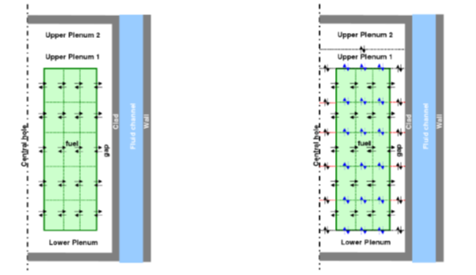

Figure : schemes of gas flow modelling with SCANAIR considering an instantaneous equilibrium of pressure in the free volumes (on the left) and with the "2D multi-species gas flow model" (on the right) [*2*]

Fuel coolant interaction during RIA transient

In some hypothetical conditions, reactivity-initiated accidents could lead to the rod failure and, subsequently to the clad opening, to the ejection toward the coolant flow of a mixture of fission gases and of fuel particles. Such an ejection implies hot fuel particles to come into contact with relatively cold liquid coolant, initiating a heat and mass transfer process. The associated vaporization rate under such large thermal disequilibrium condition is specific since rapid: the time scale for the expansion rate of the produced steam is governed by a momentum balance at the liquid-steam interface. Therefore, if sufficiently large vaporization rate has to be considered, pressure relief is not instantaneous, leading to the generation of sharp pressure increase followed by a rapid expansion. Those phenomena generate mechanical energy as well as transient mechanical forces related to sharp pressure gradients through the fluid. The impact of the corresponding pressure wave on surrounding structures is then a matter of study for safety since the integrity of those structures has to be ensured for such solicitation. This type of fuel coolant interaction and associated pressure peak and mechanical energy formation have been observed in several past in-pile experiments considering typical RIA pulses effect on fuel rodlets. Nevertheless, those experiments are difficult to instrument and have deficiencies in term of representativity with respect to the fluid pressure and temperature conditions, the latter affecting the phenomena. Violence of the interaction and of the resulting mechanical solicitations also depend on the fuel properties. The most violent ever observed RIA related interactions are related to the waterlogging of fuel rods. The specificity of high burnup fuel with respect to this fuel coolant interaction has not been specifically studied. Since burnup affects the fuel fragmentation, following fuel failure, smaller fuel fragments could be ejected through the clad opening, therefore a larger mass. Moreover, their relatively smaller size increases the surface area to volume ratio of the fuel in contact with the coolant and therefore enhances the heat and mass transfer process. Both larger mass and size should therefore lead to a more violent fuel-coolant interaction with respect to fresh fuel, as outlined by [8], Without any experimental data in those specific conditions, estimation of this violence could be only inferred from a model that has to take into account the basic of fuel ejection dynamics (that scales the typical amount of fuel in contact with the coolant) and of thermal interaction (that scales the pressure surge intensity with respect to a given temperature difference between solid and coolant). IRSN has launched an R&D program on those topics. First, dedicated experimental program have focused on the flow of dense granular flow, modelling the fragmented fuel within the clad, from a confined cylinder through an aperture (the clad opening), [9]. The coupling of such flow with the ejection of pressurized gases (modelling the fission gases initially within the rod) has been taken into account [10]. The study of the thermal interaction has been performed thanks to the study of the consequences of a very rapid heating power pulse within a confined pressurized and subcooled liquid tank at various pressure and temperature conditions, reaching similar conditions of water in PWR with CO2 as a simulant fluid, [11]. It has then been clearly shown how the pressure surge was associated to the very intense vaporization process at the time of the power pulse, and the scaling of the pressure surge with absolute pressure revealed a less intense interaction for larger pressures, [12]. All those experimental data are then used to feed the modelling of the IRSN CIGALON code, developed for the interpretation of in-pile RIA experiments leading to fuel-coolant interaction, as those of the Cabri International Program [3].

**High burn-up fuel key phenomena to address during a LOCA transient at the rod fuel scale**

With regards to the study of fuel behaviour under LOCA, the extensive state of the art review performed by IRSN led to identify the pending questions related to fuel fragmentation, relocation and dispersal after cladding burst. In this frame, specific modelling is under development in the DRACCAR code to simulate the 3D thermo-mechanical behaviour and reflooding of a fuel rod assembly during a LOCA transient taking into account fuel fragmentation, relocation and flow blockage.

Fuel Fragmentation, relocation and dispersal

Fuel fragmentation, relocation and dispersal (FFRD) were studied by various in-pile and out-of-pile experimental programs and showed extensive relocation, fragmentation and dispersal for very high burn-up fuels [13]. The DRACCAR code is developed at IRSN to model complex configurations such as the deformation and possible contact between neighbouring rods and the associated blockage of thermal-hydraulic channels in the ballooned zone of the fuel assembly. Models for axial relocation, fragments size impact on thermal conductivity and fuel dispersal were developed and used to simulate various LOCA experiments on high burn up fuel like Halden LOCA tests.

Sensitivity studies with the DRACCAR code showed that the most influent parameter on peak cladding temperature is the filling ratio in the ballooned region which has a strong impact on the power profile. Therefore, a new model was developed in the DRACCAR code to allow a variable filling ratio with cladding strain. Indeed, recent relocation data from literature and obtained in the OECD SCIP-III program suggest that there is a strong link between filling ratio, cladding strain and fuel fragments size distribution. The data from [15] obtained by simulation using discrete elements methods were analysed in terms of filling ratio versus cladding strain and are plotted in Figure 2. In this numerical work, fragmented pellets with large polyhedral fragments (1-3 mm) and a varying proportion of small spheres (400 nm), were axially relocated by gravity. For small particles proportions (lower than ~30%), the filling ratio tends to decrease with the local circumferential strain. Some very valuable data from the OECD SCIP-III program were also analysed to propose two correlations for maximum filling ratio versus circumferential strain.

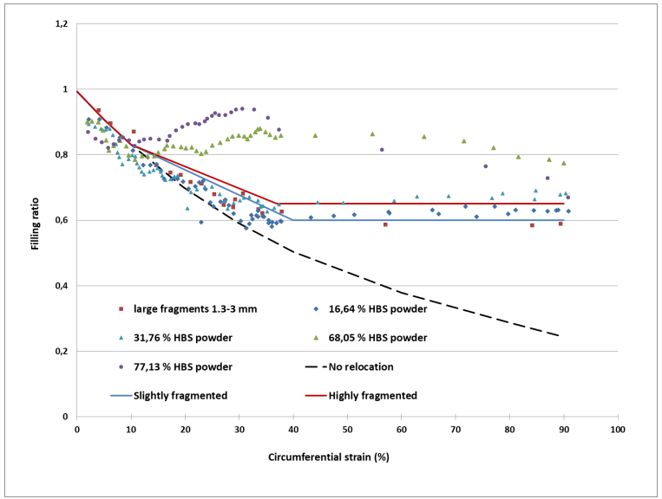

Figure : Filling ratio versus cladding strain ([14])

Experimental programs on high burn up fuels are expensive and material consuming, therefore a new manufacturing process was developed to build pre-fragmented fuel pellets surrogates with various mechanical properties [16]. Laser stereolithography is used to print fuel surrogates in the shape of pre-fragmented alumina pellets. The internal 3D architecture of these alumina pellets can be adjusted on demand. The pellets are typically made up of 50 fragments spaced apart by an average space of 200 μm and interconnected by solid bridges of 400 μm in diameter as illustrated in Figure 3. The fracture strength of these pellets was tailored to simulate nuclear fuel by investigating debinding and sintering thermal treatments. That fracture strength was tested by lateral compression with a piece of cladding or by Brazilian tests. These pellets will be used to study axial relocation inside a cladding with dedicated experiments and discrete elements methods modelling.



Figure : Pre-fragmented alumina pellet printed by stereo-lithography

Core coolability of ballooned region with power relocation

Validation of the DRACCAR code on the coolability of assemblies including ballooned rods with power relocation is performed using the recent COAL experiments carried in the framework of the PERFROI project [17]. The COAL bundle consists of rods (electrically heated), some with a pre-deformed zone (Figure 4a) with local overheating representing fuel relocation. A bundle is made of 49 (7 x 7) rods, including 16 deformed rods in the centre, 30 non-deformed rods and 3 guide tubes (Figure 4b). The test section also includes 6 spacer grids (4 mixing vanes grids plus 2 holding grids at the bottom and at the top of the bundle) each 500 mm apart. The test section is surrounded by a heated square housing (Figure 4c) which is included in a pressure vessel (Figure 4d) with two lower and upper plenums for the electrical and instrumentation connections and the fluid supply. The test device is inserted in the STERN-Laboratory loop (Hamilton, Canada) to carry out the reflooding scenario.

a) 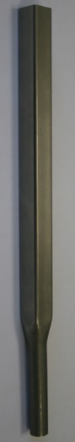 b) c) 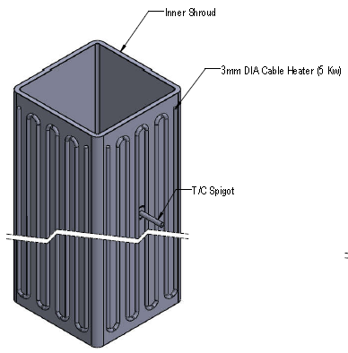d) 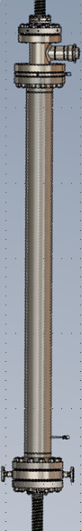

Outlet

Balloon

Inlet

B0

B1

B2

Pressure vessel

Heaters

Inconel shroud

Inconel grid

Guide tube

*Inside*

Blocked area



Figure : Overview of the COAL device [18]

COAL bundle is instrumented with many thermocouples (up to 400) located in the rods, guides tubes, fluid channels and housing external faces to cover all the spatial volume of the bundle. Additional measurements give access to the inlet and outlet flowrate (steam and liquid phase) and to evolution of mass inventory during the transient (through differential pressure transducers).

The scenario is divided in two phases as for classical “Reflooding experiments” performed in the 80’s:

* Heat up phase in dry steam atmosphere (the depressurization is not simulated),
* Reflooding by water injection with different thermal hydraulic conditions.

During a COAL reflooding campaign, almost 25 tests are carried out to cover a wide range of main thermal hydraulics parameters expected during intermediate (high pressure) and large break (low pressure) LOCA:

* coolant pressure: 0.2 to 3 MPa;
* inlet water flow velocity: 1.5 to 8 cm/s (15 to 80 kg/s/m2);
* sub-cooling water temperature: -60°C to 0°C (saturation conditions);
* power per rod: from 1.5 kW to 3.3 kW.

Three experimental campaigns have already been achieved. In the first campaign, the bundle does not include ballooned rod: it is the reference bundle B0 with intact rods. In the two other campaigns, the geometry of the ballooned zone changes (B1 with blockage ratio of 80% / balloon length 100 mm and B2 with blockage ratio of 90% / balloon length 300 mm) in order to study the impact of the blocked area on the reflooding behaviour. An additional campaign is planned in which the impact of the balloons coplanarity will be studied (the bundle design is in progress).

**Summary**

Key phenomena to study for modelling high burnup fuel behaviour during RIA and LOCA:

* Fission gas release in transient conditions;
* Axial and radial gas flow in the rod;
* Fuel coolant interaction after clad failure (RIA);
* Fuel fragmentation, relocation and dispersal (LOCA);
* Core coolability of ballooned region with power relocation (LOCA).

FUEL+ software platform was created in 2020 with the aim to model the behaviour of nuclear fuel during normal, incidental and accidental conditions, as well as during storage in pools and transport. FUEL+ includes several long-standing and newer software:

* FIRST: Fuel Irradiation in Reactor, Storage and Transport (coupled with SCIANTIX for the calculation of gas distribution in the fuel);
* SCANAIR: System of codes for normal operating conditions and RIA analysis;
* CIGALON: Fuel-coolant interaction during RIA;
* DRACCAR: Deformation and reflooding of a fuel rod assembly during LOCA;
* SHOWBIZ: Study of Hydrogen and Oxygen Weakening Behaviour In Zirconium.

REFERENCES

[1] Papin, J. et al., Summary and interpretation of the CABRI REP-Na Program, Nuclear Technology, Vol. 157, 2007

[2] Moal, A., Georgenthum, V., Marchand, O., SCANAIR: A transient fuel performance code Part One: General modelling description, Nuclear Engineering and Design 280 (2014)

[3] Biard, B. et al., *Reactivity Initiated Accident transient testing on irradiated fuel rods in PWR conditions: The CABRI International Program* Annals of Nuclear Energy 141 (2020) 107253

[4] Manorosoa, Z. A. et al., Multiscale - atomistic/mesoscopic approach for the determination of fracture criterion in uranium dioxyde - UO2 The Seventh International Conference on Computational Modeling of Fracture and Failure of Materials and Structures, Prague, Czech Republic, 2023

[5] Rondinella, V. V. et al., *Measurement of gas permeability along the axis of a spent fuel rod*, JRC94524, TopFuel, Zurich, 2015.

[6] Magnusson, P., *Integral LOCA test to study fuel fragmentation of the high burnup fuel rod 3V5-Q13* Studsvik Report, STUDSVIK/N-17/068, STUDSVIK-SCIP III-209, February 2017 (p 8).

[7] Dagbjartsson, S.J. et al., *Axial Gas Flow in Irradiated PWR Fuel Rods* INEL, TREE-NUREG-1158, September 1977.

[8] Wachs, D.M., *Performance of waterlogged LWR fuel during RIA*. In Top Fuel 2016, Boise, ID, September 11-15, 2016, USA, 2016.

[9] Z. Zou et al., Discharge of a silo through a lateral orifice: Role of the bottom inclination versus friction Physical Review E 102, 052902 (2020)

[10] Zou, Z. et al., Nonsteady discharge of granular media from a silo driven by a pressurized gas Physical Review Fluids, 7, 064306 (2022)

[11] Muller, J. et al., First characterization of two phase phenomena occurring during a rapid energy discharge in saturated carbon dioxide Experimental Thermal and Fluid Science 129 (2021) 110471

[12] Muller, J. et al., Pressure transient and vaporization process following the rapid heating of a liquid—Experiments and modelling Experimental Thermal and Fluid Science 137 (2022) 110674

[13]Report on Fuel Fragmentation, Relocation and Dispersal, NEA/CSNI/R(2016)16, 2016

[14] Taurines, T. et al., *New burst criteria, axial fuel relocation and fission gas release models in the DRACCAR code* In Proceedings, TOP Fuel meeting, Santander 2021

[15] Ma, Z., et al., *A three-dimensional axial fuel relocation framework with discrete element method to support burnup extension*. Journal of Nuclear Materials, Volume 541, December 2020

[16] Belqat, M et al., *Development of a manufacturing process for a simulating fuel for the study of fine fragmentation in LOCA*, 2022 Nuclear Materials Conference (NuMAT 2022), NuMat organizing committee and IAEA, Oct 2022, Ghent, Belgium

[17] Repetto, G. et al., COAL experiments investigating the reflooding of a 7 X 7 rods bundle during a LOCA - Thermalhydraulics results 19th Int. Topical Meeting on Nuclear Reactor ThermalHydraulics (NURETH 19), Brussels, Belgium, March 6-11, 2022

[18] Lejosne, A. et al, State of the art of IRSN’s studies regarding fuel behavior during LOCA, Int. Conf. on Topical Issues in Nuclear Installation Safety: Strengthening Safety of Evolutionary and Innovative Reactor Designs, 18–21 October 2022, Vienna, Austria

II.2.5. Ken Yueh, Electrical Power Research Institute**Fuel Fragmentation, Dispersal and Consequence Evaluation**

Ken Yueh

Electrical Power Research Institute

Nuclear fuel pellet is known to be susceptible to fragmentation when subjected to temperature transients where the temperature profile within the fuel pellet departs from the previous thermal equilibrium. Fresh or low burnup fuel pellets typically fragment into few large pieces due to thermal stress on initial powering up or under transient conditions. Recent tests of high burnup fuel showed fine fragmentation, beyond thermal fracturing, is possible without exposure to extreme temperatures, e.g., below 1273°C [1]. The fine fuel fragmentation is typically not an issue for current fuel designs since most plants operate high burnup fuel at power sufficiently low to preclude fuel cladding burst. However, the industry’s desire for higher burnup and greater fuel utilization requires operation of high burnup fuel at high power and thus fuel rod bursts and release of fuel fragment is possible. In order to assess potential consequences of fuel fragments release from burst of high burnup fuel rods, it is necessary to determine the number of burst rods, extent of fuel release from each rod, and under high steam flow conditions, how the fuel disperses in the fuel assembly, the reactor coolant system (RCS) and containment.

An 18-month high burnup core design with peak rod average burnup of ~75 GWd/MTU was used to evaluate high burnup fuel rods burst potential. The evaluation showed very high rod internal pressure at end of life (EOL), significantly exceeds the system pressure. This significantly changes how the cladding balloons. Lower burnup core designs that operate intermediate high burnup fuel at lower power releases less fission gas during operation. During the initial temperature ramp from stored energy in a LOCA, the rod pressure is typically low enough that the cladding does not creep out prior to RCS depressurization. The pressure inside a high burnup rod is sufficiently high to overcome the pre-depressurization system pressure and plastically deforms the cladding. This sets up the condition that potentially determines how the cladding balloons later in the transient since the portion that experiences plastic deformation would creep preferentially. Burst assessment using criteria/data documented in references [2,3] suggests high burnup rods operating above the core average power may burst and thus, depending on the core design, significant mass could be released.

Experimental data indicates the process of fuel fragmentation may be retarded by cladding restraint and fuel in the region may become immobile when the outward cladding deformation is small [4]. Model calculations show the lower power underneath a grid and enhanced heat transfer at the grid location from steam cooling may result in lower cladding temperatures beneath grids. The lower temperature could result in cladding strain below the fuel mobility strain threshold established in Reference [4]. Such a condition could separate parts of a fuel rod from the burst node and thus reduce the amount of fuel that could be released from a burst fuel rod. Experimental demonstration of this effect is being considered but testing condition is likely very complicated since the cooling condition changes rapidly in a LOCA.

An EPRI developed thermal-hydraulic code, GOTHIC, was used to evaluate fuel fragments dispersal within the RCS and containment. The code has the capability to track individual fuel fragments once released from a burst fuel rod. The evaluation used fuel fragments size distribution based on mass assay reported in Reference [3] and the simulation was biased to release more finer fragments at the start of a rod burst. The evaluation utilized a mathematical blockage model and showed significant mass could be blocked by the spacer grids. Fuel fragments that escape the fuel assembly may deposit in other parts of the RCS, but mostly ends up in the containment. As may be expected, with grid blockage more fuel fragments are transported to the containment when starting fragments, e.g., fragments leaving a burst rod, are smaller. Without grid blockage, most of the fuel fragments are carried by steam to the containment. Simulations are in progress to evaluate fuel fragments dispersal inside a containment. Initial runs without fuel fragment loading suggests timing of rod burst may have a significantly impact on dispersal pattern inside the containment. Steam velocities in the containment are much higher the first few seconds after the break and this could result in a wider dispersal pattern compared to rod bursts later in the transient when the steam velocity decreases.

Some of the models used in the GOTHIC simulation, such as the blockage algorithm at grid locations and particle terminal velocity are not based on actual fuel fragments geometries. Experimental verification of these models is in progress. The terminal velocity of some of the larger fuel fragment sizes will be measured in air and the equivalent hydraulic diameter will be calculated for different fragment weights. Water flow velocities needed to carry fuel fragment of different sizes on the containment floor or major component surface will also be measured to evaluate potential accumulation of fuel fragments at the sump.

To evaluate possible blockage at the grid, a flow experiment with a 3x3 fuel bundle with two spacer grids will be conducted. The experiment will use crushed non-irradiated UO2 fuel fragments that are sorted to into size groups (bins) described in Reference [3]. Model calculations show fuel fragments carried by steam could impact a grid at significant velocities and recent drop tests of post-LOCA fuel fragments showed sub-fragmentation is likely. The drop test results showed approximate 50% of the sub-fragment mass after impact with a spacer grid is contained in the next smaller bin size. Therefore, mass contained in the larger bin sizes will be down converted per experiment results. Fuel fragments will be ejected from a perforated center rod by air pressure. Air will be used to simulate steam flow in the experiment and flow velocity will be varied per LOCA calculation. The amount of fuel relocation to below the burst node, trapped in the fuel and carried outside of the fuel assembly will be measured. Fuel remaining in the fuel assembly is of primary interest for cool-ability evaluation. Additional evaluations will be performed with the trapped fuel composition to determine coolant permeability for subsequent cool-ability evaluations.

[1] Kolstad, E. et al, High burnup-up fuel behavior under LOCA conditions as observed in Halden experiments”, IAEA Technical Meeting on Fuel Behavior and Modelling under Sever Transient and LOCA Conditions, MITO, Japan, October 18-21, 2011

[2] NUREG-630, Cladding Swelling and Rupture Models for LOCA Analysis

[3] NUREG-2121, Fuel Fragmentation, Relocation, and Dispersal During the Loss-of-coolant Accident

[4] NRC RIL-2021-13, Interpretation of Research on Fuel Fragmentation, Relocation, and Dispersal at High Burnup

II.2.6. Nathan Capps, Oak Ridge National Laboratory

Assess the Impact of Prototypic High Burnup Operating   
Conditions on Fuel Fragmentation, Relocation, and Dispersal

Nathan Capps1, Ian Greenquist1, Aaron Wysocki1, Jake Hirschhorn1,2

*1: Oak Ridge National Laboratory, Oak Ridge, Tennessee  
2: Current affiliation: Idaho National Laboratory, Idaho Falls, Idaho*

The US nuclear energy industry is investigating strategies to further reduce the cost of energy production by using its existing fleet of nuclear generating stations. Nuclear power plant operating costs are governed by maintenance, surveillance, outage cost, purchase of fresh fuel assemblies, and efficiency of core design. Material costs are typically beyond the operator’s control, but core design optimizations offer potential operational savings. The core design envelope available to operators is constrained by regulatory criteria limiting fuel enrichment to 5% 235U and safety concerns limiting the peak rod average burnup to 62 GWd/tU. These constraints have led to renewed efforts by the nuclear industry to extend the peak rod average burnup beyond 62 GWd/tU. This effort will likely require additional safety analyses beyond those currently accepted by the US Nuclear Regulatory Commission (NRC). The purpose of this work is to demonstrate a best-estimate-plus-uncertainty pin-by-pin high-burnup loss-of-coolant accident (LOCA) analysis technique to assess full-core high-burnup fuel fragmentation, relocation, and dispersal (FFRD) and to identify approaches for minimizing or potentially mitigating FFRD through core design optimizations.

The first nuclear power stations licensed in the United States were approved to operate on fuel-to-rod average burnups of approximately 30 GWd/tU. This decision was based on a variety of experimental fuel performance and safety data sources that demonstrate safe operation. Extensive demonstration and testing under normal operating conditions were conducted in power-generating stations to characterize relevant performance attributes in support of this limit. Simultaneous integral testing under power-cooling mismatch conditions representative of LOCA and reactivity insertion accident scenarios were also conducted at transient test reactors to identify the dominant fuel failure modes and develop relevant fuel safety criteria. The results were essential for developing empirical fuel performance limits and validating the computer codes to demonstrate design compliance with the experimentally determined safety limits required under commercial operation. The knowledge acquired during these tests is reflected in the fundamental structure of the NRC regulatory documents, including Title 10 of the Code of Federal Regulations Part 50, “Domestic Licensing of Production and Utilization Facilities,” and the *Standard Review Plan for the Review of Safety Analysis Reports for Nuclear Power Plants: LWR Edition* [1].

Subsequent work was conducted over the following decades to extend the allowable utilization envelope for UO2/Zr alloy (Zry)-based fuels to the current limits (i.e., 62 GWd/tU peak rod average). Burnup extension was made possible by fuel technology improvements, most notably the movement of cladding designs from Zircaloy-4 to Zircaloy concepts containing Nb. Additionally, fuel material responses under postulated severe accident conditions are better understood.

Historically, the design basis limits for these materials were determined by mechanically testing cladding alloys that had been irradiated under normal service condition and subsequent semi-integral LOCA testing to determine the embrittlement thresholds. Claddings were generally found to embrittle if the peak temperature exceeded ~1,204°C or if the cladding that reacted with steam exceeded 17% of the original cladding thickness [2]. This effort was further expanded when a limited number of integral tests were performed to identify and evaluate the dominant failure modes and remained unchanged as burnup levels increased to 62 GWd/tU. Thus, it was determined that semi-integral or separate effects test data were applicable to further extend the relevant fuel safety limits without changing the fundamental safety criteria or analysis techniques.

Integral tests using the Halden reactor in Norway—and later semi-integral tests at Studsvik—revealed that the response of high-burnup fuel pellets to LOCA conditions could dramatically change from that seen in previous observations [3]. Up to ~67 GWd/tU fuel pellets were observed to fragment into pieces that were large compared with the size of the cladding rupture, and large fragments relocating into the balloon region were modest. However, some Halden and Studsvik tests conducted on fuel samples irradiated to >67 GWd/tU showed that fuel pellets could pulverize into small fragments [3]. A significant fraction of these particles was fine enough to relocate axially within the balloon region and eject through the rupture opening into the coolant. If this behavior were sufficiently significant, then it could invalidate historical approaches used to demonstrate safety and the effect of FFRD, specifically assumptions related to core coolability and criticality.

In response to these results, NRC commissioners wrote a letter to their staff identifying a need to “…define the boundary of safe operation for key fuel design and operating parameters,” stating that “the staff is challenged to evaluate the acceptability of future fuel design advancements and fuel utilization changes” [4]. This work builds on previously developed methodologies [3,5,6] to evaluate core-wide FFRD susceptibility. This work assesses important steady-state operational and fuel performance parameters that are known to contribute to FFRD susceptibility. The parameters are evaluated to support future high-burnup LOCA test plans and to inform core design strategies that reduce or potentially mitigate FFRD. Additionally, a subset of high-burnup fuel rod data representing the high-burnup operation envelope will be passed to the TRAC/RELAP Advanced Computational Engine (TRACE) for detailed thermal-hydraulic (TH) evaluation and subsequently to BISON for transient fuel performance analysis. The results from this study will be used to inform semi- and fully integral LOCA tests programs, determine cladding rupture susceptibility and those parameters that increase it, and FFRD susceptibility if rupture is predicted. Again, the goal of this work is to demonstrate a best-estimate-plus-uncertainty methodology to assess core-wide FFRD susceptibility and to inform high-burnup core design approaches intended to minimize or potentially mitigate FFRD susceptibility.

The commercial pressurized water reactor (PWR) chosen for this analysis is a Westinghouse four-loop plant with an ambient pressure containment design, a capacity of 193 nuclear fuel assemblies, and a rated power of 3,626 MWth. Current fuel management strategies for the PWR employ 18-month fuel cycle designs. However, a transition scheme to a 24-month cycle design was modeled by Southern Nuclear Company and Oak Ridge National Laboratory (ORNL) [5,6]. The design utilizes fresh fuel, once-burned fuel, and twice-burned fuel. The twice-burned fuel is always placed on the core’s periphery, where power ratings and temperatures are lowest. A methodology was developed to characterize the operating conditions and fuel performance of high-burnup fuel rods during both steady-state operations and during a postulated large-break LOCA (LBLOCA). First, the Virtual Environment for Reactor Applications (VERA) was used to model the transition from an 18-month fuel cycle to a 24-month fuel cycle, followed by steady-state 24-month operating cycles for the full reactor core. VERA calculated the power and temperature histories of every rod in the core. A statistically representative subset of rods was selected and modeled using the finite element method (FEM)-based fuel performance code BISON. VERA results and BISON temperature predictions were used as the initial conditions for a TH LBLOCA simulation using the TRACE code. TRACE predictions were then used as boundary conditions for a second set of BISON simulations predicting fuel performance during the LBLOCA. A statistical analysis of these BISON results was performed to predict the full-core susceptibility to FFRD during an LBLOCA event.

This work summarized a series of multiphysics simulations to predict the FFRD susceptibility of a full-power LWR during a postulated LBLOCA event of high-burnup fuel. First, VERA was used to model the full core during steady-state operation of a high-burnup loading pattern. The VERA predictions were used to inform steady-state BISON models of a statistically representative set of fuel rods. The steady-state BISON results were used to benchmark a TRACE simulation of the LBLOCA event. Finally, the TRACE results were used to inform a set of transient BISON models. Over the course of these simulations, the number of rods was reduced from 32,944 high-burnup rods in VERA to 242 rods in the transient BISON simulation.

The transient BISON simulations included two models for cladding failure: the Chapman correlation and the strain rate criterion. These models were used to predict if, when, and where cladding burst could occur during the LBLOCA. Additional models were applied to predict the amount of fuel fragmentation in the regions surrounding the bursts and, therefore, the FFRD susceptibility. The margins of error of these predictions were also calculated to give estimated ranges for the FFRD susceptibility.

The FFRD susceptibility could be as high as 5,392 kg of fuel. However, it is important to note that this is a worst-case scenario built upon another worst-case scenario. Both cladding failure and pulverization models are meant to be conservative, and this amount of fuel dispersal is the highest value that was predicted among six model combinations. In addition, the postulated LBLOCA was also a worst-case accident scenario occurring at the end of the cycle, when burnups were highest. Such a perfectly timed accident is relatively unlikely.

##### References

[1] US NRC, Part 50—Domestic Licensing of Production and Unilization Facilities, (n.d.). https://www.nrc.gov/reading-rm/doc-collections/cfr/part050/full-text.html (accessed December 7, 2022).

[2] US NRC, 50.46 Acceptance criteria for emergency core cooling systems for light-water nuclear power reactor, (2021). https://www.nrc.gov/reading-rm/doc-collections/cfr/part050/part050-0046.html (accessed October 27, 2022).

[3] N. Capps, R. Sweet, B.D. Wirth, A. Nelson, Development and demonstration of a methodology to evaluate high burnup fuel susceptibility to pulverization under a loss of coolant transient, Nuclear Engineering and Design. (2020) 17.

[4] P.A.C. Raynaud, Fuel Fragmentation, Relocation, and Dispersal During the Loss-of-Coolant Accident, United States Nuclear Regulatory Commission, 2012. https://www.nrc.gov/docs/ML1209/ML12090A018.pdf.

[5] N. Capps, A. Wysocki, A. Godfrey, B. Collins, R. Sweet, N. Brown, S. Lee, N. Szewczyk, S. Hoxie-Key, Full Core LOCA Safety Analysis for a PWR Containing High Burnup Fuel, Oak Ridge National Laboratory, Oak Ridge, Tennessee, 2020.

[6] N. Capps, A. Wysocki, A. Godfrey, B. Collins, R. Sweet, N. Brown, S. Lee, N. Szewczyk, S. Hoxie-Key, Full core LOCA safety analysis for a PWR containing high burnup fuel, Nuclear Engineering and Design. 379 (2021) 111194. https://doi.org/10.1016/j.nucengdes.2021.111194.

II.2.7. Davide Pizzocri, Politecnico di Milano

**Status and planned activities for the SCIANTIX code application to high burnup fuels**

D. Pizzocri1, T. Barani1,*, A. Magni1, G. Zullo1, L. Luzzi1

1Politecnico di Milano, Department of Energy, Nuclear Engineering Division, Milan, 20156, Italy

\**­Current address* : Commissariat à l’Energie Atomique et aux Energies Alternatives, Saint-Paul-lez-Durance, 13108, France

**Extended abstract**

The SCIANTIX code capabilities to describe fission gas behaviour in high burnup fuels have been progressively extended since the release of the code (Pizzocri et al., 2020). The current version of SCIANTIX can be used both as stand-alone for the simulation of separate effect experiments and coupled with fuel performance codes as a fission gas behaviour module. The scale at which SCIANTIX operates is the scale of fuel grains, at which the assumption of uniform temperature, fission rate, and hydrostatic stress are reasonable. This working hypothesis requires caution when it is applied in the rim of pellets in light water reactors, in which the self-shielding of thermal neutrons generates high gradients of fission rate.

Recent developments of SCIANTIX involved (i) restructuring the code with an object-oriented programming logic, enabling the way for faster and easier further inclusion of physical models and software maintenance, (ii) completely separating the parts of the code devoted to defining material properties, implementing behavioral models, and solving the associated differential equations. This separation allows for once and for all verification of the numerical solvers and for the application of the same behavioral model (e.g., fission gas diffusion) in different fuel matrixes (e.g., non-restructured uranium dioxide and high burnup structure).

As for behavioral models, several developments have been put into place targeting improved simulation capabilities of high burnup fuels. In synthesis

* A fuel material representing the high burnup structure has been added to SCIANTIX, incorporating the properties of the restructured fuel (e.g., grain size, lattice parameter).
* The formation of the high burnup structure is based on a combination of an empirical threshold based on effective burnup (Holt et al., 2014; Khvostov et al., 2005; Pizzocri et al., 2017) and KJMA model describing the fraction of fuel that undergoes restructuring (Barani et al., 2020).
* The high burnup structure porosity is based on an empirical model and predicted based on the local burnup (Lassmann et al., 1995, 2014).
* A physics-based model for the evolution of the porosity distribution in terms of pore number density, average number of gas atoms per pore, and variance of the number of gas atoms per pore (Barani et al., 2022). This model is derived from a Fökker-Planck approximation of the cluster dynamics master equations of pore-size evolution (Pizzocri et al., 2018).
* The size of the high burnup structure pores is derived semi-empirically as a function of the porosity and the number density of pores, in line with state-of-the-art models available in similar codes (Kremer et al., 2018).

Figure 1 collects a set of representative model results, compared with recent experimental data (Cappia et al., 2016). The semi-empiric nature of the model is evident in Fig. 1c, in which the porosity increase is clearly proportional to the local effective burnup up to 15% (the SCIANTIX result has not been adjusted to the set of experimental results used for this comparison). The nucleation of pores is correlated with the KJMA-based rate of formation of the high burnup structure (increase in pore number density from 50 to 100 GWd/tHM in Fig. 1a), followed by pore interconnection as the average pore radius increases (decrease in pore number density above 100 GWd/tHM in Fig. 1a).

The current model also includes a physics-based description of the evolution with burnup of the high burnup structure pore-size distribution (Fig. 1d). This feature is currently considering a one-dimensional phase space represented by the number of gas atoms per pore but can be extended towards a two-dimensional phase including the number of vacancies per pore. This extension is going to be critical in the future since it is linked with the capability of predicting a pressure distribution, which in turn allows physics-based modelling of fuel fragmentation.

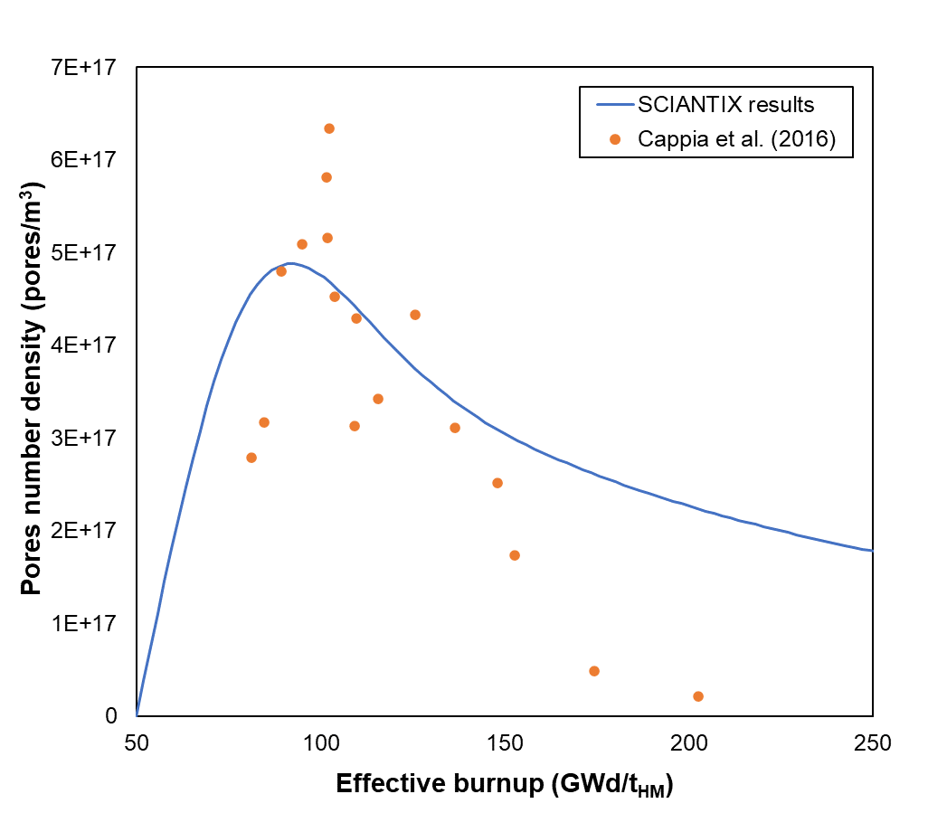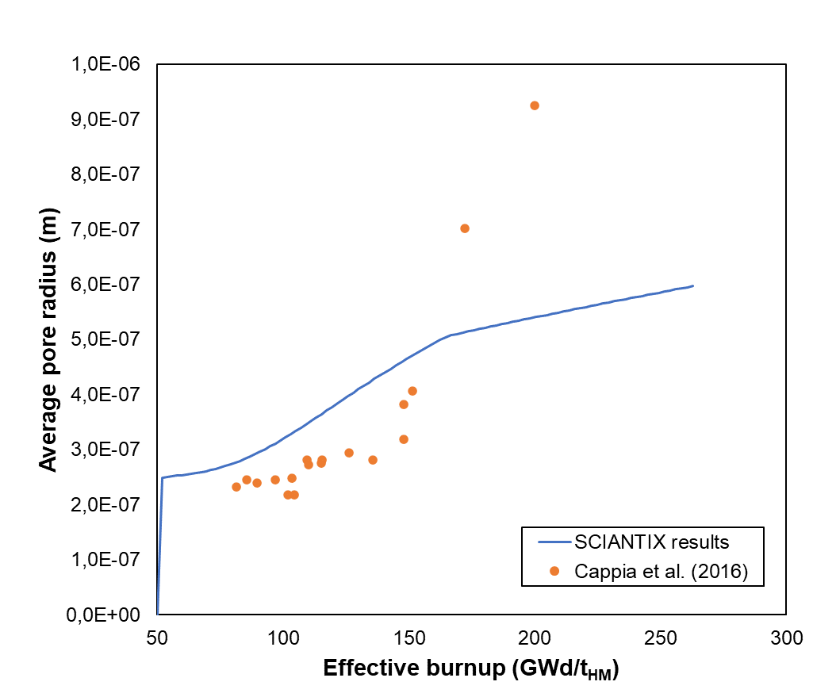

(a) (b)

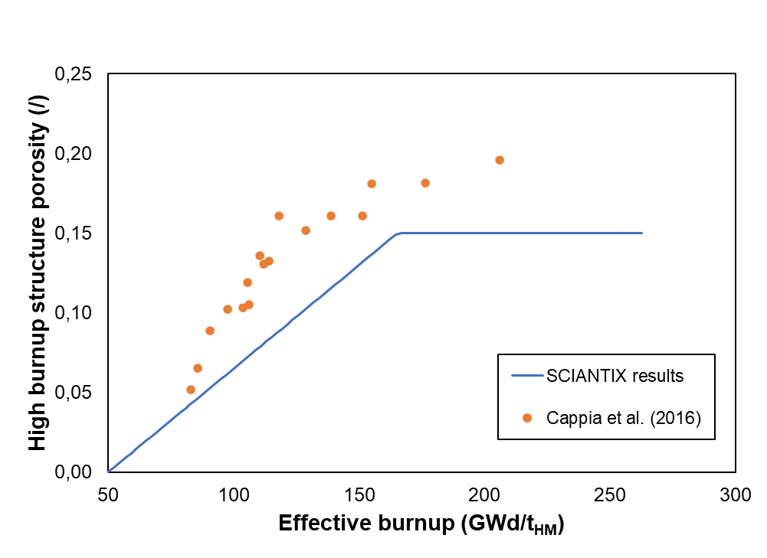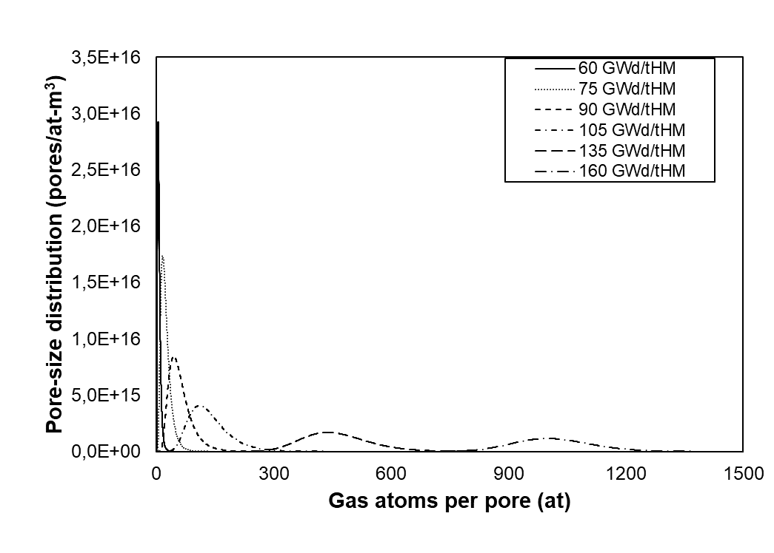

(c) (d)

Figure 1. Representative results of the behavioral model describing high burnup structure in SCIANTIX. The model includes, (a), a description of the pore number density based on the KJMA model of high burnup structure formation rate and pore interconnection, (b) and (c), a semi-empirical description of the pore radius based on local high burnup structure porosity proportional to the local effective burnup, and (d), a physics-based description of the evolution of the pore-size distribution. Data from (Cappia et al., 2016). Figure courtesy of Davide Pizzocri, Politecnico di Milano.

As shown, the current version of SCIANTIX includes all the capabilities required for a semi-empirical description of high burnup structure formation and porosity evolution at high burnup. These modelling capabilities are suitable for direct coupling within fuel performance codes, in terms of numerical robustness, computational time, verification, and validation.

Further developments include the already mentioned extension towards a description of the pore-pressure distribution, which is key towards fuel fragmentation, and

* Overcoming the empirical nature of the description of porosity, which is achieved with the physics-based description of the vacancy concentration in high burnup structure pores.
* Overcoming the semi-empirical nature of the KJMA model of high burnup structure formation via the modelling of the dislocation network evolution (Veshchunov & Shestak, 2009), paired with considerations of the effect grain size in postponing the formation itself (e.g., in Cr-doped fuels (Noirot et al., 2008)).

These models’ developments are currently being targeted in synergy with international partners and in the framework of international research projects.

**References**

Barani, T., Pizzocri, D., Cappia, F., Luzzi, L., Pastore, G., & Van Uffelen, P. (2020). Modeling high burnup structure in oxide fuels for application to fuel performance codes. part I: High burnup structure formation. *Journal of Nuclear Materials*, *539*, 152296. https://doi.org/10.1016/j.jnucmat.2020.152296

Barani, T., Pizzocri, D., Cappia, F., Pastore, G., Luzzi, L., & Van Uffelen, P. (2022). Modeling high burnup structure in oxide fuels for application to fuel performance codes. Part II: Porosity evolution. *Journal of Nuclear Materials*, *563*, 153627. https://doi.org/10.1016/j.jnucmat.2022.153627

Cappia, F., Pizzocri, D., Schubert, A., Van Uffelen, P., Paperini, G., Pellottiero, D., Macian-Juan, R., & Rondinella, V. V. (2016). Critical assessment of the pore size distribution in the rim region of high burnup UO2 fuels. *Journal of Nuclear Materials*, *480*, 138–149. https://doi.org/10.1016/j.jnucmat.2016.08.010

Holt, L., Schubert, A., Van Uffelen, P., Walker, C. T., Fridman, E., & Sonoda, T. (2014). Sensitivity study on Xe depletion in the high burn-up structure of UO2. *Journal of Nuclear Materials*, *452*(1–3), 166–172. https://doi.org/10.1016/j.jnucmat.2014.05.009

Khvostov, G., Novikov, V., Medvedev, A., & Bogatyr, S. (2005). Approaches to Modeling of High Burn-up Structure and Analysis of its Effects on the Behaviour of Light Water Reactor Fuels in the START-3 Fuel Performance Code. *Water Reactor Fuel Performance Meeting/WRFPM 2005*, 2-6 October 2005, Kyoto, Japan.

Kremer, F., Dubourg, R., Cappia, F., Rondinella, V. V, Schubert, A., Van Uffelen, P., & Wiss, T. (2018). High Burn up Structure formation and growth and fission product release modelling: new simulations in the mechanistic code MFPR-F. *TopFuel2018,* 30 September - 4 October 2018, Prague, Czech Republic.

Lassmann, K., Schubert, A., Van Uffelen, P., Gyori, C., & van de Laar, J. (2022). *TRANSURANUS Handbook, Copyright © 1975-2022*. Joint Research Centre, Karlsruhe, Germany.

Lassmann, K., Walker, C. T., van de Laar, J., & Lindström, F. (1995). Modelling the high burnup UO2 structure in LWR fuel. *Journal of Nuclear Materials*, *226*(1–2), 1–8. https://doi.org/10.1016/0022-3115(95)00116-6

Noirot, J., Desgranges, L., & Lamontagne, J. (2008). Detailed characterisations of high burn-up structures in oxide fuels. *Journal of Nuclear Materials*, *372*(2–3), 318–339. https://doi.org/10.1016/j.jnucmat.2007.04.037

Pizzocri, D., Barani, T., & Luzzi, L. (2020). SCIANTIX: A new open source multi-scale code for fission gas behaviour modelling designed for nuclear fuel performance codes. *Journal of Nuclear Materials*, *532*, 152042. https://doi.org/10.1016/j.jnucmat.2020.152042

Pizzocri, D., Cappia, F., Luzzi, L., Pastore, G., Rondinella, V. V., & Van Uffelen, P. (2017). A semi-empirical model for the formation and the depletion of the high burnup structure in UO2 fuel. *Journal of Nuclear Materials*, *487*, 23–29. https://doi.org/10.1016/j.jnucmat.2017.01.053

Pizzocri, D., Pastore, G., Barani, T., Magni, A., Luzzi, L., Van Uffelen, P., Pitts, S., Alfonsi, A., & Hales, J. D. (2018). A model describing intra-granular fission gas behaviour in oxide fuel. *Journal of Nuclear Materials*, *502*, 323-330. https://doi.org/10.1016/j.jnucmat.2018.02.024

Veshchunov, M. S., & Shestak, V. E. (2009). Model for evolution of crystal defects in UO2 under irradiation up to high burn-ups. *Journal of Nuclear Materials*, *384*(1), 12–18. https://doi.org/10.1016/j.jnucmat.2008.09.024

II.3. EXPERIMENTAL PROGRAMS SUPPORTING THE DEVELOPMENT OF HBU NUCLEAR FUELS

II.3.1. Terje Tverberg, IFE

Experience with irradiation testing in relation to high burnup investigations at the OECD Halden Reactor Project

**Introduction**

The Halden Reactor started in the late 1950’s, and over the years since then, until its eventual closure in 2018, the research conducted there has made important contributions research on in-pile behavior of water reactor fuels and materials. The establishment of the OECD Halden Reactor Project facilitated comprehensive international research programs related both to fuel and cladding, as well as materials related phenomena. The ability to instrument fuel rods that could allow for concurrent on-line monitoring of major parameters like fuel center temperature, fuel rod pressure, fuel axial displacement, cladding deformation on both axial and radial direction etc. While such tests with instrumented fuel rods always important part of it starting with fresh fuel, high burnup phenomena became increasingly important. A major milestone in this respect was in the 1980’s when the technology for re--fabrication and instrumentation of commercially irradiated fuel rods (the so-called re-instrumentation of irradiated fuel) was developed for employment in the hot-cells at the Kjeller facilities of Institute for Energy Technology (IFE) [1, 2]. The introduction of external loop systems, facilitating the possibility of simulated LWR thermal hydraulic conductions with controlled water chemistry, was also an important development. This was in particular the case for cladding corrosion experiments and IASCC related studies [3], which became an increasingly important part of the research activities at the Halden reactor, but also for studies of phenomena related to the interaction of pellet and cladding at high burnup. The present work aims at giving a brief overview of, with the main emphasis to experiments devoted to study fuel behavior at high burnup.

**High burnup fuels testing methodologies in the HRP over the years**

Instrumented fuels tests on high burnup fuel were conducted either starting from fresh fuel, irradiated over several years while continuously collecting data on properties like fuel temperature, rod pressure and fission gas release, pellet cladding interaction through cladding elongation and/or cladding diameter sensors. Fuels in this type of irradiation would invariably have enrichments higher than 5% (typically 10 - 13 wt. % 235U for tests with BU >90 MWd/kgU) in order to achieve high burnup in a reasonable time frame. Of note in this respect were also the fuel disk test type where instead of fuel pellet, the fuel would be stacked between molybdenum disk for rapid burnup accrual. These test could often have fuel with enrichment up to 20% facilitating burnup accumulation 100 MWd/kg in a few calendar years. While these disk irradiation tests would also be instrumented, and in many cases accumulate data on e.g. fuel volume change and fission gas release as function of burnup, their main purpose would typically be to produce high burnup fuel sample (in some cases in excess of 100 MWd/kg) for later studies in hot-cells using advanced techniques [4]

Another type of high burnup fuels testing was developed during the 1980’s, where irradiated fuel segments from commercial irradiations in LWRs were transported to the Kjeller hot cells for re-fabrication and instrumentation for test programmes in the Halden reactor. The subsequent re-irradiation in the Halden reactor would for such re-instrumented tests regularly also be conducted in LWR experiment loops where thermal hydraulic and water chemistry conditions typical of PWR/BWR/VVER (or even CANDU) reactor conditions could be simulated.

**Examples of conducted tests on fuel at very high burnup**

Halden reactor (HBWR) irradiations (fresh pellet fuel)

As mentioned above, pellet tests starting from fresh fuel were typically done with fuel higher than 5% enriched fuel pellets, and conducted in HBWR rigs (240°C, 34 bar D2O) allowing for highly instrumented typically in a six-rod configuration. The objectives of such long term irradiations would be integral testing of with highly instrumented rods Fuel rod instrumentation in such long term irradiation tests would typically include from a list of:

* Fuel temperature, rod pressure , fuel elongation, clad elongation, clad diameter
* gas line + gamma spectroscopy

In order to be able to achieve high burnup within a reasonable time frame, rods in such tests would also usually be of higher than 5% enrichment (typically 10 - 13 wt. % 235U for tests with BU >90 MWd/kgU). A list of some high burnup experiments starting with fresh fuel is provided in Table 1.

Table 1 Examples of HRP high burnup HBWR irradiations

|  |  |  |  |  |  |
| --- | --- | --- | --- | --- | --- |
| **Test ID** | **Max. BU**  **[MWd/kgU]** | **Enr.**  **[wt.% 235U]** | **Test objectives** | **Instrumentation** | **Remarks** |
| IFA-504 | 90 | 10 | Gas flow test. Fission gas release measurements. Study effect of fill gas composition on fuel T. | TF, EC, γ-spectr. | UO2 variants,  diff. gr. sizes, hollow and solid pellets |
| IFA-515.10 | 85 | 11.5 / 13 | Investigate the thermal behaviour of Gd fuel as compared to UO2 fuel | ET  (fuel centre T) | UO2 + Gd |
| IFA-519.9 | 90 | 13 | To evaluate the effect of load follow on fission gas release | PF | UO2,  diff. gr. sizes |
| IFA-533.2 | 90 | 9.88 | Investigate fuel thermal conductivity degradation at high BU | TF | Rods pre-irr. in IFA-409 |
| IFA-550.8 | 65 | 10 / 11 | To investigate the effect of load follow operation on PCMI. | EC, DG |  |
| IFA-676 | 75 | 10 | Comparative test of large gr. and std. gr. hollow pellet (VVER) UO2 fuel, and VVER Gd fuel. | TF, EF, PF, EC | FGR data at high burnup. |

Instrumentation:

TF: Fuel thermocouple EF: Fuel elongation PF: Rod inner pressure

ET: Expansion thermometer (Fuel centre T) EC: Cladding elongation DG: Diameter gauge

**IFA-519.9 (HRP)**

An example of a high burnup irradiation starting from fresh fuel was the IFA-519.9 experiment, where rods with different grain size UO2 fuels, that had first been irradiated in the IFA-429 rig, were re-instrumented with pressure transducers to study effect of fuel grain size and pellet-clad gap on fission gas release at extended burnup. Periods with power cycling (facilitated through the use of a 3He coil incorporated into the rig) was also included in this irradiation. Some main observations from the IFA-519.9 experiment were [REF]:

* reduced FGR from large grain fuel
  + most efficient at modest power and low FGR (10%)
* at high power and high release, an increase in grain size is less effective
* power cycling did not show enhanced FGR

An example of fission gas release data collected from the IFA-519.9 experiment is shown in Figure 6 below.



Figure 6 Fission gas release data collected in the IFA-519.9 experiment together with model predictions. (From ])

Refabricated LWR segments

Experiments with re-fabricated fuel segments from fuel irradiated in commercial LWR plants, were an important addition to the previous irradiation capabilities at Halden from the 1980’s. The ability to re-instrument with fuel thermocouples in the refabrication process from the 1990’s, that also facilitated fuel temperature monitoring for such refabricated rods was particularly important. Over the years, a wealth of data from re-instrumented test segments from high burnup fuel rods have been collected. Topics covered include studies on fuel thermal conductivity degradation with burnup, as well as for instance fission gas release and pellet cladding mechanical interaction (PCMI) at extended burnup. A special test program to study the extent of cladding lift-off – and its potential impact of fuel temperature - from extended periods of high overpressure was also conducted in the IFA-610 test series, where rods were instrumented with gas lines to provide high rod overpressure (and also gamma spectroscopy for fission gas release studies), together with fuel thermocouples, cladding elongation sensors.

Table 2 Examples of HRP high burnup irradiations with re-instrumented LWR fuel

|  |  |  |  |  |
| --- | --- | --- | --- | --- |
| **Test ID** | **Max. BU**  **[MWd/kgU]** | **Fuel Type** | **Test objectives** | **Instrumentation** |
| IFA-534.14 | 62 | UO2 various gr. size | PCMI | EC |
| IFA-597.2/.3 | 70 | UO2 | FGR + PCMI | TF, PF, EC |
| IFA-610  series | 60 - 80 | UO2 and MOX,  PWR, BWR, VVER | Lift-off / overpressure | TF, EC, γ -spectr.,  hydr. diam./gas flow |
| IFA-700.4 | 69 | UO2 | FGR + PCMI | TF, PF, EC |
| IFA-720.2 | 63 | 8% Gd | FGR + PCMI | TF, PF, EC |
| IFA-720.3 | 60 | Cr-doped + UO2 | Comparative study of FGR of Cr-doped + UO2 | TF + PF |

Instrumentation:

TF: Fuel thermocouple EF: Fuel elongation PF: Rod inner pressure

ET: Expansion thermometer (Fuel centre T) EC: Cladding elongation DG: Diameter gauge

**LWR fuel irradiation: IFA-597.3 (HRP)**

An example of a test with re-instrumented LWR fuel was the IFA-597.3 experiment , where BWR rods irradiated to ~> 65 GWd/tUin a commercial reactor were re-instrumented with fuel thermocouples and fuel rod pressure gauges or cladding elongation detectors to study fission gas release and PCMI at high burnup [REF]. A data point for onset of FGR (>1%) is shown in Figure 7, together with other data collected in Halden tests as well as from other experimental programs, that were used for establishing the Halden (Vitanza) 1% FGR threshold (also included in the figure). The observation from the IFA-597.3 experiment was onset of >1% FGR at a fuel centre temperature of 950°C at an oxide burnup of 59 MWd/kgUO2, which is about 100°C below the Halden threshold curve extrapolated to this burnup.

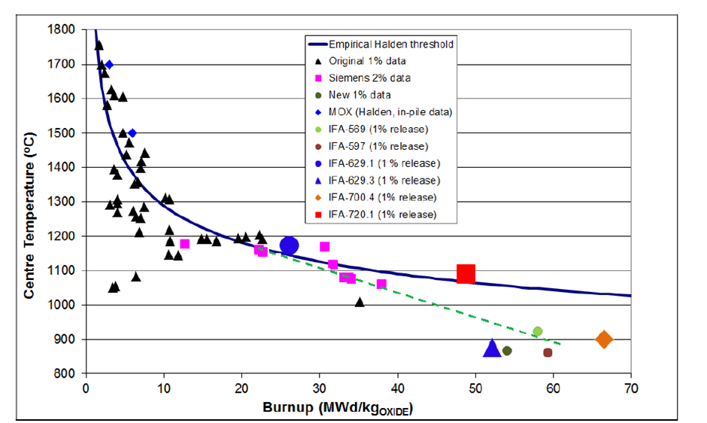

Figure 7 Halden (Vitanza) 1% fission gas release threshold and data collected at different burnups. (from [7]).

Fuel disk irradiations

A special type of Halden irradiation for studies of fuel at extended burnup, were the fuel disk irradiation designs. In these irradiations, the fuel consisted of thin (typically 1 mm thick) with increased enrichment (up to 19.8% 235U). These disks would be stacked between thicker Mo disks and mounted in fuel rods with Zry cladding. This design facilitated conditions for rapid fuel burnup accrual at near isothermal irradiation conditions. The main objective of such fuel disk tests was often to produce high burnup samples for advanced PIE at external laboratories [REF], but individual rods in these experiments would usually also be instrumented for monitoring in-pile behaviour during burnup accumulation. Fuel rod instrumentation for such tests would typically consist of

* Fuel thermocouples (TF) for monitoring fuel disk irradiation temperature
  + Rods with TF measurements would in several cases also include gas lines which when connected to gamma spectroscopy equipment allowed for measurements of radioactive fission gas release through the irradiation
* Fuel rod pressure transducers (PF) to monitor fission gas release and fuel volume change
* Fuel stack elongation detectors (EF) to monitor fuel volume change
  + Characteristics:
    - rapid burnup accumulation, uniform irradiation temperatures and burnup, high enr. (19.8 wt%)

A list of fuel disk irradiations to high burnup is provided in the table below

Table 3 Selected high burnup disc irradiations

|  |  |  |  |  |  |
| --- | --- | --- | --- | --- | --- |
| **Test ID** | **Max. BU**  **[MWd/kgU]** | **Enr.**  **[wt.% 235U]** | **Test objectives** | **Instrumentation** | **Remarks** |
| IFA-569  (EPRI/NFIR) | 77 | 19.8 | Produce uniform irradiated fuel samples for high burnup | TF, g-spectr. | UO2 + Gd |
| IFA-601  (CRIEPI/HBRP) | 100 | 19.8 | Produce uniform irradiated fuel samples for HBS studies (PIE) | TF, g-spectr. | UO2 + Gd |
| IFA-655  (HRP) | 130/200 | 19.8 | Study high burnup effects of fission gas release and fuel volume change. Transient test studies performed in some rods after irradiation completion | TF, EF, PF, g-spectr. | UO2 + MOX |
| IFA-649  (EPRI/NFIR) | 50, 75, 100 | 19.8 | Produce uniform irradiated fuel samples for HBS studies (PIE) | TF, PF | UO2 variants + MOX |

Instrumentation:

TF: Fuel thermocouple EF: Fuel elongation PF: Rod inner pressure

ET: Expansion thermometer (Fuel centre T) EC: Cladding elongation DG: Diameter gauge

**IFA-655 (HRP)**

An example of a fuel disk experiment for studies of HBS fuel behavior was the IFA_655 experiment. This experiment consisted of 12 short length rods, each with 25 disks (8.d mm disk diameter; 1 mm disk height) divided into two clusters with 6 rods each. In each cluster, 4 rods UO2 rods (19.8% enrichment) and 2 MOX rods (14% Pu) were irradiated. The UO2 fuel was consisted of standard and large grain UO2 (two of each in each cluster) while the MOX rods were of a homogeneous and heterogeneous type (one each in each cluster). Target irradiation temperatures were ~500°C and 700°C. Instrumentation consisted of fuel temperature and gas lines for the upper cluster rods, and fuel pressure and elongation for the lower cluster rods. Discharge burnups were ~130 MWd/kgHM for the UO2 rods, and ~110 MWd/kgHM for the MOX rods. Two of the UO2 rods and both MOX rods from the lower cluster were later subjected to transient testing in a separate rig for studies of fission gas release from HBS fuel. Figure XX shows data from the fuel elongation sensors in the lower cluster rods through the full irradiation (only data at hot stand-by conditions are shown). The data indicate enhanced swelling rates for all fuel variants above a burnup of ~70 MWd/kgHM.

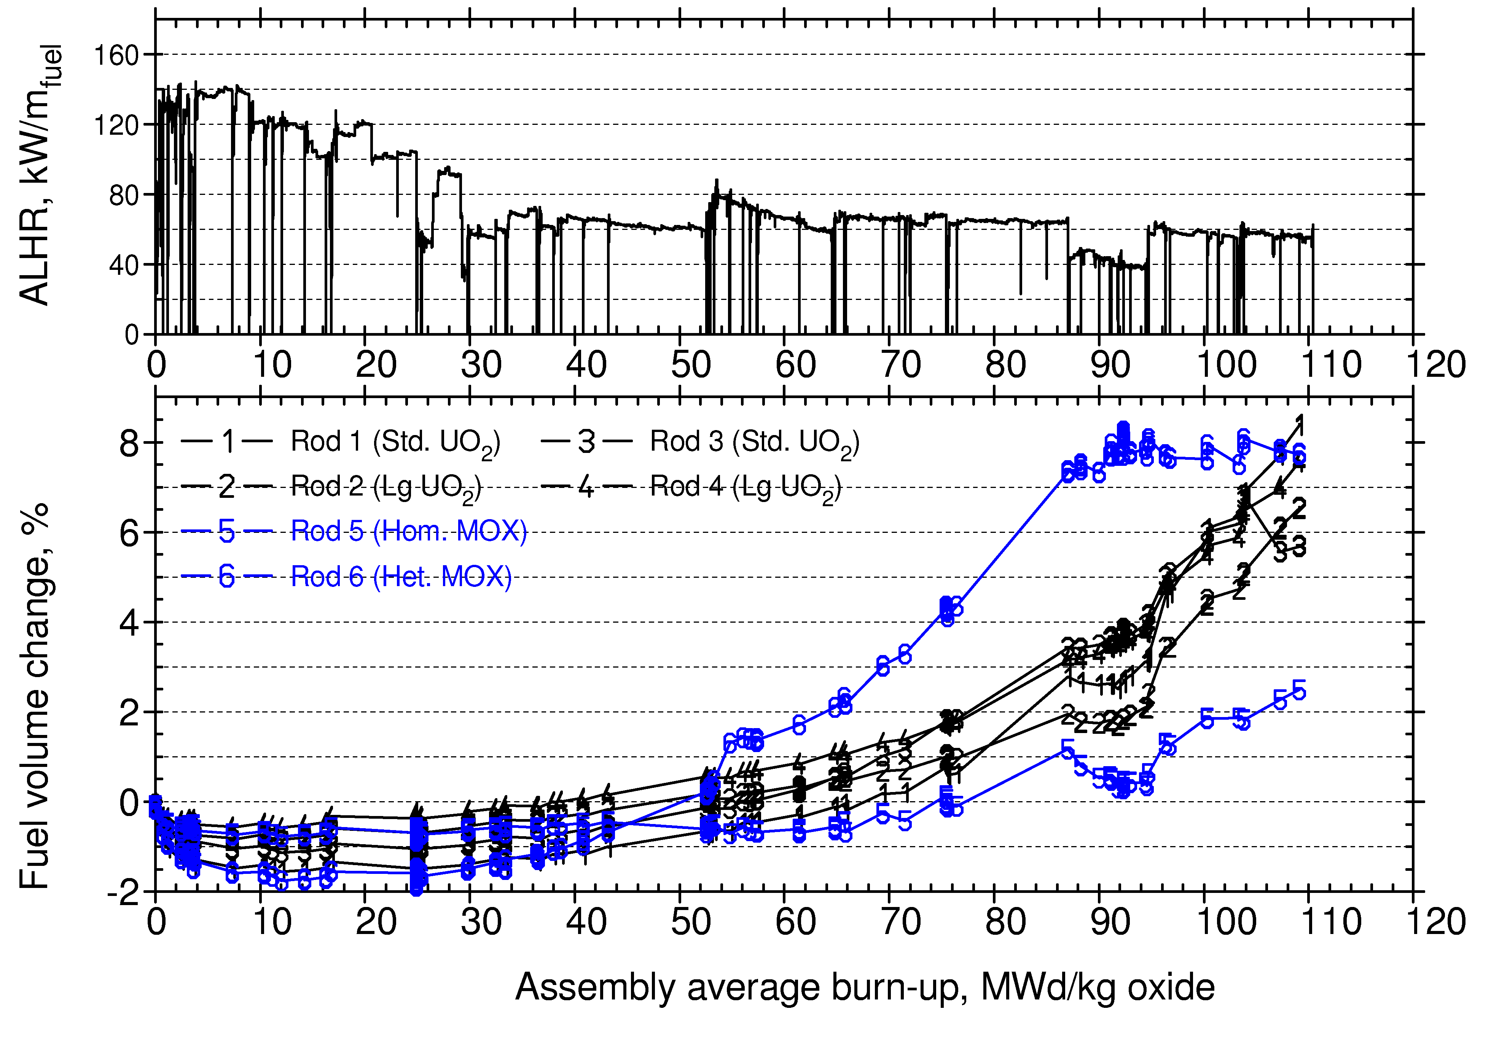

Figure 8 Fuel volume change deduced from fuel stack elongation measurements in IFA-655. (From [8])

LOCA studies of high burnup fuel – The IFA-650 LOCA test series

Aside from 3 commissioning tests with fresh fuel, a total of 13 tests with pre-irradiated LWR fuel were conducted between 2003 and 2017, with burnup ranging from ~45 MWd/kgU to above 90 MWd/kgU. The tests (all with UO2 fuel) that were carried out in the IFA-650 test series consisted of

* + 1. 3 commissioning and system check tests (with fresh fuel)
    2. 7 tests with PWR high burnup fuel
    3. 4 tests with BWR medium/high burnup fuel
    4. 2 tests with VVER medium/high burnup fuel

The test scheme for the IFA-650. LOCA tests was with a single fuel rod inserted into a pressure flask connected to a water loop. A low level of nuclear power generation in the fuel rod was used to simulate decay heat, whereas an electrical heater surrounding the rod acted to simulate the heat from neighbouring rods in a real fuel bundle situation.

In general, the rod instrumentation during an IFA-650 LOCA test would include two cladding thermocouples at the upper part of the rod (at the same elevation, 90° apart), a thermocouple at the lower part, two heater thermocouples at different elevations, a cladding extensometer and a rod pressure sensor. For power calibration and axial power distribution purposes, the test rig contained coolant thermocouples at inlet and outlet, as well as axially distributed vanadium neutron detectors.

**Main observations from the IFA-650 LOCA test series**

Some main observations from the IFA-650 LOCA test series in terms of fuel fragmentation, relocation and dispersal are from the high burnup tests in this test series are listed below:

* Fuel fragmentation:
  + The extent of fine fragmentation is strongly correlated with burnup
  + From the PIE results it was found that only rods with burnup >60 MWd/kgU showed an appreciable amount of fine fragmentation
    - It was found that a clad distension above 5% combined with a an estimated pellet surface temperature above of 870 – 930°C during LOCA was necessary for extensive fuel fragmentation to take place
* Fuel relocation:
  + The extent of fuel relocation is correlated with the amount of fine fragmentation
  + Regions with coarse fragments had less propensity for relocation, even when clad distension was large enough to allow for fuel to move into it.
* Fuel dispersal:
  + Due to how the IFA-650 test series was designed and executed, the amount of fuel dispersal during test was not quantifiable.
  + Nevertheless, some important information can be extracted:
    - Appreciable fuel dispersal was not seen for fuel with burnup < 60 MWd/kgU
    - Where photographs were taken of dispersed fuel, these invariably showed predominantly very fine fragments

In addition to the above observations related to FFRD, it should be noted that plenum pressure was measured during all tests, and data from these can assist in modelling (transient) FGR during the LOCA event. In particular, one test (IFA-650.14), was a non-burst test where post test rod puncturing data are also available as valuable data point for validation of transient fission gas release calculations.

Overview of data sets available at IAEA and/or NEA (IFPE/DATIF)

A number of datasets from Halden Reactor irradiations – in the frame of the HRP or in bilateral projects – have been made available to the nuclear community either through the NEA IFPE (or DATIF) [14] database or as datasets used in IAEA code benchmark exercises like e.g. FUMEX [] and FUMAC [17]. The tables below list some datasets available in these fora.

Table 4 Some Halden Reactor HBU Data Sets in IFPE

|  |  |
| --- | --- |
| [nea-1599](http://www.oecd-nea.org/tools/abstract/detail/nea-1599/) | IFPE/FUMEX-I, Data from OECD Halden Reactor Project for FUMEX-1 (Fuel Modelling at Extended Burnup) |
| [nea-1546](http://www.oecd-nea.org/tools/abstract/detail/nea-1546/) | IFPE/IFA-429, Fission Gas Release, Thermal Behaviour U02 Fuel, Halden Reactor |
| [nea-1488](http://www.oecd-nea.org/tools/abstract/detail/nea-1488/) | IFPE/IFA-432, Fission Gas Release, Mechanical Interaction BWR Fuel Rods, Halden |
| [nea-1860](http://www.oecd-nea.org/tools/abstract/detail/nea-1860/) | IFPE/IFA-519.9, Three PWR rods irradiated to 90 MWd/kg UO2 |
| [nea-1549](http://www.oecd-nea.org/tools/abstract/detail/nea-1549/) | IFPE/IFA-533.2, Fuel Thermal Behaviour at High Burnup, Halden Reactor |
| [nea-1684](http://www.oecd-nea.org/tools/abstract/detail/nea-1684/) | IFPE/IFA-534.14 R1, fission gas release as a function of burnup at high power (52-55 MWd/kg) |
| [nea-1548](http://www.oecd-nea.org/tools/abstract/detail/nea-1548/) | IFPE/IFA-535, Fission Gas Release, Power Ramps, High Burnup Fuel |
| [nea-1803](http://www.oecd-nea.org/tools/abstract/detail/nea-1803/) | IFPE/IFA-585, In-Reactor Creep Behaviour of Zircaloy-2 and Zircaloy-4 under Variable Loading Conditions |
| [nea-1772](http://www.oecd-nea.org/tools/abstract/detail/nea-1772/) | IFPE/IFA-597-MOX, Hollow and solid MOX rods experiments |
| [nea-1685](http://www.oecd-nea.org/tools/abstract/detail/nea-1685/) | IFPE/IFA-597.3, centre-line temperature, fission gas release and clad elongation at high burn-up (60-62 MWd/kg) |
| [nea-1861](http://www.oecd-nea.org/tools/abstract/detail/nea-1861/) | IFPE/IFA-629.1, The Re-irradiation of MIMAS-MOX Fuel in IFA-629.1 |
|  | Also the various IAEA FUMEX modelling exercises included several data set from Halden irradiations |

Table 5 Halden Reactor LOCA (IFA-650) Data Sets

|  |  |
| --- | --- |
| [nea-1862](http://www.oecd-nea.org/tools/abstract/detail/nea-1862/) | IFPE/IFA-650.1 & 2, LOCA testing at Halden, Two experiments, IFA-650 series |
| [FUMAC](https://www.iaea.org/publications/13604/fuel-modelling-in-accident-conditions-fumac) | [IAEA-TECDOC](https://www.iaea.org/publications/search/type/tecdoc-series)-1889 Fuel Modelling in Accident Conditions (FUMAC) |

**References**

1. W. Wiesenack, Review of Halden reactor project high burnup fuel data that can be used in safety analyses, Nuclear Engineering and Design 172, 83-92 (1997)
2. Wolfgang Wiesenack et al., The OECD Halden reactor project fuels testing programme: methods, selected results and plans, Nuclear Engineering and Design 207, 189–197 (2001)
3. T.M. Karlsen, Achievements and further plans for the OECD Halden reactor project materials programme, Nuclear Engineering and Design 207, 199–206 (2001)
4. M. Kinoshita et al., “High Burnup RIM Project (II) Irradiation and Examination to Investigate RIM-Structured Fuel”, ANS Meeting on Light Water Reactor Fuel Performance, Park City, Utah (2000)
5. C. Vitanza, Overview of the OECD–Halden reactor project. Nuclear Engineering and Design 207. 207-221. 10.1016/S0029-5493(00)00384-8 (2001).
6. [G. Khvostov et al., Analysis of selected Halden overpressure tests using the FALCON code, Nuclear Engineering and Design 310, 395–409 (2016)](http://dx.doi.org/10.1016/j.nucengdes.2016.10.033)
7. Vitanza et al., Fission gas release from UO2 pellet fuel at high burn-up, ANS meeting, Portland OR (1979)
8. L. Klecka, Summary report of the fission gas release experiments in IFA-629/700/720, HWR-1012 (2011)
9. T. Tverberg, The High Burn-up Disk Irradiation Test, IFA-655: Final Report on the In-pile Performance, HWR-837 (2008)
10. Report on Fuel Fragmentation, Relocation and Dispersal (FFRD), [NEA/CSNI/R(2016)16](https://www.oecd-nea.org/jcms/pl_19748/report-on-fuel-fragmentation-relocation-and-dispersal-ffrd)
11. Vladimir Brankov et al., Characterization of the relocated and dispersed fuel in the Haldenreactor project LOCA tests based on gamma scan data, Nuclear Engineering and Design 300, 97–106 (2016)
12. [Grigori Khvostov, Modelling effects of transient FGR in LWR fuel rods during a LOCA, Journal of Nuclear Materials 559, 153446 (2022)](https://doi.org/10.1016/j.jnucmat.2021.153446)
13. G. Khvostov et al., Some insights into the role of axial gas flow in fuel rod behaviour during the LOCA based on Halden tests and calculations with the FALCON-PSI code, Nuclear Engineering and Design 241, 1500–1507 (2011)
14. [OECD-NEA International Fuel Performance Experiments (IFPE) database](https://www.oecd-nea.org/science/wprs/fuel/ifpelst-request.html)
15. Fuel Modelling at Extended Burnup, [IAEA-TECDOC-998 (1998)](https://www.iaea.org/publications/5653/fuel-modelling-at-extended-burnup)
16. Fuel Modelling at Extended Burnup (FUMEX-II), [IAEA-TECDOC-1687 (2012)](https://www.iaea.org/publications/8782/fuel-modelling-at-extended-burnup-fumex-ii)
17. Fuel Modelling in Accident Conditions (FUMAC), [IAEA-TECDOC-1889 (2019)](https://www-pub.iaea.org/MTCD/Publications/PDF/TE-1889web.pdf)

II.3.2. Yoshinori, Taniguchi, JAEA

**JAEA studies on high-burnup LWR fuel behavior under reactivity-initiated accident conditions**

Y. TANIGUCHI, Y. UDAGAWA

Fuel Safety Research Group, Nuclear Safety Research Center, Japan Atomic Energy Agency

Tokai-mura, Ibaraki-ken, Japan

The Japan Atomic Energy Agency (JAEA) has performed extensive research programs to better understand the transient behavior of LWR fuels under reactivity-initiated accident (RIA) conditions. RIA-simulated pulse irradiation tests on high burnup LWR fuels, irradiated in commercial reactors, were conducted at the Nuclear Safety Research Reactor (NSRR) primarily in the framework of the Advanced LWR Fuel Performance and Safety (ALPS) research program and in the subsequent ALPS-II program launched in 2010. These experimental programs have thus far added more than 20 data points to the NSRR experiment database and extended its burnup range to 84 GWd/t. In these programs, the primary interest has been on the influence of burnup extension on Pellet-cladding mechanical interaction (PCMI) failure limit and transient fission gas release (FGR).

Based on the NSRR database on more than 1000 fresh fuel tests and about 100 irradiated fuel tests including the extensive high burnup fuel test campaign (ALPS + ALPS-II), it was found that the burnup extension significantly affects the PCMI failure limit, heat transfer and transient FGR as described below:

* PCMI failure limit (see Fig.1)
* Cladding hydrogen embrittlement is the primary factor; H content and hydride morphology are important parameters as understood from the comparison between Tests HBO-1 and VA-1 and Tests VA-5 and LS-1, respectively [1, 2, 3, 4].
* Effect of clad initial temperature (onset of transient) is also significant: increase in failure limit with ductility enhancement as understood from the comparison between Tests VA-1 and VA-3 and Tests VA-5 and VA-7 [4].
* Effect of irradiation damageaccumulated in the cladding matrix is not evident [1].
* The MOX fuel tests at the NSRR did not present clear signs of MOX-specific effect*i.e.* additional PCMI loading by gas-induced fuel pellet transient swelling: see the results of Tests BZ-1 and BZ-2 [3].
* Heat transfer
* Cladding surface heat transfer is significantly enhanced, probably owing to surface wettability enhancement by irradiation, and peak cladding temperature is suppressed [5].
* Transient FGR [4]
* Transient fission gas release monotonously increases with burnup above ~30 GWd/t, reaching ~40% above 70 GWd/t. Enthalpy dependency, suggested in the earlier studies, has become less evident through transient FGR data accumulation (see Fig.2).

Remaining knowledge gap and ongoing challenge

JAEA is planning to address one of knowledge gaps related to transient FGR. While burnup effect on transient FGR is evident, many datapoints of the TFGR database should have been results interfered by failure event (*e.g.* FCI) and the evaluation has fully relied on PIE: quite a limited knowledge of release kinetics as release rate and gas communication in rod axial direction. Furthermore, there's still limited data for HB MOX and doped fuels, and no data for ATF. To address this knowledge gap, Fission Gas Dynamics (FGD) test [6] focusing on fission gas release/migration behavior has been developed under collaboration with IRSN, as complementary effort to the integral RIA tests of NSRR, Cabri and expected TREAT experiments.



Fig. 1: PCMI failure thresholds: fuel enthalpy increase at PCMI failure expressed as a function of cladding hydrogen content.(Courtesy of Yoshinori TANIGUCHI, JAEA)

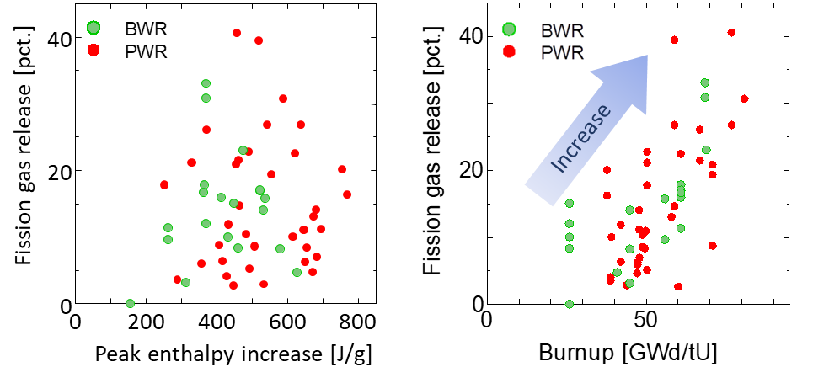

(a) (b)

Fig. 2: Relationship between fission gas release data of the existing RIA-simulated experiment data and (a) peak enthalpy increase or (b) burnup. (Courtesy of Yoshinori TANIGUCHI, JAEA)

Reference

1. Y. UDAGAWA, T. SUGIYAMA and M. AMAYA, “Thresholds for failure of high-burnup LWR fuels by Pellet Cladding mechanical interaction under reactivity-initiated accident conditions,” J. Nucl. Sci. Technol. 56, pp. 1063-1072 (2019).
2. T. FUKETA, H. SASAJIMA and T. SUGIYAMA, “Behavior of High-burnup PWR Fuels with Low-tin Zircaloy-4 Cladding under Reactivity-initiated-accident Conditions,” Nucl. Technol. 133, pp. 50-62 (2001).
3. T. SUGIYAMA, M. UMEDA, T. FUKETA, H. SASAJIMA, Y.UDAGAWA and F. NAGASE, “Failure of high burnup fuels under reactivity-initiated accident conditions,” ANE 36, pp. 380-385 (2009).
4. T. MIHARA, Y. UDAGAWA, T. SUGIYAMA and M. AMAYA, “Mechanical failure of high-burnup fuel rods with stress-relieved annealed and recrystallized M-MDA cladding under reactivity-initiated accident conditions,” J. Nucl. Sci. Technol. 58, pp. 872-885 (2019).
5. Y. UDAGAWA T. SUGIYAMA, M. SUZUKI and M. AMAYA, “ Experimental analysis with RANNS code on boiling heat transfer from fuel rod surface to coolant water under reactivity-initiated accident conditions,” INERNATIONAL ATOMIC ENERGY AGENCY, IAEA-TECDOC-CD-1775 (2013).
6. Y. UDAGAWA, T. SUGIYAMA and M. AMAYA, “Recent Research Activities Using NSRR on Safety Related,” ICAPP 2016, San Francisco, CA, USA (2009).

II.3.3. Youho Lee, Seoul National University

**Integral behavior of high burnup fuel rod under LOCA: effect on steam oxidation, integral FFRD experiment, and regulatory implications**

Youho Lee*, Dongju Kim, Hyunwoo Yook

Department of Nuclear Engineering, Seoul National University, Korea  
*[leeyouho@snu.ac.kr](mailto:leeyouho@snu.ac.kr)

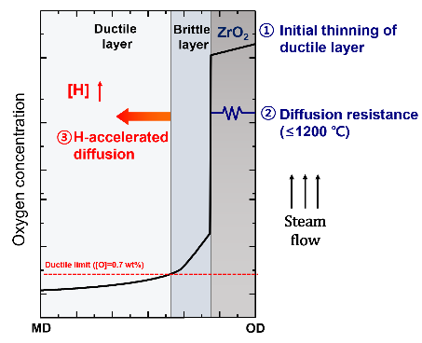This work presents recent research findings that may critically advance the current understanding of integral behavior of high burnup fuel rod under Loss of Coolant Accident (LOCA) and associated regulatory implications. Firstly, the effect of high burnup represented by pre-transient oxide and hydrogen on Zircaloy steam oxidation is discussed with experimental results and developed Zircaloy steam oxidation model (TRANOX). The sanity and potential limitations of the prevailing high burnup oxidation regulatory audit method that uses the Cathcart-Pawel correlation with the corrected cladding thickness are discussed (**Fig. 1**).

**<Fig.1 Schematic of combined effects of pre-transient oxide and hydrogen on high burnup Zircaloy cladding steam oxidation (Journal of Nuclear Materials 567 (2022) 153801)>**

Secondly, Seoul National University (SNU)’s out-of-pile integral fuel rod LOCA experiments is presented. Using induction heating for pressurized fuel rods containing surrogate pellets (i.e., whole pellet or crushed powder form (**Fig. 2**))that undergo the entire process of ballooning, burst, steam oxidation, and reflood quenching **(Fig. 3)**, this study reports results of dispersed fraction of powdered surrogate pellet with respect to various conditions such as fuel rod internal pressure, and relative size of burst hole and fragmented pellet. Along with FFRD experiments, the integral behavior of fuel rod is presented (**Fig. 4**). Based on the experimentally obtained results, preliminary regulatory implications on the audit technology of FFRD are discussed.



**<Fig.2. Whole pellet or crushed powder form loaded in cladding>**

**<Fig3 SNU’s integral fuel rod LOCA experiment for FFRD phenomena investigation: Ballooning-burst-steam oxidation- reflood quenching>**

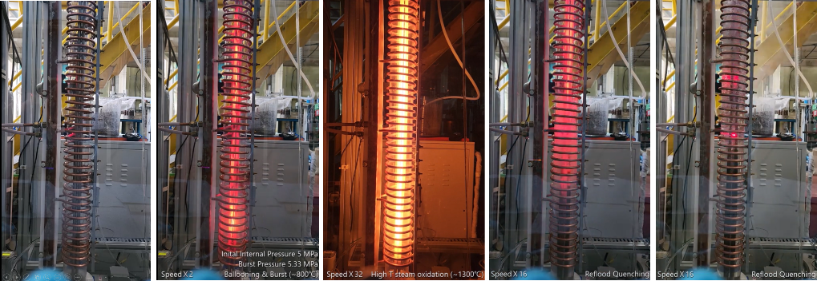

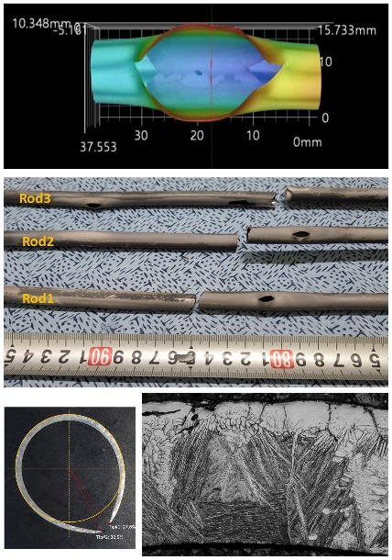Lastly, the origin of the difference between the post-LOCA ductility-based criteria (i.e., U.S NRC and Korea) and fracture-based criteria (i.e., Japan) for high burnup fuel is discussed with highlights on hydride-induced Zircaloy embrittlement. The MARS-GIFT integrated analysis revealed that burnup-insensitive fracture-based criteria are primarily due to delayed hydride precipitation upon quenching. The comparison of two different regulatory perspectives demonstrate both strength and potentially excess conservatism associated with the ductility-based regulation for high burnup fuels.

**<Fig.4 Post characterization and analysis of integral fuel rod LBLOCA experiment >**

II.3.4. Robert Armstrong, INL

**Combined TREAT-LOC and SATS LOCA Experiment Plan: Integral LOCA Experiments on High-Burnup Fuels**

Colby Jensen, Robert Armstrong*, Charles Folsom, Nicolas Woolstenhulme, David Kamerman, Fabiola Cappia, Daniel Wachs

**Idaho National Laboratory**;[*robert.armstrong@inl.gov](mailto:*robert.armstrong@inl.gov)

Nathan Capps, Jason Harp, Kory Linton

**Oak Ridge National Laboratory**

This extended abstract serves as a summary of the U.S. Department of Energy (DOE) Advanced Fuels Campaign (AFC) Combined TREAT-LOC and SATS LOCA Experiment Plan. The full plan can be found in [1].

**Introduction**

The Transient Reactor Test Facility (TREAT) loss-of-coolant (LOC) and high-burnup (HBu) experiment series, along with the Severe Accident Test Station (SATS) HBu experiment series, are integral LOC accident (LOCA) experiments planned under DOE’s AFC program. These experiments aim to support burnup extension needs by addressing identified R&D priorities in order to achieve an improved understanding of HBu fuel fragmentation, relocation, and dispersal (FFRD) during LOCA events. Data generated under this plan will be used to further validate and confirm existing models and inform future R&D and model development.

The experimental program was specifically designed to address knowledge gaps and opportunities identified through a detailed review of existing public knowledge on LOCA-induced FFRD. The test program employs a unique combination of in- and out-of-pile experimental approaches and state-of-the-art facilities to provide a clear connection to the existing integral and semi-integral LOCA experiment database. The primary goal of the program is to investigate the impact of prototypic HBu fuel/cladding thermomechanical behaviors under postulated light-water reactor (LWR) LOCA conditions that have not yet been fully studied. These conditions correspond with prototypic decay-energy heatup (DEH) and stored-energy heatup (SEH) conditions. Importantly, TREAT’s unique capability will enable the first-ever evaluation of the impact of SEH conditions on HBu fuels. The test program will emphasize development of an improved mechanistic understanding of key experimental phenomena through independent experimental systems, development of a database to support fuel performance modeling tools, and the employment of world-leading advanced materials characterization and in-situ diagnostics to evaluate FFRD. The results generated by the program will provide novel data to support modeling development and validation and will represent a significant advancement in evaluating prototypic conditions, in addition to informing the technical basis for LOCA-induced FFRD.

**Purpose and Objectives**

Nuclear- and furnace-heated LOCA experiments based on a first-of-a-kind experimental approach are planned in order to address outstanding questions regarding the FFRD phenomena in HBu fuels [2,3]. The experimental methods were specifically designed to consider the impact of prototypical conditions on relevant FFRD phenomena, and with reference to the classical LOCA experiment database conducted on HBu fuels. One key aspect of the new methods pertains to the prescribed heatup rate of the cladding and fuel temperature profiles, in recognition of the need to address SEH- and DEH-driven LOCA scenarios by applying both nuclear-fission-induced internal and external heating approaches. Notably, SEH conditions and the full nuclear heating of test fuel have never been explored in regard to HBu fuels. Thus, the primary objectives of the dual-facility experimental program are to systematically achieve the following:

1. Establish world-leading integral LOCA experiment capabilities by tying back to existing databases and leveraging integral hot-cell furnace and in-pile experimental testing approaches
2. Evaluate the integral impacts of SEH and DEH conditions (depending on the HBu core design) on FFRD and transient fission gas release (tFGR) during LOCAs
3. Measure key behavioral phenomena in situ (e.g., cladding deformation and burst dynamics, tFGR, fuel relocation and dispersal, and cladding balloon surface temperature) to reduce the uncertainty in phenomena interdependencies (e.g., temperature profile and plenum pressure/volume), while also allowing for first-of-a-kind model development and validation
4. Perform LOCA tests on material samples, with detailed relevant microstructural characterization both pre- and post-testing
5. Provide expanded LOCA datasets for model development and code validation in regard to relevant HBu fuels near important burnup thresholds

To achieve these objectives, the experimental program will conduct experiments on fuel segments irradiated to HBu levels in commercial nuclear power plants. The experiment goals require the use of a semi-integral LOCA furnace, SATS (located at Oak Ridge National Laboratory [ORNL]), and the integral in-pile LOCA capability developed for TREAT at Idaho National Laboratory (INL). These tests will be supplemented by targeted separate-effects testing and characterization using the post-irradiation examination capabilities of hot-cell laboratories located at various U.S. national laboratories.

**SEH vs. DEH LOCA Conditions**

The AFC LOCA design teams invested heavily in ascertaining prototypic or licensing-relevant conditions for FFRD in large-break (LB)-LOCAs in order to translate them for use in experiment design and test program development. As with any experiment or model, the assumptions made to represent the true application (i.e., full-plant LOCA simulation) are of paramount importance and were thus scrutinized heavily. The general conclusions of these studies indicate that the LOCA conditions (i.e., fuel/cladding temperature and cladding wall pressure differential dynamics) experienced by fuel rods may vary rather widely, depending on many factors. However, certain key behaviors observed under pressurized-water reactor (PWR) LB-LOCA conditions may notably affect FFRD, including the impacts of SEH as compared to DEH conditions. These classifications are defined to highlight potentially important differences in temperature spatial/temporal evolution and rate effects.

While DEH conditions always exist in LOCAs, they may be masked by much more dominant SEH effects during the first 10–20 seconds of the transient event. The level of SEH contribution appears dictated by several factors, though the dominant ones include the pre-accident linear heat rate and the fuel burnup [4] and blowdown cooling parameters. The former is also an important input to decay heat levels, which play an important role in determining the peak cladding temperatures reached during LOCAs. SEH conditions were found to generally correspond to higher peak cladding temperatures.

To illustrate the scenarios described above, Figure 1 provides LB-LOCA temperature prediction examples that specifically contrast the SEH and DEH conditions. The fuel and cladding temperature histories from the two LB-LOCA simulations are included. For both scenarios, Figure 1 also shows the radial temperature profile of the fuel at various times throughout the LOCA. The Scenario A simulation results stem from a coupled BISON/TRACE LB-LOCA analysis of a generic end-of-life (EOL) Westinghouse 4-loop PWR with an HBu-cycle core design. This work was performed by INL to support development of the in-pile Transient Water Irradiation System for TREAT (TWIST) LOCA vehicle by identifying representative LOCA scenarios of interest. Scenario B stems from work performed by ORNL [5], who used RELAP5-3D and BISON to simulate a LB-LOCA in an EOL Westinghouse 4-loop PWR featuring an HBu core design. In both scenarios, the fuel is operating at the same linear heat rate of ~21 kW/m prior to the LOCA, generating nearly identical radial temperature profiles through the fuel; however, the temperature response of the fuel rod following the LOCA vastly differs between the two scenarios.

In Scenario A, the coolant in the core flashes to steam within the first few seconds after pipe rupture, greatly reducing the coolant’s heat transfer capability. This results in a rapid redistribution of the fuel’s stored energy, causing temperatures in the central region of the fuel to decrease at a rate of ~100°C/s, while the cladding heats up at this same rate. After this SEH-driven heatup, core flow reversals decrease the fuel rod temperature for a period of time, followed by a second, slower, DEH-driven heatup of the fuel rod. In Scenario B, the coolant’s heat transfer capabilities directly following pipe rupture remain high enough to completely remove the stored energy from the fuel, such that the fuel rod is cooled to approximately the coolant temperature. In this scenario, there is no SEH-driven temperature peak, and the subsequent ~5°C/s temperature ramp is only due to the decay heat in the fuel.

Since the potential impacts of these different conditions may be of great importance for FFRD, they are a main focus of this experimental plan, but should also be considered in the context of specific events. Significant SEH influence may be absent in smaller-break LOCA or boiling-water reactor LOCA events [6]. The lack of data presently available makes the influence of heating ramp rates difficult to assess, especially when using models that lack appropriate validation and fail to account for all the necessary mechanisms.



Figure 1. Examples of relevant LOCA heatup conditions, illustrating SEH vs. DEH. (Top) Fuel and cladding temperatures as a function of time for Scenario A, with a strong SEH effect, and for Scenario B, with no observed SEH contribution. (Bottom left and right) Radial temperature profiles in the fuel at different points in time during the transient progression for Scenarios A and B, respectively.

**Severe Accident Test Station (SATS)**

The SATS system was initially developed to conduct high-temperature steam oxidation testing of unirradiated candidate accident-tolerant fuel cladding concepts at ORNL [7]. Leveraging this experience, the out-of-cell SATS capabilities were replicated and modified for hot-cell operation. The system has been exercised through extensive commissioning exercises and has performed multiple experiments on HBu fuels [7]. SATS consists of two modules: the Design Basis Accident Module and the Beyond Design Basis Accident Module. Figure 2 provides an overview of the two-module test station prior to insertion into the hot cell. Figure 2a shows the integral LOCA test apparatus (blue outline) and the high-temperature test furnace (red outline). A zoomed-in view of the integral LOCA test apparatus is shown in Figure 2b. The SATS LOCA integral test train can house a fuel rod segment up to 30-cm long designed to be externally heated up to 1200°C, using an infrared radiation furnace under high internal rod pressure (maximum ~20 MPa at 300°C). The internal pressure is generated by high-pressure argon gas and is monitored via a digital output pressure transducer.

(a) (b)

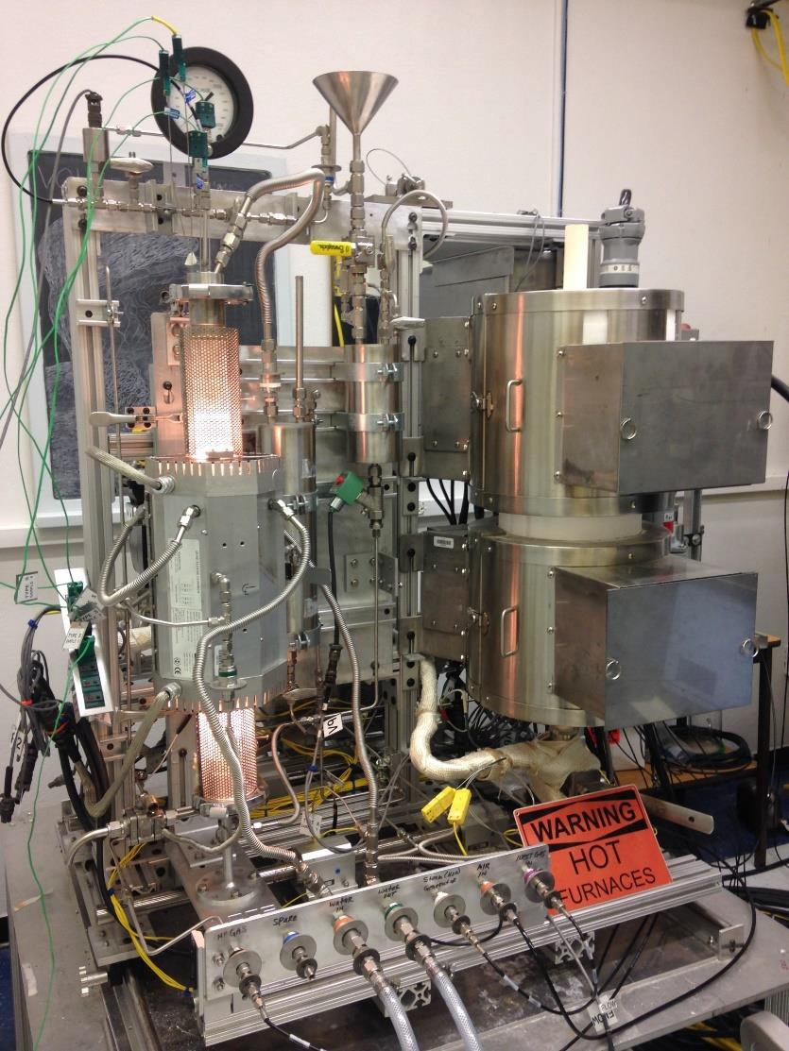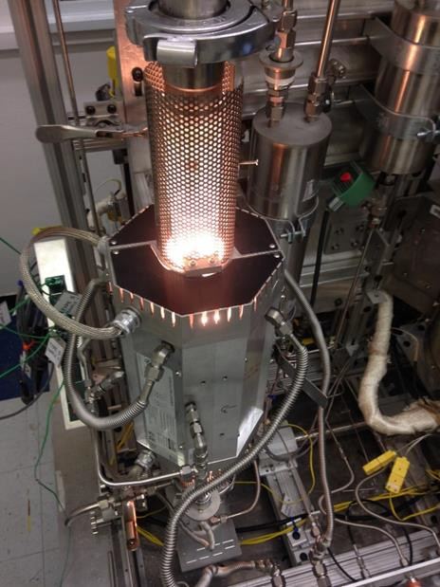

Figure 2. (a) SATS, consisting of a single unit with two modules: one for design basis accident integral LOCA testing (outlined in blue) and one for beyond design basis accident high-temperature testing (outlined in red); (b) LOCA integral test apparatus [8].

Cladding temperature control and monitoring are extremely important for understanding FFRD performance and for code validation. Analyses have shown that the cladding and fuel temperatures will differ from each other at high heating rates of 100°C/s (corresponding to SEH conditions), whereas under DEH conditions (5°C/s), fuel temperatures remain flat (~25°C across the fuel pellet). Slower heating rates consistent with DEH conditions produce greater uniformity between the cladding and fuel temperatures. Therefore, each test rodlet is fitted with up to four thermocouples: two at the specimen axial midplane, 180° apart; one positioned 5 cm above the midplane; and one positioned 50 cm below the midplane. Sample heatup occurs quickly for short samples, but temperature overshoot can be avoided by applying an integrated, well-instrumented control system. Upgrades to SATS are underway to increase the cladding heating rate from the current range of 5–17°C/s to 45–60°C/s. The upgrades are also expected to reduce the axial and azimuthal temperature gradients.

**TREAT and the TREAT LOCA Device**

TREAT offers the unique flexibility to serve many fuel and reactor designs by enabling a modular experiment strategy, as well as a highly agile control rod system for tailoring desired power histories for experiments [9]. Special experimental devices have been (and are currently) under development to aid in performing integral LOCA experiments and related separate-effects studies [10]. TREAT is an adiabatic, transient-shaping reactor with an air-cooled core. In terms of thermal capacity, the core is limited to a total deposition energy of near 2500 MJ, with the ability to deliver that total over a period ranging from ms to several minutes. Relative to other transient reactors, TREAT is especially well suited to drive HBu low-enriched specimens to nearly any power level.

With static-gas and -water capsules being routinely used in TREAT, a static-water blowdown capsule (i.e., TWIST) is being developed to enable control of relevant heat-transfer boundary conditions in order to create a testing capability that specifically addresses fuel behaviors and FFRD during LOCAs. Figure 3 gives a schematic overview of the TWIST capsule design, with tables listing its capabilities. A detailed evaluation study for a similar first-generation TREAT device is given in [11]. The primary difference in that study is a smaller capsule that has since been expanded with TWIST to accommodate longer-length specimens (i.e., up to 50 cm in fueled length) and to afford improved instrumentation options.

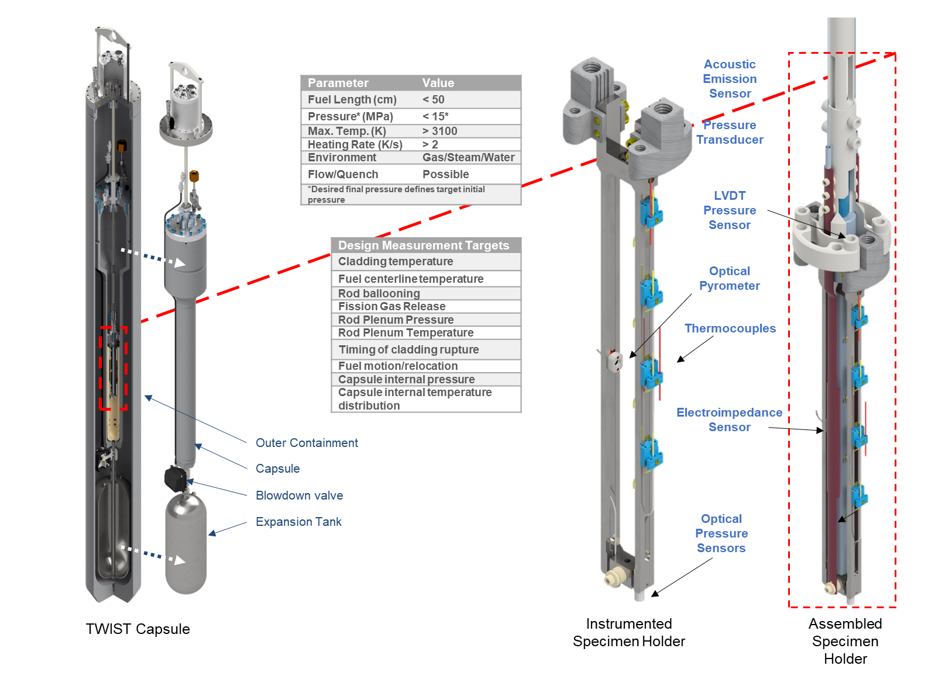

Figure 3. Schematic overview, key specifications, instrumentation measurement targets, and test train overview of the TREAT LOCA device, TWIST.

The TREAT TWIST design experiment strategy represents a unique opportunity for LOCA testing (one not previously explored for HBu fuels), with the primary objective being to use unique instrumentation to investigate thermal histories, starting from full-power conditions. Figure 4 is a schematic representation of the nominal design conditions for a TREAT experiment, for which each segment may be tailored to suit the specific objectives. The capsule relies on careful selection of specimen power input to reach nucleate boiling conditions and prototypic linear heat rates (so as to generally not overheat beyond EOL conditions) in the specimen prior to opening an expansion tank valve, while simultaneously reducing the reactor power. This simplistic approach creates a suitable balance between heat input and heat rejection in order to control the rate of temperature change across the fuel/cladding radii. For example, the relative timing of liquid blowdown, the rate of blowdown, and the power reduction in the rod can be fine-tuned to achieve specific targeted conditions. This approach was developed to represent certain LOCA events of great importance to LWR limiting conditions and has been shown to provide the flexibility to achieve that goal. The reflood capability is not currently considered an immediate testing requirement and has thus not yet been incorporated into the TWIST capsule, but could be added with basic modifications. The capsule is designed to provide a range of boundary conditions corresponding to LWR LOCAs.



Figure 4. Schematic representation of the TREAT LOCA experiment sequence in the TWIST device.

**TREAT LOC-HBu and SATS-HBu Series**

Utilization of both TREAT and SATS represents a key opportunity and feature afforded by the LOCA test program. More specifically, though the two experimental approaches are fully independent, they feature some overlap in terms of the available test conditions, thereby reducing uncertainties and allowing for enhanced interpretation of results in an optimal manner. Materials that feature similar burnups and are of identical origin (sister materials) or composition will, after consideration of their operational histories, be used to systematically reduce the associated uncertainties. The companion hot-cell facilities are also independent and offer state-of-the-art characterization capabilities, thus allowing for increased throughput between both institutions. Table 1 provides an overview of the planned LOC-HBu and SATS-HBu experiments.

Table 1. Joint LOC-HBu and SATS-HBu experiment test matrix overview. Each line represents a paired experiment conducted at TREAT and SATS. Applicable differences in test conditions are noted by dual inputs.

|  |  |  |  |  |  |  |
| --- | --- | --- | --- | --- | --- | --- |
| Test ID | Seg.  Burnup  (GWd/t) | PCT  (K) | Max. Temp.  Ramp Rate  (K/s) | Fuel  Length  (cm)* | Rod Free  Volume  (cc) | Purpose |
| LOC-1  SATS-1 | ~65 | 1173 | 5 | 25 | 15 | HBWR IFA 650.10/15 and SCIP test 36U-N05 tieback, simulate “classic” Halden/furnace condition |
| LOC-2  SATS-2 | ~65 | 1173 | <100  50 | 25 | 15 | SEH heat-up comparison to test #1 |
| LOC-3  SATS-3 | ~75 | 1173 | 5 | 25 | 15 | SCIP tieback with higher burnup |
| LOC-4  SATS-4 | ~75 | 1173 | <100  50 | 25 | 15 | SEH vs. DEH comparison with higher burnup (comparison test #3) |
| LOC-5  SATS-5 | ~75 | 1173 | <100  5 | 25 | 15 | Evaluate different failure conditions; target failure of the rod at a distinct point in the heatup/blowdown vs. refill phases |
| LOC-6  SATS-6 | ~75 | 1173 | <100  5 | 25 | 15 | Evaluate non-failure conditions; target conditions similar to #3–5, without rod burst (tFGR data with no burst and no burst effects) |
| LOC-7  SATS-7 | ~85 | 1173 | <100  5 | 25  25 | 15 | Very high burnup |
| LOC-8  SATS-8 | ~75 | 1173 | <100  5 | 50  25 | 15 | Length effects, plenum size, axial gas communication effects, SCIP complements |
| LOC-9  SATS-9 | ~75 | 1173 | <100  5 | 50  25 | 2.5 | Length effects, plenum size, axial gas communication effects, SCIP complements |
| * Fuel length will be limited to the distance between grid spacers, or would include a grid spacer if present in the commercial irradiation (likely applicable for 50-cm-long specimens in TREAT). Most semi-integral furnace tests have been conducted on segments with a length of nearly 30 cm. | | | | | | |

The test matrix defines several planned experiments that will be conducted at a nominal rate of 2–3 per facility, per year, and are envisioned to provide a balance between affording a significant data generation rate to the R&D community for interpretation and still allowing the opportunity to incorporate learning from previous experiments. Ultimately, the throughput will likely be determined by the available resources (and demand). Currently, INL is expected to receive the first test materials—which will be collected from HBu commercial fuel—from ORNL and/or Byron Nuclear Generating Station in the spring and/or winter of 2023, with testing beginning in 2024. Materials available from other commercial sources and international facilities are also being considered, as the latter can provide direct linkage to R&D program results. As the test program progresses, new insights may impact the current testing plan.

**Summary**

This extended abstract summarizes the DOE AFC Combined TREAT-LOC and SATS LOCA Experiment Plan. The full plan can be found in [1]. The experimental program aims to support burnup extension needs by addressing identified R&D priorities in order to achieve an improved understanding of FFRD of HBu fuel during LOCA events. The data generated under this plan will be used to further validate and confirm existing models and to inform future R&D and model development. Experiments will be performed on commercially irradiated HBu fuels in the semi-integral SATS furnace at ORNL, as well as in-pile in the TREAT LOCA device at INL. This approach will systematically evaluate LOCA experiments under full nuclear heated (in-pile) vs. externally heated (furnace) conditions.

**References**

[1] INL/RPT-22-69915

[2] Nuclear Energy Institute, “The Economic Benefits and Challenges with Utilizing Increased Enrichment and Fuel Burnup for Light‐Water Reactors,” 2019. Accessed March 2022, <https://www.nei.org/CorporateSite/media/filefolder/resources/reports-and-briefs/NEI-White-Paper-The-Economic-Benefits-and-Challenges-with-Utilizing-Increased-Enrichment-and-Fuel-Burnup-for-LWR.pdf>.

[3] Bales, M., et al., “Interpretation of Research on Fuel Fragmentation, Relocation, and Dispersal at High Burnup,” Nuclear Regulatory Commission, RIL 2021-13, 2021, <https://www.nrc.gov/docs/ML2131/ML21313A145.pdf>.

[4] Terrani, K., et al., “The effect of fuel thermal conductivity on the behavior of LWR cores during loss-of-coolant accidents,” Journal of Nuclear Materials 448(1-3):512-519, 2014, <https://doi.org/10.1016/j.jnucmat.2013.09.051>.

[5] Capps, N., et al., “Full Core LOCA Safety Analysis for a PWR Containing High Burnup Fuel,” ORNL/TM-2020/1700, Oak Ridge National Laboratory, 2020.

[6] Raynaud, P., and I. Porter, “Predictions of Fuel Dispersal During a LOCA,” Paper no. 100026, Proceedings of Water Reactor Fuel Performance Meeting, Sendai, Japan, 2014, <https://www.researchgate.net/publication/263965796_Predictions_of_Fuel_Dispersal_During_a_LOCA>.

[7] Snead, M., et al., “Severe Accident Test Station Design Document,” ORNL/TM-2015/556, Oak Ridge National Laboratory, 2015.

[8] Capps, N., et al., “Integral LOCA fragmentation test on high-burnup fuel,” Nuclear Engineering and Design 367:110811, 2020, <https://doi.org/10.1016/j.nucengdes.2020.110811>.

[9] Parry, J., “Foreword Special issue on Restarting the Transient Reactor Test Facility,” Nuclear Technology 205(10):3, 2019, <https://doi.org/10.1080/00295450.2019.1650604>.

[10] Woolstenhulme, N. E., et al., “Development of Irradiation Test Devices for Transient Testing,” Nuclear Technology 205(10):1251-1265, 2019, <https://doi.org/10.1080/00295450.2019.1590072>.

[11] Woolstenhulme, N. E., et al., “Thermal-hydraulic and Engineering Evaluations of New LOCA Testing Methods in TREAT,” Nuclear Technology 207(5):637-652, 2021, <https://doi.org/10.1080/00295450.2020.1807280>.

II.3.5. Michelle Bales, OECD NEA

NEA Activities Supporting Improved Understanding of High Burnup Fuel Behavior

*M. Bales, T. Ivanova, V. Rouyer, D. Jacquemain, M. Beilmann*

IAEA Technical Meeting on Safety and Performance Aspects in the Development and Qualification

of High Burnup Nuclear Fuels for Water-Cooled Reactors; 14-18 Nov 2022

**Introduction**

The mission of the Nuclear Energy Agency (NEA) is to assist its member countries in maintaining and further developing the scientific, technological and legal bases required for a safe, environmentally sound and economical use of nuclear energy for peaceful purposes through international co-operation. Two key mechanisms for facilitating this international co-operation are NEA’s expert communities and joint projects. On the subject of nuclear fuel behavior, key expert communities include the Working Group on Fuel Safety (WGFS) under the Committee on the Safety of Nuclear Installations (CSNI) and the Expert Group on Reactor Fuel Performance (EGRFP) under the Nuclear Science Committee (NSC). Joint projects that have historically and are currently providing insight on nuclear fuel behavior include the [Halden Reactor Project](https://www.oecd-nea.org/jcms/pl_24970/halden-reactor-project-fuels-and-material), the [Framework for Irradiation Experiments (FIDES-II)](https://www.oecd-nea.org/jcms/pl_70867/second-framework-for-irradiation-experiments-fides-ii) and the [Studsvik Cladding Integrity Project](https://www.oecd-nea.org/jcms/pl_25445/studsvik-cladding-integrity-project-scip).

**Activities of the NEA expert communities**

*Working Group on Fuel Safety (WGFS)*

The main mission of the WGFS is to advance the current understanding and address cross-cutting issues related to fuel behaviour in accident conditions. The Working Group aims at facilitating international convergence in fuel safety issues, including experimental approaches, interpretation and use of the experimental data or of other relevant information. Specifically, on the subject of high burnup fuel behavior, one recently publication and one ongoing activity can be highlighted.

The recently published [State-of-the-art report on nuclear fuel behavior under RIA conditions, NEA 7575](https://www.oecd-nea.org/jcms/pl_74371/state-of-the-art-report-on-nuclear-fuel-behaviour-under-reactivity-initiated-accident-conditions-ria-soar) is an update of 2010 report ([NEA N°6847](https://www.oecd-nea.org/jcms/pl_14526/nuclear-fuel-behaviour-under-reactivity-initiated-accident-ria-conditions?details=true)) considering significant expansion (revisions, corrections and supplements to data and information) of the knowledge base on fuel behavior under RIA. The report discusses the implications of high burnup microstructure on RIA performance and adds two new chapters on reviewing regulatory acceptance criteria and on applicability and transferability of test data.

The recently concluded task under WGFS on Fuel Safety Implications of Extended Enrichment and High Reactivity/High Suppression Core Designs will conclude with the publication of a status report. The status report aims to consolidate information regarding fuel enrichment limits and utilize WGFS expertise to evaluate possible fuel safety implications of extended enrichment (5-8%) and high reactivity/high suppression core designs. The report will also provide recommendations for collaborative analytical and experimental research on this topic. The task group recognized that the recent interest within the nuclear industry to extend enrichment beyond 5% is closely motivated by the desire to increase burnup. However, the task group examined the fuel safety implications of extended enrichment independent of coincident fuel safety implications of extended burnup. Nevertheless, it is interesting to note a few of the task group’s findings. First, they recognized that starting with increased enrichment means rods have greater reactivity at high burnup, which may challenge failure limits in some accident scenarios (e.g., RIA). Therefore, the task group’s final recommendations included that additional tests on behavior of extended enrichment fuel during power ramps or RIA would be useful. Second, they recognized that core designs with extended enrichment will likely require increased use of burnable absorbers. Burnable absorbers often have negative impact on fuel performance, specifically, lower thermal conductivity of Gd-fuel and increased rod internal pressure due to He release from ZrB2. Therefore, the task group’s final recommendations also included that additional experiments on gad-doped and extended enrichment fuel under DBA conditions, particularly at high burnup would be useful.

*Expert Group on Reactor Fuel Performance (EGRFP)*

The EGRFP performs specific tasks associated with fuel performance aspects of present and future nuclear power systems, with a focus on normal operating conditions. One mechanism for deepening their understanding of fuel performance is code benchmarks. Further, a key activity of the EGRFP is the identification and preservation of appropriate experimental data.

In the area of code benchmarks, the EGRFP recently concluded [a benchmark on Pellet-Cladding Mechanical Interaction (PCMI)](https://www.oecd-nea.org/jcms/pl_15168/pellet-cladding-mechanical-interaction-pcmi-benchmark) and recently launched [a benchmark on Burst Fission Gas Release (bFGR)](https://www.oecd-nea.org/jcms/pl_70791/burst-fission-gas-release-fgr-benchmark-of-the-expert-group-on-reactor-fuel-performance-egrfp)**.** The objectives of the bFGR benchmark include:

* Improving understanding of burst FGR amongst NEA member organisations
* Facilitating development of new fuel performance code models, or improvements of existing models, for burst FGR
* Facilitating improvement in accuracy of FGR predictions and hence reduction in modelling uncertainties, increased margin to fuel performance limits (e.g. rod internal pressure), and increased plant flexibility

On the subject of data preservation, the EGRFP is responsible for the [International Fuel Performance Experiments (IFPE)](http://www.oecd-nea.org/ifpe); a public domain data collection, developed jointly by the NEA and IAEA, on nuclear fuel performance experiments for the purpose of code development and validation. In recent years, significant investment has been made to facilitate easier electronic distribution in a single package and increase usability of the data collection through a software tool called [DATIF, the DATabase for IFpe](https://www.oecd-nea.org/jcms/pl_33943/database-for-ifpe-datif). Considering high burnup fuel behavior specifically, IPFE includes a few datasets >60 GWd/tHM.

**Joint Projects**

*Halden Reactor Project (HRP)*

The HRP ran for over 60 years and in that time produced a large number of experiments on high burnup fuel. This legacy data has high value for code validation to high burnup levels. Following the reactor closure in 2018, the HRP approved transfer of data for preservation and administration. The NEA is currently seeking to implement an integrated, cost-effective approach for managing key data sets for fuel safety in the future, considering developments made for IFPE and DATIF.

*Framework for Irradiation Experiments (FIDES-II)*

The NEA Second Framework for Irradiation Experiments (FIDES-II) supports the fuel and material experimental needs of nuclear safety regulators, technical support organisations, research institutions and industry and safeguards experimental knowledge for future generations. FIDES-II connects a global network of research facilities to perform high-priority experiments through Joint ExpErimental Programmes (JEEPs). One JEEP in particular, HERA Joint Experimental Project (JEEP), is focused on improved understanding of high burnup fuel behavior. The HERA experiments are being conducted at the TREAT reactor (Idaho National Laboratory) and NSRR reactor (Japan Atomic Energy Agency). The objectives of the experiment set are to (1) quantify the impact of pulse width on fuel performance, (2) investigate performance of modern high burnup fuel in RIA transients at representative pulse widths, (3) identify available cladding failure margin in modern claddings and (4) identify any safety impacts from operation of extending the burnup of UO2 fuels.

*Studsvik Cladding Integrity Project (SCIP)*

The SCIP project has been conducted, so far, in four phases, with each phase having a separate focus. Common to all phases is advanced out-of-pile experiments on irradiated nuclear fuels and claddings in its laboratories, complimented by advanced microscopy and other characterisation technologies. SCIP-III (2014-2019) focused on LOCA issues, in particular on fuel fragmentation, relocation and release. The influence of burnup, cladding strain, temperature, rod internal pressure and free volume and of microstructural effects were assessed. SCIP-IV (2019-2024) includes studies on the behaviour of fuel during a loss-of-coolant accident (LOCA) as well as fuel behaviour under dry storage conditions. Data from both phase three and four is key to understanding FFRD behavior, which is critical to understanding the behavior and boundaries of acceptable performance of high burnup fuel under LOCA conditions.

**Conclusion**

The expert communities and joint projects organized under the auspices of the NEA have produced, and continue to produce, key contributions on the subject of nuclear fuel behavior. As our members increase their focus on the development of improved understanding of high burnup fuel behavior, NEA’s expert communities and joint projects have proved to be key mechanisms to advance their knowledge and understanding.

II.3.6. Fabiola Cappia, INL

**Recent advanced post-irradiation examinations of high burnup UO2 fuels at Idaho National Laboratory**

F. Cappiaa*, D. Frazera, T. R. Pavlova, K. Wrighta, K. Bawanea, B. Kombaiaha, F. Tenga, R. Daumb, C. Jensenc, D. Wachsc

*aIdaho National Laboratory, Characterization and Advanced Post Irradiation Examination Division, P.O. Box 1625, Idaho Falls, ID 83415, USA*

*bElectric Power Institute, 1300 W W.T.Harris Blvd, Charlotte, NC 28262, USA*

*cIdaho National Laboratory, Nuclear Fuels and Materials Division, P.O. Box 1625, Idaho Falls, ID 83415, USA*

## Introduction

The changes in physical and chemical properties that the fuel endures under extended in-reactor service have been identified as one of the critical parameters contributing to the fuel fine fragmentation [1,2], one of the biggest outstanding technical issues that are a knowledge gap and performance concern for burnup extension [3].

The development of a mechanistic criterion for fuel fragmentation and pulverization is the ultimate goal in a science-based approach to fuel performance. With the increased complexity of the physics-based models and their improved ability to spatially resolve chemical and microstructural variations in the fuel [4,5], it is imperative that experimental techniques can obtain information on changes in physical and chemical properties with the same spatial accuracy to provide a robust feedback process.

New analytical material science techniques have been made available in the last two decades to study highly radioactive materials, such as high burnup fuels. The application of techniques such as micro-mechanical testing and spatially-resolved thermal property measurement techniques now enable the study of these properties of high burnup fuels as a function of the fuel radius, producing the necessary inputs to validate meso-scale physics-based models. In this study, application of micro-tensile testing [6] and local thermo-reflectance method [7] are particularly demonstrated on a high burnup UO2 fuel. These techniques, combined with traditional post-irradiation examination and advanced microscopy, create a powerful toolbox to investigate the property degradation of high burnup fuels.

## Materials and experimental techniques

The sample used in this work belongs to a high burnup rod irradiated between 1997 and 2004 for four eighteen-months cycles to provide M5® cladding performance data at high burnup [8]. The pellet average burnup was ≈80 GWd/tHM calculated from the Electron Probe Micro-Analyzer (EPMA) data [9].

Electron Backscattered Diffraction (EBSD) orientation maps were collected using the EDAX Hikari Super EBSD detector of the Plasma Focused Ion Beam (PFIB) using a step of 0.1 µm and processed using the EDAX TSL OIMTM 8.0 software. The EBSD mapping along the fuel radius revealed three regions in the fuel pellet: a first one from the fuel center till approximately half of the radius where the grains were internally subdivided with low-angle grain boundaries. A second region from the mid radius till approximately 85%-90% of the radius exhibited grains similar to the as-fabricated ones and the peripheral region showed the progressive formation of the High Burnup Structure [9].

Micro-tensile bars 2 µm x 2 µm x 10 µm in size were prepared from grains with target orientation {111} and {100}, with and without internal subgrain boundaries, using the PFIB. Additional details of the sample preparation procedure can be found in Ref. [10]. Micro-tensile tests were performed using a push-to-pull device. Values of the fracture strength were calculated by dividing the measured force at fracture by the area of the bars measured during fabrication.

For the local thermal conductivity and diffusivity measurements, the thermal conductivity microscope (TCM) installed in a shielded glovebox at the Irradiated Materials Characterization Laboratory at Idaho National Laboratory was employed. A complete description of the system and measuring protocol can be found in Ref. [7].

## Results and discussion

Figure 1 shows the summary of the experimental fracture strength values obtained from the sample in comparison with the literature data from non-irradiated and low-burnup samples [11,12]. This initial dataset shows that at high burnup the intergranular fracture strength is comparable to the fracture strength at lower burnup, while the intragranular fracture strength is significantly degraded compared to the low burnup counterpart. The difference could be due to the extensive accumulation of intragranular dislocation observed in the sample [9] that weakened the interior of the grains at high burnup.

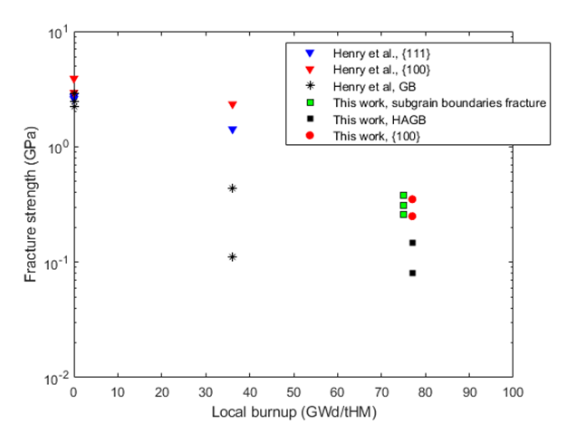

Figure 1: Local fracture strength as a function of local burnup from this study and the study by Henry et al. [11].

Figure 2 reports the radial variations of thermal conductivity obtained either directly from the TCM measurements or derived by the measured thermal diffusivity measurements. It is shown that the thermal conductivity remains approximately constant from the pellet center to the pellet mid-radius followed by a gradual decrease in these properties towards the pellet periphery. This trend is consistent with the measured inventory of fission gases such as Xe measured by EPMA in the sample [9], which precipitate in nanometric bubbles with a limited quantity present in matrix solution in a three vacancy Schottky cluster. Such bubbles and point defects are effective phonon scattering sites and contribute to the degradation of thermal conductivity. Furthermore, the accelerated decrease in thermal diffusivity and conductivity towards the pellet periphery is in line with the significant increase in porosity and burnup [9]. These measurements, coupled with the microstructural characterization performed on the sample in [9], can be used to validate meso-scale thermal conductivity models such as the one reported in Ref. [5].

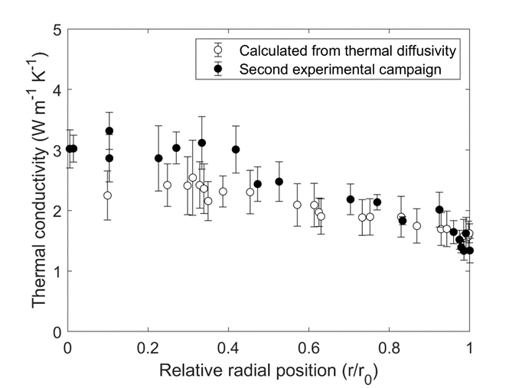

Figure 2: Radial profile of the measured thermal diffusivity of the sample.

## Conclusion and perspectives

The current study demonstrated the deployment of state-of-the-art local characterization techniques to obtain new experimental data on high burnup fuels, with spatial resolution previously not accessible. The current approach, coupled with extensive microstructural characterization, paves the way for exploring the influence of irradiation-induced modifications on fundamental material properties such as mechanical and thermal properties needed to develop and validate physics-based fuel performance modeling. Systematic synergy between these experiments and modeling efforts are expected to be employed in the future to address the knowledge gaps for burnup extension of nuclear fuels.

## References

[1] J.A. Turnbull, S.K. Yagnik, M. Hirai, D.M. Staicu, C.T. Walker, "An Assessment of the Fuel Pulverization Threshold During LOCA-Type Temperature Transients", *Nuclear Science and Engineering*. **179** (2015) p. 477–485. 10.13182/NSE14-20.

[2] N. Capps, C. Jensen, F. Cappia, J. Harp, K. Terrani, N. Woolstenhulme, D. Wachs, "A Critical Review of High Burnup Fuel Fragmentation, Relocation, and Dispersal under Loss-Of-Coolant Accident Conditions", *Journal of Nuclear Materials*. **546** (2021) p. 152750. <https://doi.org/10.1016/j.jnucmat.2020.152750>.

[3] K.J. Geelhood, "Fuel Performance Considerations and Data Needs for Burnup above 62 GWd/MTU", (2019).

[4] W. Jiang, T. Hu, L.K. Aagesen, S. Biswas, K.A. Gamble, "A phase-field model of quasi-brittle fracture for pressurized cracks: Application to UO2 high-burnup microstructure fragmentation", *Theoretical and Applied Fracture Mechanics*. **119** (2022) p. 103348. <https://doi.org/10.1016/j.tafmec.2022.103348>.

[5] X.-M. Bai, M.R. Tonks, Y. Zhang, J.D. Hales, "Multiscale modeling of thermal conductivity of high burnup structures in UO2 fuels", *Journal of Nuclear Materials*. **470** (2016) p. 208–215. <https://doi.org/10.1016/j.jnucmat.2015.12.028>.

[6] C. Howard, C.D. Judge, P. Hosemann, "Applying a new push-to-pull micro-tensile testing technique to evaluate the mechanical properties of high dose Inconel X-750", *Materials Science and Engineering: A*. **748** (2019) p. 396–406. <https://doi.org/10.1016/j.msea.2019.01.113>.

[7] T.R. Pavlov, S.C. Middlemas, B.D. Miller, F. Cappia, J.I. Cole, J.J. Giglio, "Understanding the local thermal conductivity evolution of neutron irradiated U3Si2 dispersion fuel via state-of-the-art thermo-reflectance measurements", *Journal of Nuclear Materials*. **557** (2021) p. 153280. <https://doi.org/10.1016/j.jnucmat.2021.153280>.

[8] G.L. Garner, B.A. Hilton, E. Mader, "Performance of Alloy M5® Cladding and Structure", in: *Proceedings of the 2007 International LWR Fuel Performance Meeting*, San Francisco, 2007.

[9] F. Cappia, K. Wright, D. Frazer, K. Bawane, B. Kombaiah, W. Williams, S. Finkeldei, F. Teng, J. Giglio, M.N. Cinbiz, B. Hilton, J. Strumpell, R. Daum, K. Yueh, C. Jensen, D. Wachs, "Detailed characterization of a PWR fuel rod at high burnup in support of LOCA testing", *Journal of Nuclear Materials*. **569** (2022) p. 153881. <https://doi.org/10.1016/j.jnucmat.2022.153881>.

[10] F.CAPPIA, D. FRAZER, F. TENG, K. BAWANE, C. Jensen, D. Wachs, K. Yueh, R. Daum, "FRACTURE PROPERTIES AND ADVANCED CHARACTERIZATION OF HIGH BURNUP FUEL RELEVANT TO FRAGMENTATION DURING ACCIDENT CONDITIONS", in: *TopFuel 2021*, Santander, 2021.

[11] R. Henry, I. Zacharie-Aubrun, T. Blay, S. Chalal, J.-M. Gatt, C. Langlois, S. Meille, "Fracture properties of an irradiated PWR UO2 fuel evaluated by micro-cantilever bending tests", *Journal of Nuclear Materials*. (2020) p. 152209. <https://doi.org/10.1016/j.jnucmat.2020.152209>.

[12] R. Henry, I. Zacharie-Aubrun, T. Blay, N. Tarisien, S. Chalal, X. Iltis, J.-M. Gatt, C. Langlois, S. Meille, "Irradiation effects on the fracture properties of UO2 fuels studied by micro-mechanical testing", *Journal of Nuclear Materials*. **536** (2020) p. 152179. <https://doi.org/10.1016/j.jnucmat.2020.152179>.

II.4. EXPERIENCE BY FUEL DEVELOPERS IN DEVELOPMENT AND QUALIFICATION OF FUEL DESIGNS FOR HIGH BURNUP

II.4.1. Yongjun JIAO (Nuclear Power Institute of China, China)

**Fuel management strategy and plan for Increasing fuel burnup**

**Nuclear Power Institute of China**

**Yongjun JIAO**

**2022-11-16**

**Nuclear Power in China**

Based on the background that Chinese government has announced China will reach the Carbon peak by 2030 and realize the Carbon neutrality by 2060 at the 75th United Nations General Assembly. In order to promote green transformation of economic and social development, improve industrial structure, and formulate plans for carbon peak in energy, petrochemicals, transportation and other sectors, and accelerate the building of a clean, low-carbon, safe and efficient energy system, strictly control the consumption of fossil energy, and actively develop non-fossil energy, nuclear energy is the main option to provide stable and clean base-load energy. Take Gen-II+ million-level reactor units as example, during the whole industrial chain and lifespan, the emission is 11.9g-CO2, eq/(kW·h); without considering irradiated fuel reprocessing and disposal, the emission is 6.2g-CO2, eq/(kW·h).

In China, 54 nuclear power units are under operation by June 2022, total installed capacity is 55.78 GWe, ranking third in the world. While 23 nuclear power units are under construction or approved, ranking first in the world.

The total nuclear power units under operation or construction are the second in the world. In 2022, 10 units are approved. 34 nuclear power units in China received a full score in the WANO composite index 2021. Full score units account for 70% of the total Chinese nuclear power units. The full scale of WANO composite index and the average WANO composite index of Chinese nuclear power units are among the top in the world.

It is estimated that the target for nuclear power development in China is to generate around 10% of total energy from installed capacity by 2035 and 15-20% of total energy by 2050.

**Fuel Management in China**

The major refueling cycle length of nuclear power plant is around 18 months in China, including the combination of two enrichments, 4.45% and 4.95%, and the increasing number of refueling fresh fuel assembly compared with 12-mouth fuel management strategy.

The objective of fuel management is to prolong the refueling period and increase fuel discharged burnup, so that the economy of the nuclear power plant and the availability of fuel can be increased.

Currently, most of the Gen- II+ reactor units in China adopt 18-month refueling strategy. While the fuel economy of this strategy is relatively low. Certain Gen-II+ also adopt the mixed enrichment and 18-month refueling strategy, with higher average fuel assembly discharge burnup and better fuel economy. Besides, some of Gen-II+ units adopt long and short alternate 18-month refueling strategy as well. As for VVERs, AP1000 and CNP1000, all of them adopt 18-month refueling strategy.

To conclude, the major refueling cycle length of nuclear power plant is around 18 months in China, while the fuel enrichment is low than 5%. The major fuel assembly burnup limit is 52000MWd/tU, except for AP1000 and VVER. Fuel assembly discharged burnup can reach to 57000MWd/tU in some fuel management strategy, nevertheless.

**24-month Fuel Management**

Some Chinese nuclear power units are considering to adopt 24-month refuelling strategy. Compared with 18-month refuelling, increasing the cycle length to 24- months brings the benefits of increase power generation and the capacity factor of nuclear power plant, reducing times of shutdown and refuelling overhaul, the cost of major repairs, and radiation exposure levels of workers. Additionally, adjusting refuelling overhaul to a certain time, which is conducive to the rational arrangement of the unit overhaul and increase the capacity factor of nuclear power plant.

When enrichment is less than 5%, the number of fresh FA is increased to enlarge cycle length, thus, the average discharged burnup decreases and the fuel economy deteriorates. When enrichment exceeds 5% and the FA burnup limit increases, the number of fresh FA can be effectively reduced and the fuel economy can be improved at a similar cycle length.

According to the analysis, for the VVER and AP1000 units, there is no need to increase fuel burnup limit when the fuel enrichment is less than 5%. For CNP650 units with 121 fuel assembly cores, the fuel economy is acceptable when the fuel enrichment is less than 5% and fuel burnup limit does not exceed 55000MWd/tU. While for M310 units with 157 fuel assembly cores and CNP1000 with 177 fuel assembly cores, the fuel economy is not ideal when the fuel enrichment is less than 5% and fuel burnup limit does not exceed 55000MWd/tU.

In order to increase the fuel economy of 24-month refuelling strategy, fuel enrichment exceeding 5% and fuel burnup limit exceeding 55000MWd/tU are necessary for M310 and CNP1000 units, which adopt the more prevalent fuel assembly nowadays.

**Plan for increasing Burn-up**

Currently, approved burnup limit of the widely used fuel assembly is 52000MWd/tU. In 2019, four lead fuel assemblies were reloaded for higher burnup irradiation test, and the discharged burnup is close to 57000MWd/tU. Before and after irradiation test, full poolside inspection was conducted, including deformation of fuel assembly and oxide film thickness. To increase batched fuel assemblies burnup limits is still underway. Some ATF types currently under research will increase FA burnup to above 62000MWd/tU, and can be applicated by 2030.

**Conclusion**

To sum up, the major refuelling cycle length of nuclear power plant is around 18 months and Fuel burnup limit is around 52000MWd/tU in China.

To further improve fuel economy, some nuclear power units are considering to adopt 24-month refuelling strategy and increase fuel burnup limit. While the national regulatory authority’s safety supervision is relatively strict, which brings challenge to increase fuel burnup limit. The irradiation test plan is being designed to progressively increase fuel burnup limit.

II.4.2. Nuria DONCEL (ENUSA, Spain)

**ENUSA EXPERIENCE ON HIGH BURNUP DEMONSTRATION PROGRAMS**

N. DONCEL

Fuel Performance

*ENUSA Industrias Avanzadas S.A. SME*

Email: [ndg@enusa.es](mailto:ndg@enusa.es)

J.M ALONSO

Research and Development Manager

*ENUSA Industrias Avanzadas S.A. SME*

Email: [jap@enusa.es](mailto:jap@enusa.es)

**ABSTRACT**

The good collaboration among technological partners, utilities and ENUSA has resulted in very dynamic programs continuously growing in scope to face the new goals and industry trends in a safe manner and applying a broad spectrum of inspection techniques. One of the main goals of these programs along the years has been the investigation of the effects of increasing both, assembly and fuel rod, burnup.

This paper presents the scope and results of those programs showing a wide range of operational conditions and fuel characteristics, including fuel cladding and fuel assembly behavior, grid and rod dimensional changes, fuel rod fretting wear as well as hot cell examinations. The excellent performance of the *ENUSA Industrias Avanzadas S.A. SME* (ENUSA) manufactured fuel is one of the best indicators of the confirmed expectations and benefits of all those efforts. Finally, partially related with the improvements in the cycle economy and with a potential increase of the burnup, we found the Accident Tolerant Fuels (ATF).

1. **BACKGROUND**

In Spain, nuclear energy has represented approximately 20% of the total production of electricity in recent years. Spanish companies had focused their activity in the nuclear sector, based on the experience and thanks of their participation in the development of the Spanish nuclear program since its beginnings and were present in the whole chain of value.

All this industrial structure has evolved with the circumstances of each moment, incorporating modern technologies adapted to current needs and requisites. This have making possible that Spanish companies are present today in projects in more than 40 countries, in four of the five continents.

The Spanish nuclear industry has also taken part in international research and development projects for advanced nuclear reactors related to high burnup purposes.

The electrical companies focus their main activity in production, transportation, distribution, and commercialization of electricity. The goal of these companies is to work permanently towards excellence in the management of nuclear power plants, with a commitment to continue to produce in a scale and reliable way and promoting growth in their areas of influence both from the social, economic, and environmental point of view. Since the construction of the first NPP they have extended their actions to the study of the optimization of the performance, maintenance, management of improvements in equipment and procedures, management of the fuel cycle and development of new reactors.

The design, manufacture, and supply of fuel to Spanish and international nuclear power plants is made by the public capital company *ENUSA Industrias Avanzadas* S.A. SME. ENUSA was founded in 1972 as a public Enterprise **Error! Reference source not found.** 60% owned by the *Sociedad Estatal de Participaciones Industriales (SEPI)*, and the remaining 40% by the CIEMAT.

ENUSA's purpose is to develop innovative nuclear and environmental solutions at a global level, contributing to the sustainable progress of society through the values of Safety, Flexibility, Innovation, Commitment and Collaboration and focuses on activities of the nuclear fuel cycle:

* Management of the enriched uranium supply to the Spanish nuclear power plants under the criteria of security and flexibility.
* Engineering Services in all technical aspects of the lifetime of the nuclear fuel, from design and operation in the nuclear power plant up to his tenure as irradiated fuel for transport and dry storage.
* Manufacturing nuclear fuel assemblies to national and foreign nuclear power plants for both Pressurized Water Reactors (PWR and VVER) as well as Boiling Water Reactors (BWR).
* On-site Services for handling, inspection and repair campaigns that take place during the refueling programs, supplying fresh fuel reception and irradiate fuel handling services and supervising the process during the reload (inspection, repair, characterization, and cleaning)
* Transport of nuclear and radioactive materials (through the subsidiary ETSA).

As part of nuclear activities, we also develop technological capabilities for the second stage of the fuel cycle and for the sale of equipment for manufacturing fresh fuel and for inspection of irradiated fuel. On the engineering side, ENUSA is responsible of the product design as well as nuclear and safety analysis for the Spanish nuclear plant. The reload activities (design, follow up and support operation), together with the design of spent fuel management methodologies and new products and technology introduction (R&D) are also part of our portfolio for the European PWR and BWR market.

*Spanish National Integrated Energy and Climate Plan (PNIEC)*

The National Energy and Climate (ENCP) Plan 2021-2030 is a ten-year integrated document [mandated by the European Union](https://ec.europa.eu/energy/topics/energy-strategy/national-energy-climate-plans_en) to each of its member states in order for the EU to meet its overall greenhouse gases emissions targets. The Energy and Climate Plan addresses all five dimensions of the EU Energy Union: de-carbonization, energy efficiency, energy security, internal energy markets and research, innovation, and competitiveness.

The government released a second version of the plan in September 2020. According to that version, Spain is on track to complete the nuclear power phase-out by 2035. The nuclear power capacity in the country is expected to decline sharply from 7.1 GW in 2020 to 3 GW by 2030. As of August 2021, the country had seven operational nuclear power reactors, the majority of which owned and managed by Iberdrola and ENDESA. Spanish Government is planning to decommission nuclear power capacity during the 2027 to 2035 period.

1. **HIGH BURNUP DEMONSTRATION PROGRAMS IN SPAIN**

Spanish nuclear industry has conducted joint experimental programs with the Japanese PWR industry since early 1990’s to address fuel performance issues such as cladding corrosion resistance, dimensional stability, and fission gas release.

These efforts have produced substantial amounts of valuable information on in-reactor performance of fuel materials standing for current as well as potential future fuel designs.

Characterized fuel rods composed of different cladding materials were irradiated in the Spanish PWR Vandellós II NPP for up to five irradiation cycles achieving values up to 75 MWd/kgU, rod average burnup. An extensive PIE program, both on-site and in hot-cells, was conducted over this higher burnup fuel as well as other related data on similar fuel rods at lower burnup thus supporting and strengthening the conclusions.

*Vandellós Segmented Fuel Rod Program and Extension* ***Error! Reference source not found.***

The Segmented Fuel Rod Irradiation Program consisted of four major phases:

1. design, licensing, fabrication, and characterization of the fuel assemblies,
2. irradiation of the fuel assemblies and on-site examination,
3. ramp testing and hot cell Post Irradiation Examination (PIE) and,
4. extension of irradiation up to high burnup, together with PIE.

Phase I was performed as a collaboration program between the Japanese organizations Kansai Electric Power Co., Inc. (KEPCO) standing for other Japanese PWR utilities, and Mitsubishi Heavy Industries, Ltd. (MHI); and ENDESA, S.A. representing Vandellós II, and ENUSA; with the collaboration of Westinghouse. Phases II and III were conducted by the Nuclear Power Engineering Corporation (NUPEC) under the sponsorship of Japanese Ministry of International Trade and Industry (MITI).

The program started in 1991 and it was completed in 2001. The purpose was to obtain performance data on advanced fuel materials at high assembly burnup (55 MWd/kgU). To supply a range of fuel pellet and cladding combinations, thirty-two segmented rods were fabricated and loaded into four fuel assemblies. Each segmented rod consisted of seven segments, jointed by intermediate end plugs. The main design features of the segments were:

* 1. Cladding alloy composition (MDA, ZIRLO and Low-tin Zircaloy-4)
  2. Cladding texture (conventional and texture controlled claddings)
  3. Pellet grain size (conventional and large grain pellets)

ENUSA manufactured four Segment Fuel Assemblies (SFA) with eight segmented fuel rods installed per assembly. The segmented fuel rod consisted of seven short segments, designed for convenience of the extended irradiation and/or power ramp test in the test reactor.

The four cycles of irradiation in Vandellós II was completed in March 1999 up to 53 MWd/kgU (assembly average burnup). On-site examination including underwater TV inspection and oxide thickness measurement by Eddy Current Test (ECT) were performed after each irradiation cycle. After the second, third and fourth-cycle irradiation, several segmented rods were withdrawn from fuel assemblies and sent to Studsvik Nuclear AB (Studsvik) in Sweden for hot cell examination and ramp testing.

There are several papers presented in different TopFuel meetings which provided a large number of results from on-site examinations, as well as hot cell PIE and ramp testing.

Power ramp tests to simulate transient event were conducted and the test results showed the relation with the terminal power and power increment during ramp tests with higher failure threshold than earlier database, and there was no failure beyond approximately 55 MWd/kgU (peak pellet). Ramp test with large power increase(ΔP) caused several small surface cracks on the high burnup low tin Zircaloy-4 cladding, although the segment did not fail. This information was very valuable for completing the knowledge and model of the Pellet Cladding Interaction (PCI) phenomenon.

*High Burnup Irradiation Behavior in Hot Cell* ***Error! Reference source not found.***

After the four cycles of irradiation and on-site inspection, several segment rods were removed and transported to Studsvik. There, designed facilities, installed in the R2 reactor as self-convection BOiling water CApsules (BOCAs), were used to achieve higher burnup. The BOCA facilities were able to replicate Light Water Reactor (LWR) coolant operating pressure, temperature and neutron flux conditions.

Some of the segments were re-irradiated in BOCA of R2 in Studsvik at high Linear Heat Rate (LHR) approximate 30 kW/m, up to a maximum of 71 MWd/kgU peak pellet burnup.

To confirm the integrity of SFAs, the coolant activity was monitored during irradiation and ultrasonic tests were performed after irradiation, and no leakage was detected. Visual inspections were performed, and no anomalies were detected. The dimensional changes and waterside oxide thickness were measured by the on-site inspection equipment and no anomalies of the advanced materials were detected.

The detailed PIE works in the hot cell were performed to evaluate the irradiation behavior at high burnup. The segment rod length and diameter profile were measured to investigate the dimensional change during irradiation. To investigate the fuel pellet volume change during irradiation, the density of the fuel pellets was measured by the immersion method. The fission gas release (FGR) was evaluated by puncture tests on the segments. Results of the waterside oxide thickness measurements as well as hydrogen content were evaluated in this project.

*Extension to High Burnup in Reactor (Phase IV)* ***Error! Reference source not found.***

Phase IV consisted in movement of 12 reference fuel rods, with different features, into a fresh fuel assembly to achieve first-hand experimental data beyond the licensed rod average burnup. One of the challenges of Phase IV of this program was to manage those irradiated rods on site fulfilling all the safety and operational requirements from the customer and safety authorities.

These efforts produced amounts of valuable information on in-reactor performance of fuel materials representing current as well as potential future fuel designs. Those well characterized fuel rods, composed of different cladding and pellets materials, were irradiated in Vandellós II a fifth cycle of irradiation up to 75 MWd/kgU rod average burnup.

Regarding the fuel volume change, the results show that within the burnup range of the data, up to 82 MWd/kgU (peak pellet burnup) no acceleration in solid swelling occurs, despite of the formation of the fully developed high burnup structure in the pellets’ periphery. As regards the fission gas release, the measured gas release fraction under normal operation was within expected limits, up to 8% for 70 MWd/kgU average rod burnup. No significant gas release occurred despite the high burnup structure formation at the pellets’ periphery.

Finally, no dish filling or axial gaps were encountered along the whole length of the rod demonstrating the fuel pellet stability maintained up to high burnup **Error! Reference source not found.**.

*High Burnup Vandellós Program* ***Error! Reference source not found.*** *&* ***Error! Reference source not found.***

In the year 2000, the PWR utility *Asociación Nuclear Ascó-Vandellós II (ANAV)* and ENUSA jointly launched the High Burnup Irradiation Program (*Programa de Alto Quemado, PAQ*) to understand the margin available at high burnups and high residence times using Robust Fuel Assembly (RFA), which was the standard PWR product at that moment, with a 17x17 array and 9.50 mm diameter fuel rods.

Four RFA assemblies were irradiated in Vandellós II up to an assembly average burnup beyond the licensed value with the purpose to analyze both the fuel rods and also skeleton (guide thimbles and grids) performance at those conditions.

The RFA High Burnup fuel assemblies were irradiated in Vandellós II during four consecutives eighteen-month cycles, reaching 68 MWd/kgU assembly average burnup, after 2030 EFPD (Effective Full Power Days), and following a demanding operating history representative of the one expected in commercial operation.

After each cycle, the four high burnup fuel assemblies were inspected for assembly length, grid width, shape (bow, tilt, and twist) and distance between rods (after 3rd and 4th cycle). After the fourth cycle, additional inspections were carried out to assess grid to rod fretting and grid cell size, and some vanes were cut from the outer straps of the uppermost ZIRLOTM mid grids and sent to hot cells.

Post Irradiation Examination of High Burnup assemblies irradiated for four eighteen-month cycles in Vandellós II has shown that the skeleton (grids and thimbles) of the RFA fuel design is capable to support burnups up to 68 MWd/kgU (assembly average burnup) with adequate margin.

The High Burnup Vandellós II Program allowed to assess the existing margin at high burnup for the following parameters: fuel assembly growth, grid growth, fuel assembly deformation, channel spacing, grid to rod fretting, grid cell size, corrosion and hydriding.

Eight rods from the High Burnup Program, in the range of 64.0-74.5 MWd/kgU average rod burnup, were selected to be characterized in a Post Irradiation Examination (PIE). The PIE program was completed with four other standard fuel rods irradiated in Vandellós II irradiated for two eighteen-month cycles at high power up to a value around 52 MWd/kgU rod average burnup.

Therefore, this characterized fuel was operated under high duty conditions, as high power, and high burnup and moreover, these additional twelve fuel rods were selected to cover several other features as different pellet densities from standard to high densities on UO2 fuel rods, and a wide range of gadolinia concentrations from 2% to 8%.

Additionally, the hot cell program was completed with other examinations such as rod visual inspection, clad corrosion and hydriding measurements, clad metallography and fuel rod growth. All the generated information was incorporated into the ENUSA database on fuel behavior and used to feedback the fuel performance models.

*Almaraz New Cladding Program*

During early 2000’s, ENUSA arranged a new fuel irradiation program focused on the development and validation of alternative new cladding allows with enhanced corrosion resistant and good dimensional stability.

Finally, two subprograms were agreed:

* the so-called J-Alloy Program (three types of cladding alloys) in collaboration with KEPCO (representing Japanese PWR plants), ENDESA (representing Spanish PWR Plants), MHI and ENUSA
* the so-called Alloy-X Program (five variants of cladding alloys) in collaboration with Westinghouse, ENDESA and ENUSA.

ENUSA designed and manufactured between 2005 and 2007, 8+2 RFA LTAs with 36 special fuel rods per Lead Test Assembly (LTA). They were irradiated in Almaraz 2 NPP in two stages:

* 8 LTAs (2007-2011) up to licensed burnup limits.
* 2 LTAs (2011-2015) to achieve 68 MWd/kgU rod average burnup.

An extensive PIE, including hot cell exams, were conducted for these rods.

Furthermore, some J-Alloy cladding tubes were subjected to a joint research program with OECD Halden Reactor Project **Error! Reference source not found.** to evaluate the corrosion resistance of cladding tubes.

1. **ENUSA PERSPECTIVE (PARTICIPATION AND BENEFITS)**

ENUSA, in these programs, held different roles and responsibilities:

* Manufacturing: for qualification of new materials and processes, traceability, pre-characterization and documentation.
* Design: verification of the applicability of codes and methods and specific development (if needed) to address material variants and/or operation beyond commercial limits.
* Licensing: All aspects are subjected to the safety authorities and the conditions and controls, to accomplish the irradiation, are discussed with them.
* Irradiation: Close follow up and documentation.
* Post irradiation examinations (both on-site and hot cell):
  + Development of techniques and devices for reliable and accurate on-site characterization.
  + Arrangements of on-site required fuel services: handling, re-constitution, inspection.
  + Arrangements of irradiated materials (fuel rods, component parts…) to a hot cell laboratory.

Most important, these programs as well as other Spanish Coordinated Research Programs **Error! Reference source not found.**, evolved different acting lines:

*Fuel Failure Anticipation and Monitoring*

A radiochemistry follow-up during operation is performed as an efficient way to detect early in time any fuel failure allowing, thus, the adoption of the operation practices and the scheduling of the needed activities during the outage to minimize the impact of the failure in the plant.

*Surveillance Associated to Changes in the Operating Conditions.*

The needs and limitations of the primary water-cooling system (PWCS); i.e., the corrosion of the system materials, the presence of deposits that increase the radiation fields and the prevention of stress corrosion cracking, among others, govern the primary water chemistry. For instance, on-site activities were complemented with dedicated autoclave tests aiming to understand the effects the Li, Ni, Zn, etc. on the Boron incorporation in the crud.

*Systematic Surveillance and Fuel Performance*

Even on conventional (not new) fuel or without any change in the operation conditions, determination of the real design margins, characterization of the material properties and improvement of the fuel performance databases are valuable pieces of information resulting from a surveillance program.

Besides, changes in the fuel design require the monitoring of the fuel behavior to verify the expected performance, the applicability of the prediction models and the absence of co-lateral effects **Error! Reference source not found.**.

Introduction of new products or new materials normally requires the use of precursor fuel assemblies with specifically designed surveillance programs including also on-site and hot cell inspections.

With these purposes, on-site clad corrosion and fuel dimensional characterization or hot-ell examinations were included routinely in these programs.

1. **FUTURE INITIATIVES. ATF, ADVANCE TECHNOLOGY FUEL**

The severe nuclear accident at the Fukushima Daiichi nuclear power plant in March 2011 highlighted the benefits for improvement in the current cladding material. Since then, the nuclear industry, research centers and governmental organizations started numerous R&D programs focused on the development of ATF (Accident Tolerant Fuel or Advance Technology Fuel). ATF is based on the development of new pellet and cladding designs that provide accident tolerance while maintaining or improving the performance of the original fuel, and which, in turn, allow fuel cycle lengthening at lower cost.

One of the most studied ATF concepts is the coating of the zirconium alloy cladding by deposition of a protective layer on its surface. A framework cooperation agreement between Westinghouse and ENUSA in 2018-2020 was a first step for the implementation of Westinghouse EnCore® Fuel technologies in Europe.

As a continuation of this collaboration, both companies in agreement with Electrabel/Tractebel participates in a demonstration program of Cr-coated Lead Test Rods (LTRs) under irradiation into Unit 4 of the Doel nuclear power plant in Belgium.

There was a precedent on Byron-2 LTRs program, which introduced lead test rods into demonstration assemblies with cold spray Cr-coated claddings in 2019. The Doel-4 Cr-coated Cladding Demonstration Program aims to irradiate four RFA-2 OPT XLR assemblies containing 32 Cr-coated LTRs with EnCore® technology to enable the collection of first-hand information on the operational behavior of this novel fuel.

After the first irradiation cycle, an on-site visual inspection of the four LTAs was performed in November 2021, the integrity of the LTR coatings was confirmed and all the LTAs were reloaded for a second cycle of irradiation **Error! Reference source not found.**.

1. **REFERENCES**
2. FORO NUCLEAR. Spanish Nuclear Industry 2022. [Online catalogue](https://www.google.es/url?sa=t&rct=j&q=&esrc=s&source=web&cd=&cad=rja&uact=8&ved=2ahUKEwje8d6F9-r-AhXzQaQEHZfdDz8QFnoECBMQAQ&url=https%3A%2F%2Fwww.foronuclear.org%2Fwp-content%2Fuploads%2F2021%2F07%2F2022-Catalogue-Spanish-nuclear-industry-OK-WEB.pdf%3Fx19466%26x19466&usg=AOvVaw1HWTHGxYT4-8D6zqHxjYLC)
3. Yasuhiro IRISA, Kenji MURAI, Ken GOTO, Sigemitsu SUZUKI, R. SABATÉ, J. M. ALONSO "Segmented Fuel Rod Irradiation Program on Advanced Materials for High Burnup" Proceedings of 2000 LWR Fuel Performance/TopFuel/WRFPM
4. Yoshiaki TSUKUDA, Yuji KOSAKA, Toshiya KIDO, Soichi DOI, Toshikazu SENDO, Pedro GONZÁLEZ, J.M.ALONSO "Performance of Advanced Fuel Materials for High Burnup" Proceedings of 2003 LWR Fuel Performance/TopFuel/WRFPM
5. Juan J. SERNA, Pekka TOLONEN, Sadaaki ABETA, Seiichi WATANABE, Yuji KOSAKA, Toshikazu SENDO, Pedro GONZALEZ "Experimental Observations on Fuel Pellet Performance at High Burnup" Proceedings of 2005 LWR Fuel Performance/TopFuel/WRFPM
6. Miguel AULLÓ, Juan M. GARCIA-INFANTA, David CHAPIN, Jose Luis GAGO, Antonio Pontejo CALVENTE, Jose Sanchez BAPTISTA "Post Irradiation Examination of High Burnup Assemblies in Vandellós II" Proceedings of 2010 LWR Fuel Performance/TopFuel/WRFPM Orlando, Florida, USA, September 26-29, 2010, Paper 098
7. Ignacio ARANA, Cristina MUÑOZ-REJA, Francisco CULEBRAS "Post-irradiation Examination of High Burnup Fuel Rods from Vandellós II" Proceedings of 2012 LWR Fuel Performance/TopFuel/WRFPM
8. Shinya NISHIKAWA, Hajime FUJII, Yoshihiro TSUCHIUCHI, Manuel Novo SANJURJO, José Manuel ALONSO "J-AlloyTM, Advanced PWR Fuel Cladding Material Program of J-AlloyTM Development" Proceedings of 2010 LWR Fuel Performance/TopFuel/WRFPM Orlando, Florida, USA, September 26-29, 2010, Paper 035
9. C. MUÑOZ-REJA, M QUECEDO, J.A. GAGO, M. NOVO "PWR Fuel Surveillance in Spain: A Decade of Fuel Examinations" 2010 LWR Fuel Performance Meeting/TopFuel/WRFPM September 26-29. Orlando, Florida, USA Paper 95
10. I. PASTOR, N. DONCEL "Fuel Rod Performance Code for demanding PWR plants" 17th International Conference on Nuclear Engineering Brussels, Belgium (2009) ICONE17-Paper No.75832
11. Lucile FALLOT, Lustolde MARTÍNEZ, Nuria DONCEL, Jorie L. WALTERS, Jinzhao ZHANG, Arnaud MEERT "Poolside Visual Inspection of Cr-Coated Lead Test Rods at Doel4 after One Irradiation Cycle" Top Fuel 2022, Raleigh, NC, October 9-13, 2022, American Nuclear Society (2022)

II.4.3. Kevin BARBER (Westinghouse, USA)

**Westinghouse Extended Abstract to Support IAEA TECDOC on**

**Technical Meeting on Safety and Performance Aspects in the Development and Qualification of High Burnup Nuclear Fuels for Water-Cooled Reactors, 15-18 Nov 2022**

Kevin Barber, Jeffrey Kobelak

*Westinghouse Electric Company LLC*

*Cranberry Township, PA 16066*

Westinghouse is supporting an industry initiative to transition to high energy, high burnup (HEHB) fuel to improve the safety and economics of operating nuclear power reactors. In support of this initiative, Westinghouse is commercializing two HEHB **EnCore®** accident tolerant fuel (ATF) designs; chromium-coated zirconium alloy cladding with doped UO2 **ADOPTTM** fuel with greater than 5% 235U enrichment in the mid-2020’s (short-term) and silicon carbide (SiC) **SiGA®** cladding with uranium nitride (U15N) fuel in the early 2030’s (long-term).

Due to the apparent ability of the Cr coated cladding to resist crud buildup and the added tensile strength imparted by the thin Cr coating, an effort was made to define potential benefits over and above those of ATF that would off-set the added manufacturing costs and neutron penalty. The benefits with qualitative economic evaluations include, but are not limited to,

Facilitating 24-month cycles through improved fuel rod accident performance in the form of higher burst temperature, reduced high temperature metal-water reaction, smaller burst balloon strain, and smaller burst opening improving fuel fragmentation, relocation and dispersal (FFRD) performance.

Increase in cladding strength and resistance to oxidation at expected departure from nucleate boiling (DNB) transient temperatures allowing significant plant uprates in linear heat generation rates and reducing FFRD.

Westinghouse is pursuing a two-step process to increase existing fuel rod average burnup limitations. Step 1, referred to as the incremental burnup extension, increases the allowable fuel rod burnup limit to

approximately 68 MWd/kgU for rods located in peripheral assembly locations within the reactor core. The incremental burnup extension primary benefits are improved fuel utilization and reduced backend costs resulting from a lower number of feed assemblies. The topical report describing the incremental burnup extension was submitted to the United States Nuclear Regulatory Commission (US NRC) in December 2020 and is currently under review.

The second step of the burnup limit increase would increase the allowable fuel rod average burnup to approximately 75 MWd/kgU for all of the fuel rods in the core. The biggest challenge to achieving this second step of burnup increase is addressing the phenomena associated with FFRD. Three (3) different options are being pursued by Westinghouse to address FFRD and the attendant consequences. The first is the development of licensing basis analysis methods to explicitly analyze FFRD and the attendant consequences. The second is supporting the Electric Power Research Institute (EPRI) Alternate Licensing Strategy (ALS) for FFRD. The third option is to demonstrate that none of the higher burnup fuel rods susceptible to fine fragmentation rupture during a postulated loss-of-coolant accident (LOCA). The Westinghouse-preferred approach to address the potential for fuel dispersal during a postulated LOCA is via the EPRI ALS.

To develop licensing basis analysis methods for FFRD, Westinghouse is updating its current analysis capabilities. Westinghouse’s latest advancement in best-estimate (BE) LOCA analysis technology is the extension to intermediate break (IBLOCA) and small break (SBLOCA) sizes with the **FULL SPECTRUM**™ LOCA (**FSLOCA**™) evaluation model (EM). This EM considers the full spectrum of LOCA scenarios that result from a postulated break in the cold leg of a pressurized water reactor (PWR). This includes any break size in which break flow is beyond the capacity of the normal charging pumps, up to and including a double-ended guillotine (DEG) rupture with a break flow area equal to two (2) times the cold leg flow area.

As part of the **FSLOCA** methodology, a new Westinghouse thermal-hydraulic system code was created and named WCOBRA/TRAC-TF2 (WCT-TF2). The code combines existing two-fluid, three-field, multidimensional fluid equations used in the vessel from WCOBRA/TRAC (WCT) with an upgraded one dimensional, two-fluid, six-equation formulation of the two-phase flow to model the loops, allowing for a complete and detailed simulation of a PWR for any postulated break size. The WCT-TF2 code is currently being updated with capability to analyze important phenomena which are associated with high burnup fuel rod response during postulated LOCAs. The updates include, but are not limited to, the following:

1) Cladding deformation and rupture models

2) Decay heat and kinetics models

3) Fuel pellet thermal conductivity model

4) Transient fission gas release model

5) Pre-burst axial fuel relocation model

6) Fuel pellet radial power profile model

7) Model for dispersal of fine fuel fragments

The updated WCT-TF2 code will interface with core designs from nuclear design (ND) and fuel performance data from fuel rod design (FRD) to calculate the amount of fuel which could be dispersed from high burnup fuel rods into the surrounding coolant during postulated LOCAs over a wide variety of boundary conditions. The potential consequences of the dispersed fuel would then be analyzed, with a focus on the following:

1) Radiological Consequences

2) Potential for Fuel Fragment Re-Criticality

3) Potential for Sump Blockage / Concerns Related to GSI-191

4) Fuel Fragment Coolability

5) Impact on Core Coolability

The first four (4) potential consequences identified above can be analyzed separately from the LOCA analysis, using output from the LOCA simulations as input to the consequence analyses. However, the last consequence above must be considered as part of the LOCA analysis to demonstrate compliance with the Emergency Core Cooling System (ECCS) acceptance criteria, since demonstration of coolable geometry is one (1) of the criteria in 10 CFR 50.46.

In order to obtain analytical capabilities for FFRD, Westinghouse is partnering with industry to perform testing as well as performing internal testing. The past, ongoing and planned activities include:

* Development of a mature testing plan for the Oak Ridge National Laboratory Severe Accident Test Station (SATS) facility
* Development of plans for shipments and testing of high burnup ATF materials at Idaho National Laboratory Transient Reactor Test (TREAT) facility
* Execution of Cr coated cladding DNB tests at Westinghouse WALT loop
* Execution of cladding deformation and rupture tests at high burnup conditions
* Shipment of KKL **ADOPT** fuel rods to Studsvik for FFRD tests and continued participation in the Studsvik Cladding Integrity Project (SCIP)
* Collaboration with EPRI on additional testing plans to address data gaps

The approach to address fuel dispersal during a postulated LOCA using licensing basis modeling capabilities is understood by industry to require a substantial amount of data in order to develop and validate models capable of predicting the high burnup fuel rod response during the transient. Therefore, under the coordination of EPRI, multiple US plant operators, vendors, and industry research organizations collaborated to investigate alternate possible paths for addressing FFRD regulatory expectations (i.e., EPRI ALS). The goal of the EPRI-led collaboration was to identify the most feasible path to enable earlier adoption of higher burnup designs, while avoiding the significant risk associated with first-of-a-kind testing and method development associated with explicit analysis of fuel dispersal. After consideration of various concepts, the one (1) deemed most viable was an approach which would continue to rely on the existing cladding-focused criteria for design-basis LOCA analyses, and which would assess the risk associated with high burnup cores and the phenomenon of FFRD in a risk-informed manner under the guidance in US NRC regulatory guide (RG) 1.174. Most recently, EPRI has modified the approach to leverage Leak-Before-Break (LBB) as part of the fuel dispersal consequence analysis.

Lead test rod (LTR) and lead test assembly (LTA) programs to gather data from in-reactor irradiation are also ongoing to support the fuel development and qualification process. Results from pool-side and non-destructive irradiation examination of LTRs inserted into the Byron Unit 2 commercial reactor in spring, 2019 along with pool-side results from Doel Unit 4 in summer, 2020 showed no-issues and the coated fuel rods were virtually free from crud buildup. Potential benefits for coated cladding in addition to those provided by corrosion resistance, based on the observations of little or no crud buildup, have been identified. Additional LTRs and LTAs of the **EnCore** fuel are planned using Cr coated cladding and **ADOPT** fuel pellets to demonstrate HEHB performance up to 75 MWd/kgU.

Finally, it is noted that Westinghouse has many recent achievements related to enabling higher burnup and the development ATF products. The final US NRC SER for **ADOPT** pellets was issued June 2022. The final US NRC SER for **AXIOM®** cladding, which is a non-ATF product with improved corrosion and growth compared to **Optimized ZIRLOTM** and **ZIRLO®** cladding to enable higher burnup, was issued in December 2022. The topical report for burnup extension to 68 MWd/kgU was submitted to the US NRC in December 2020, with the review nearing completion and significant progress made on challenging technical issues. The deposition technique for the Cr coated cladding was down selected via an engineering review process to nitrogen cold spray. The Vogtle high burnup higher enrichment license amendment request for the >5% 235U LTA program was submitted to US NRC. Westinghouse is focused on supporting industry in the transition to HEHB fuel and implementation of ATF concepts to improve the safety and economics of operating nuclear power reactors.

II.4.4. Brian FRIEND (Framatome, USA)

TBD

II.4.5. Ioan ARIMESCU (Consultant, Nufology Plus LLC, USA)

**A Review of high burnup fuel behavior during normal operation and accidental transients**

**Viorel-Ioan Arimescu**

**Nufology Plus, LLC, WA US**

The term “high burnup” fuel is defined relative to the maximum burnup achieved and/or allowed during operation in NPPs. It can be observed that approximately a doubling of the discharged burnup was achieved in the first half of the nuclear industry history, to the current licensed maximum burnups of 62 MWd/kgU (fuel rod average burnup approved by the US-NRC); therefore, what was considered high burnup 30-40 years ago is now normal burnup.

Recently, the nuclear industry has initiated activities to further extend the operational burnup range, beyond the currently approved limit. This entails research and testing of fuel behavior at extended high burnup to confirm adequate fuel performance. This means the same level of fuel reliability as for the current burnup range and no new phenomena triggered by higher than current burnup, which would require more research to understand the phenomenology and quantify the potential new processes. This is needed because of the necessity of performing design analyses to demonstrate adequate fuel behavior during normal operation as well as during anticipated abnormal occurrences and accidental situations.

The following new or enhanced-effects phenomena related to high burnup fuel behavior have been identified, e.g.:

1. Decreasing fuel thermal conductivity, a.k.a. burnup degradation of fuel thermal conductivity
2. Enhanced FGR during normal operation and thermal transients
3. High burnup structure (HBS) formation
4. Fuel-Cladding bonding
5. Cladding corrosion and hydrogen uptake
6. Zirconium alloys irradiation stress-free growth
7. Fuel fragmentation (FF)

The decrease of fuel thermal conductivity/diffusivity with burnup was known, however it took a relatively long time to acquire the irradiation data to quantify the phenomenon; it is a general feature of nuclear fuel research that the time span from initiation of a specific R&D program to interpretation of the results and implementation in production is from several years to over a decade in some cases, mostly because of the time needed to perform the irradiation tests and the associated hot-cell PIE.

Presently, the impact of irradiation damage and accumulation of fission products in the uranium dioxide matrix on thermal diffusivity is well understood and quantified in the fuel codes. Before reaching this stage, conservative biases were applied to fuel thermal models to compensate for the lack of accounting for the burnup degradation of fuel thermal diffusivity. This issue is a perfect example for an efficient way to handle a “known unknown” related to fuel behavior, namely a cautious increase of operation space, e.g., burnup in our case, by a combination of comprehensive R&D and Lead Test Assembly/Rod program to confirm the R&D results.

A related issue was the HBS formation at pellet periphery and its further inward extension with increasing burnup after a burnup threshold. The large and numerous pores formed in the HBS zone cause a drop in thermal conductivity. However, it was noticed that HBS formation led to a cleanup of the matrix form the fission products that have a deleterious impact on fuel thermal conductivity, hence on balance, the impact of HBS on fuel thermal performance is low. Among other potential negative effects of HBS, the impact on fission gas release (FGR) was resolved by detailed hot-cell PIE; combined XRF/EPMA and later SIMS microscopy studies clarified that most of the gas in the HBS region is contained in the large HBS pores and negligible quantities of FGR come from the HBS zone during normal steady-state or transient operation.

Different approaches have been used to account for the observed FGR enhancement at high burnup. To describe the proposed approaches, a summary of the phenomenological picture of FGR which emerged from the large body of experimental and theoretical studies, will be presented.

The main features of the evolution of the effective diffusion coefficient, Deff, with burnup can be summarized as follows. At the beginning of the irradiation there is a decrease of the effective diffusion coefficient due to formation of intragranular bubbles. During this stage, both bubble radius and bubble concentration are increasing and thus gas atom capture by intragranular bubbles is increasing with the result of diminishing Deff. Later, as irradiation progresses, trap saturation occurs, as bubble population stabilizes both in size and concentration (as a dynamic equilibrium between creation by gas atom capture and destruction by fission fragment re-solution) and some bubble growth can take place, notwithstanding the effect of varying fission rate, which generally decreases with burnup in fuel operation in NPPs. Therefore, Deff reaches a minimum which is then followed by an increase as irradiation continues to higher burnups.

The burnup enhancement of FGR is most likely associated with the first phase described above. One of the proposed explanations is the hypothesis of gas atom diffusion coefficient augmentation at high burnup. To that end, the increase of effective diffusion coefficient at higher burnups was attributed to the saturation of bubble capture strength and at the same time the enhancement of the other short-circuit diffusion mechanisms. One of the main candidates is the dislocation diffusion which is expected to play the major role at higher burnup and low to moderate temperatures as irradiation damage accumulates in the lattice. The role of the dislocation diffusion at lower temperatures is also the main reason for a two-term intrinsic diffusion coefficient. Other approaches hypothesized a saturation concentration limit of gas in the matrix that when attained at high burnup increases the flux of gas atoms to the grain boundary, or to the large pores of the HBS zone; however, the underlying physical mechanism was not clearly identified.

The gas accumulated on the grain boundaries (below venting threshold) is available for another FGR mechanism, namely cracking, or fracture FGR, which consists of macro or micro cracking of the fuel that intersects grain boundaries loaded with gas and release it. In some cases, the fracture can be along grain boundaries, which will enhance this type of cracking FGR. Because in many cases fuel fracture occurring during transients is fast, the cracking FGR is rapid and occurs more like a burst; therefore, this FGR process was called (transient) burst FGR.

This burst release is generally associated with micro cracking during thermal transients, such as those associated with LOCA events. The Japanese post-irradiation annealing tests of pellet fragments were interpreted based on a presumed correlation between burst FGR and fine fragmentation. The rationale was based on the large number of such post-irradiation transient heating tests, which revealed several stages of FGR, with the first one appearing as a spike of burst release at low temperatures. Although the higher temperature peaks showed diffusional characteristic kinetics, the mid-temperature peak showed mixed burst-diffusion appearance in several tests. This was interpreted as the low-temperature burst being caused by micro cracking, while the one at higher temperature by grain boundary saturation and burst release of the grain boundary inventory.

The RIA-type of transient tests performed in test reactors, such as NSRR and CABRI in combination with hot-cell PIE have shown that most of the FGR measured after the test originated from the grain boundary (GB) inventory of the central to mid-radius part of the pellet.

Therefore, the FGR during the transient is dependent not only on the transient parameters but also on the fuel state as resulting from prior base irradiation. Unidimensional correlations between FGR and transient magnitude, as characterized by deposited enthalpy for RIA transients, or maximum temperature, are therefore incomplete, albeit highly conservative.

A relatively large database of transient FGR exists for RIA-type transients performed in test reactors, as discussed above in Section 4.2. The provenience of the gas atoms for the burst FGR was determined as the grain boundary inventory for mid burnups and, also gas on HBS pores for high and very high burnups. An overall trend of increasing FGR with transient magnitude (expressed as deposited enthalpy) was noticed, although a large spread in data was remarked, e.g., the largest transient FGR occurred for both mid-burnup and high-burnup cases, while the highest FGR at low-deposited enthalpy was achieved for mid-burnup cases.

The only measured FGR for a LOCA-type test was reported for a test in which cladding rupture was avoided and the measured value of ~ 18 % (of which 2-3% was released after shutdown), which is in the range of the RIA transient FGR dataset. The thermal transients caused by a RIA and a LOCA accidental conditions have similarities as well as differences, mainly related to the maximum temperature and heating rate. Also, the radial temperature profile during the temperature excursion is different because the different causal mechanisms, namely, very fast heat generation within the pellet in the RIA case, while drastic reduction of the heat outflow because of depressurization causing DNB in the LOCA case. This leads to a different stress evolution in the outer pellet rim zone.

The thermal stress evolution in the LOCA case is different, as the cladding temperature quickly rises when DNB occurs, and clad distension occurs soon thereafter. This leaves the pellet almost stress-free, as the temperature radial profile flattens, with the central temperatures dropping and peripheral temperatures rising. Therefore, none, or much fewer macro radial cracks develop in the rim zone in the LOCA case, but microcracking is as prone to occur as in the RIA case.

The still unresolved aspect of transient FGR is its timing, namely, the evolution of FGR during the accidental transient scenario, especially for LOCA. The puncturing data obviously reflect the total FGR as existent at the end of the transient. It is of interest to know the kinetics of the FGR process and the timing of the FGR bursts, in order to resolve the question whether transient FGR contributes or not to fuel rod pressurization during a LOCA transient and thus could potentially enhance propensity to ballooning and burst. In that respect, separate-effects tests, which are representative enough of actual conditions, and in which FGR is monitored online could provide insights into FGR evolution; such tests have been initiated, but more studies are needed.

II.4.6. Prerna MISHRA (BARC, India)

**Post irradiation characterisation of high burnup**

**oxide fuels**

Prerna Mishra, B.N. Rath, Akanksha Samanta, P.M.Satheesh,

P.K. Shah, J.S. Dubey, P. P. Nanekar

Post Irradiation Examination Division

Bhabha Atomic Research Centre, Trombay

Mumbai – 400 085

Abstract

India is pursuing an indigenous three-stage nuclear power programme (NPP). The nuclear power program is guided by the limited resources of natural uranium and the vast thorium resources available in the country. First stage of the NPP consists of natural UO2 fuelled Pressurised Heavy Water Reactors (PHWRs) to generate electricity and produce Plutonium. The fuel from the first stage is reprocessed to extract Pu, which will be used in fast reactors of the second stage. Thorium will be bred in the fast reactor, to produce Uranium-233, which will be used in combination with Thorium in the third stage, thermal breeder reactor. Besides, light water reactors based on foreign cooperation are also being set up in the country.

Currently, total nuclear power plant capacity in India is 6780 MWe with 22 operating nuclear power plants. These include 2 units of 1000 MWe VVERs, 2 units of 160 MWe BWRs and 18 units of PHWRs of different installed capacities. Many more PHWRs and VVERs are under construction. Most of the reactors are PHWRs and are using natural UO2 based 19 element and 37 element fuel bundles. The core average discharge burnup and maximum design burnup of these fuel bundles is 7000 MWd/tU and 15,000 MWd/tU, respectively.

There is a worldwide trend in the nuclear industry to extend the discharge burnup of fuel assemblies in nuclear power reactors because high burnup fuels provide advantages like better utilisation of fuel, lesser refuelling rate, reduction in the volume of fuel bundles required etc. However, Irradiation of fuel to higher burnup leads to degradation in properties of the fuel and cladding, which may limit the life of the fuel pins. Hence, few natural UO2 fuel bundles were irradiated for extended periods in PHWR up to the burnup of ~22,000 MWd/tU. In order to characterise the high burnup effects in PHWR fuels, detailed post irradiation examination (PIE) of these fuel bundles was carried out.PIE to assess the performance of fuels is being carried out at the hot cell facilities of Bhabha Atomic Research Centre (BARC) for nearly five decades.The PIE techniques used to examine the fuels are visual examination, gamma scanning, profilometry, neutron radiography, fission gas analysis, autoradiography, metallography, fractography and mechanical tests on the cladding.

The PHWR fuel element is designed to operate at a high linear heat rating (LHR), hence experiences higher fuel temperature. This leads to higher fission gas release, which needs to be accommodated in the fuel pin without fission gas plenum. Hence, fission gas release is an important parameter, which is measured during PIE for fuel pin performance assessment at high burnup. PIE results show higher fission gas release at extended burnups. Modification in the fuel design parameters are required to mitigate fission gas release in the fuel pin. Studies on the extent of restructuring in the fuel and fuel centre temperature estimation is done by carrying our microstructural studies of the irradiated fuels. Characterisation of fission gas bubble size and density distribution is done by examining surfaces from fractured fuel pieces. Axial and radial fission product distribution in the fuel is assessed from gamma scanning of the fuel pins and autoradiography of fuel sections, respectively. Gamma scanning results are useful to arrive at the burnup distribution in the fuel pin. Additionallly, radiochemical burn-up analysis of fuel is carried out for accurate burnup determination.

Apart from the changes in fuel during irradiation, mechanical properties of Zircaloy cladding also degrades with irradiation due to the damage from fast neutrons, clad oxidation and hydrogen ingress in the clad matrix. Hence, evaluation of clad ductility is carried out using ring tension tests to ensure clad integrity at high burnups. Tests on the irradiated cladding have indicated adequate residual ductility at extended burnups. Hydrogen content in the cladding is analysed by differential scanning calorimetry. Extent of clad corrosion and hydriding is studied by measuring the thickness of oxide layer on the outer surface of the clad and hydride platelet distribution.

In addition to PIE studies, computer code PROFESS (performance analysis of rod-type oxide fuel elements under steady state) is used to calculate all the fuel pin parameters measured during PIE of irradiated fuel pins.

Various Non-destructive and destructive techniques at PIE hot cells of BARC and fuel performance codes are being used for performance evaluation and failure analysis of fuels. PIE of high burnup fuel bundles has shown satisfactory performance of the fuels from 15,000 MWd/tU to 22000 MWd/tU. It provides confidence to extend the average burnup of PHWR fuel with suitable fuel design modifications.

II.5. LICENSING EXPERIENCE AND REGULATORY PERSPECTIVE

II.5.1. Surik BZNUNI (Nuclear and Radiation Safety Center, Armenia)

**SAFETY IMPLICATIONS OF USING HIGH BURNUP FUEL ASSEMBLIES**

S. Bznuni

*Nuclear and Radiation Safety Center*

The nuclear industry carries out intensive R&Ds to increase nuclear fuel discharge burnup to decrease the number of fresh fuel assemblies each reload, therefore improving fuel cycle efficiency.

Currently, the main activities in the development and qualification of high burnup nuclear fuels are focused on the front end of the fuel cycle. However, implementation of high burnup fuel will have significant safety implications on back-end of the fuel cycle, since the increase of the fuel burnup would require fuel assemblies with initial enrichment higher than the established 5% threshold. This would influence validation of the reactor physics, criticality safety, source term, decay heat, and shielding codes, since codes themselves and related nuclear data libraries for LWR type of reactors were validated mainly based on experiments with enrichments less than 5%.

This in its turn could impact on transport and storage of fresh and spent fuel assemblies, leading to either design changes by adding additional neutron absorbers or limiting the number of fuel assemblies that could be loaded into transport containers to address criticality safety requirements. Another option to tackle criticality safety could be the application of the burnup credit, however, depletion codes used to feed criticality safety codes with spent fuel isotopic data were mainly validated based on spent fuel chemical assay data having discharge burnup less than 62 GWd/tU.

An increase in discharge burnup inevitably would lead to an increase in discharge decay heat, which would require either design change to handle the increased thermal load or increasing cooling time in spent fuel pools. Despite the increase in discharge burnup leading to a decrease in the amount of discharge fuel assemblies, in some cases, essential growth of cooling time could potentially lead to a shortage of available places in cooling pools.

An increase in discharge burnup causes an increase in neutron and gamma dose rates both in stages of transportation and storage of spent fuel assemblies. It would require either design change to implement enhanced shielding or increasing cooling time in spent fuel pools. This also could contribute to the rising shortage of available places in cooling pools.

The extension of the fuel rod burnup can potentially cause more corrosion, hydrogen uptake, irradiation growth of zirconium-based materials, and more fission gas release from the fuel.

Consequently, it will significantly affect radiological consequence analysis since the amount of fission products will essentially increase

More hydrogen uptake can negatively affect the storage safety of spent fuel assemblies.

In the case of LOCA analysis main concern is related to fuel fragmentation, relocation, and dispersal. According to NRC fuel fragmentation does occur in high burnup fuel, and pellet fragments could disperse from a high burnup fuel rod which ruptures during a postulated LOCA. Recently, EPRI developed risk-informed methodology to tackle this issue.

Above mentioned issues should be thoroughly and comprehensively assessed by designers and vendors to have a smooth licensing process.

II.5.2. Salvador GORANOV (Bulgarian Nuclear Regulatory Agency, Bulgaria)

A summary was presented demonstrating how relevant safety design criteria have been satisfied for a fuel transition involving high-burnup fuel for a specific reactor design (Bulgaria, S. Goranov)

**Key qualifications**

* Chapter 1 and 15 of unit 5 and 6 SAR update based on the new safety analysis performed for fuel TVSA 12 safety operation.
* TVSA 12 fuel design, review and assessment for safety operation of unit 5 and 6 for power operation level up to 3120MW ;
* Thermo hydraulic analysis in case of primary circuit LOCA (lost of coolant accident) and transients with lost of RHR (residual heat removal) for unit operational conditions definited by PSA for shut down reactor;
* Periodic safety review of unit 5 and 6
* Limit the effects of secondary circuit water or steam piping breaks in the reactor building
* Safety Analysis Report of NPP “Kozloduy” unit 5&6. Review and assessment in compliance with international requirements;
* Study out of thermal potential of warm canal and possibilities to be utilized for internal power supply of unit 5&6;
* Analysis and assessment of radiological isotopes realized in atmosphere in case of beyond design accident in NPP , analysis of radiological consequences
* Methodology elaboration for calculation of thermal power of unit 5&6 based on primary and secondary circuit real parameters measurement;
* Power upgrade of unit 5&6 up to 104%Nom;
* Carry out an analysis of the consequences of internal flooding

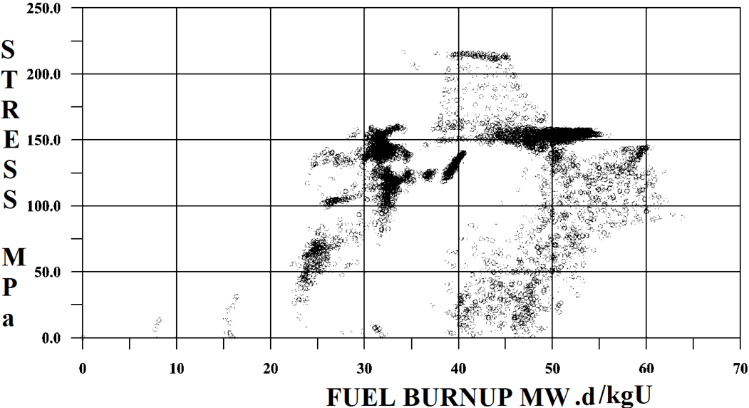

Maximum stress of FE cladding depending of fuel burn up in mode of reactor power increasing from 50 %Nnom to 100 %Nnom after long period of time operation (more than 2 weeks) at 50 %Nnom;

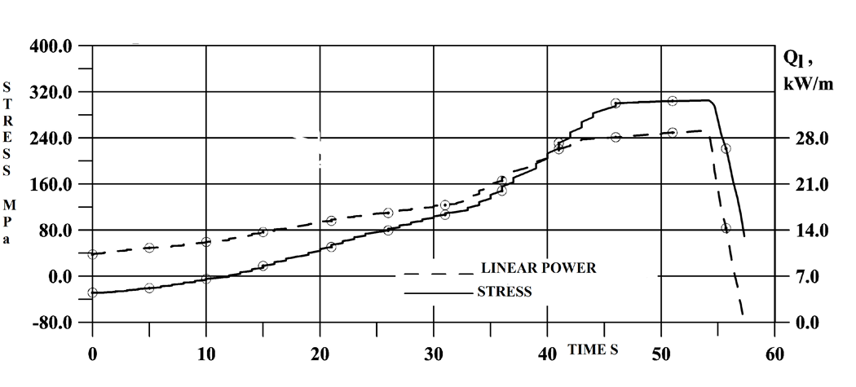

Maximum values of the stress of FE cladding depending on linear power and time in mode of uncontrolled withdrawal of a control rod group. END of FUEL CYCLE

Lose of coolant accident (2´DN 850 mm) Fulfillment of acceptance criteria

| Acceptance criteria | TVSA12 | TVSA |
| --- | --- | --- |
| The fuel rod cladding temperature should not exceed – 1200°C | 977.8°C/864°C  FE /FE Gd | 1016,2/892  FE /FE Gd |
| The equivalent cladding oxidation should not exceed a prescribed part of the initial cladding thickness ≤ 17% | 3.24%/4.61%  FE /FE Gd | 2,6925  FE |
| The fuel temperature should not exceed the melting temperature of FE <2800 оС and FE Gd temperature < 2370 оС | 1860.4°C 1720.3°C  FE /FE Gd | 1774,8/1500  FE /FE Gd |
| Total mass of reacted zirconium should not exceed a prescribed part of its total mass in the fuel rods 1% | 0.13 % | 0.165 % |

The verification of the operability and safety of the FE and FEGa of TVSA-12 and TVSA have been carried out, according to the selection of design criteria for the corresponding operational modes; a check has been made on the feasibility of the determined design criteria by comparing the predetermined values with the obtained calculated ones.

The operability of FE and FEGa is substantiated by checking to fulfill a group of design criteria, which ensure the basic requirement for the absence of damage to the fuel elements.

In certain operating modes, a short-term exceeding of the predetermined design limits (for SC1) was observed, but the satisfaction of the criterion was fulfilled according to the secondary conditions and time limits – not exceeding the incubation period – and the satisfaction of the design criterion SC5.

In case of accidents the cooling of the reactor core is ensured, as well as the possibility of post-accident removal and transportation from reactor vessel to spent fuel pool.

The activity in the primary coolant for the sum I131-135 is according to operational limit for unit 5 and 6 of Kozloduy NPP.

* Factors significantly impacting on the type of FE threshold depressurization are: excess internal pressure under the FE Cladding, sufficient margin of plasticity of the cladding with fuel burnup to 60 MWd/kg U, oxidation of the external surface of the cladding within 8 μm, oxidation on the inner surface of the cladding less than 20 μm, hydrogenation of the cladding not exceeding 100 ppm, limiting interaction of the fuel with the cladding.
* The formation of several ruptures in fuel cladding with burnup 60 MWd/kg U is associated with a substantial reduction or disappearance of the gap between the fuel and the cladding
* It can be concluded that the presence of initial technological defects with a depth of less than 7% of the cladding thickness does not affect the tendency of the FE cladding to CC under Stress To initiate the corrosion process, the presence of a sufficient amount of iodine under the cladding is necessary. A conservative calculation of the maximum concentration of free iodine under the FE cladding gives the value 0.2 mg/cm2. The limit value of the CC S at a temperature of 380 ºC for claddings with a technological defect with a depth of up to 35 μm, determined by the results of the calculations, strength limits to σ = 260 MPa.

II.5.3. Sergey MAKOVSKIY (SEC NRC, Russian Federation)

TBD

II.5.4. James CORSON (US NRC, USA)

***Author/speaker***: James Corson (NRC – United States)

***Title***: NRC’s Research Information Letter on Fuel Fragmentation, Relocation, and Dispersal

*Abstract*

In December 2021, staff from the U.S. Nuclear Regulatory Commission published Research Information Letter (RIL) 2021-13 [1]. RIL 2021-13 provides the staff’s interpretation of recent research on fuel fragmentation, relocation, and dispersal (FFRD). It focuses on five elements related to FFRD: (1) the conditions at which fuel becomes susceptible to fine fragmentation, (2) the cladding strain above which fuel can relocate axially within the fuel rod, (3) the mass of “dispersible” fuel, (4) transient fission gas release under LOCA conditions, and (5) the packing fraction of fuel fragments within the balloon region of the fuel rod. Notably, RIL 2021-13 provides the following conservative interpretations of the available data: fuel becomes susceptible to fine fragmentation starting at a pellet-average burnup of 55 GWd/MTU and to axial relocation once cladding hoop strain exceeds 3%. RIL 2021-13 also provides a conservative model for fuel dispersal based on the aforementioned burnup and strain thresholds, as well as significant uncertainty in the size of the burst opening.

RIL 2021-13 only includes information about the behavior of uranium dioxide fuel in zirconium alloy cladding; it does not address the potential impacts of adding dopants (e.g., gadolinium, chromium) to the UO2 fuel or of changes to the cladding design (e.g., chromium-coated zirconium alloy cladding). The report acknowledges that FFRD thresholds are defined in terms of surrogate parameters like burnup or cladding strain. There are almost certainly other parameters influencing FFRD, but more research is needed to develop more mechanistic models. Finally, RIL 2021-13 only addresses the behavior of a single fuel rod under LOCA conditions. However, the information in this report could be applied as part of a full core LOCA analysis to estimate the potential mass that could be dispersed under these conditions. Such estimates could then be used to evaluate the potential consequences of fuel dispersal. NRC is actively engaged in experimental and analytical research efforts to address some of these limitations, as described in RIL 2021-13 [1] and in a recent Top Fuel paper [2].

*References*

[1] M. Bales, A. Chung, J. Corson and L. Kyriazidis, " Interpretation of Research on Fuel Fragmentation, Relocation, and Dispersal at High Burnup," RIL 2021-13, U.S. Nuclear Regulatory Commission, Washington, DC (2021) (available in the NRC Agencywide Documents Access and Management System (ADAMS) at Accession Number [ML21313A145](https://www.nrc.gov/docs/ML2131/ML21313A145.pdf)).

[2] J. Corson, A. Chung, L. Kyriazidis and M. Bales, “NRC’s Research Information Letter on Fuel Fragmentation, Relocation and Dispersal,” *Top Fuel 2022*, Raleigh, NC, October 9-13, 2022, American Nuclear Society (2022) (available in ADAMS at Accession Number ML22151A117).

II.5.5. John LEHNING (US NRC, USA)

**Assessment of the U.S. Nuclear Regulatory Commission’s Regulatory Framework for the Licensing of High-Burnup Fuel**

The U.S. Nuclear Regulatory Commission (NRC) is preparing to perform independent safety reviews of anticipated licensing applications to permit reactor licensees to increase end-of-life fuel burnups beyond currently approved limits (e.g., 62 GWd/tU rod-average burnup). Proposals to increase fuel burnup may involve impacts across the nuclear fuel cycle that the NRC is assessing to assure adequate protection of public health and safety.

In preparation for these anticipated safety reviews, the NRC has performed an assessment of the existing regulatory framework for the licensing of advanced fuel designs, including high-burnup fuel, fuel with increased enrichment, and accident tolerant fuel [1]. Key impacts of high-burnup fuel considered in the assessment include the following:

* *Fuel dispersal during a loss-of-coolant accident (LOCA)*  
  Relevant issues include core coolability, coolability of dispersed fuel fragments, subcriticality of the core and any accumulations of fuel fragments, assuring no adverse impacts of dispersed fuel on safety equipment, and assuring that dispersed fuel does not unacceptably reduce defence in depth with respect to containing radioactive materials.
* *Fuel dispersal during accidents other than the LOCA*   
  Non-LOCA events are typically perceived as less challenging with respect to fuel dispersal than the LOCA because the core is expected to remain covered and impacts may be more localized. However, associated impacts for non-LOCA events have generally not been assessed in as much detail as the LOCA event.
* *Cladding embrittlement*  
  As fuel burnup increases, existing acceptance criteria in 10 CFR 50.46 may become nonconservative due to such phenomena as hydrogen-enhanced beta-layer embrittlement, oxygen ingress from cladding inner surface, and breakaway oxidation. The Commission is deliberating upon a proposed rulemaking (10 CFR 50.46c) that would address these issues [2].
* *Radiological dose*  
  While some radionuclide concentrations may attain saturation, and while complications may arise from other factors associated with increased fuel burnup (e.g., increases to fuel enrichment, burnable absorber concentration, cycle length), increasing fuel burnup may tend to increase the potential for radiological consequences.
* *Fuel storage and transportation*  
  Updates to analyses may be necessary in areas such as criticality, decay heat loadings, radiation source terms, and shielding. The NRC staff is preparing NUREG reports associated with the validation of burnup credit and criticality codes for high-burnup fuel.
* *Environmental impacts*  
  The NRC staff is evaluating accident tolerant fuel, high-burnup fuel, and increased enrichment relative to environmental impacts specified in 10 CFR 51.52.

While many potential impacts of high-burnup fuel may likely be addressed by updates to regulatory guidance, the NRC continues to evaluate potential revisions to regulatory requirements. For example, the Commission has directed that the NRC staff address fuel fragmentation, relocation, and dispersal in concert with the currently ongoing rulemaking for increased enrichment that is scheduled to be completed in 2026 [3]. The NRC staff is further preparing for regulatory reviews of industry topical reports describing methods for performing safety analyses for high-burnup fuel.

In conclusion, responsive to industry plans to propose increased fuel burnup limits, the NRC is assessing modifications to regulations and guidance across the fuel cycle to promote the safe, consistent, and efficient licensing of high-burnup fuel. Licensing high-burnup fuel is a major effort, and significant work remains underway to resolve attendant technical and regulatory issues, particularly those associated with dispersed fuel fragments. The NRC continues to evaluate changes to regulatory guidance and to regulatory requirements associated with high-burnup fuel; any regulatory or policy changes would involve deliberation and decision from the Commission.

References

[1] U.S. Nuclear Regulatory Commission, “Regulatory Framework Applicability Assessment and Licensing Pathway Diagram for the Licensing of ATF-Concept, Higher Burnup, and Increased Enrichment Fuels,” May 2022, ML22014A112.

[2] U.S. Nuclear Regulatory Commission, “Draft Final Rule – Performance-Based Emergency Core Cooling System Requirements and Related Fuel Cladding Acceptance Criteria (RIN 3150-AH42),” March 16, 2016, ML15238A947.

[3] U.S. Nuclear Regulatory Commission, “Staff Requirements – SECY-21-0109 – Rulemaking Plan on Use of Increased Enrichment of Conventional and Accident Tolerant Fuel Designs for Light-Water Reactors,” March 16, 2022, ML22075A103.

# LIST OF ABBREVIATIONS

ATF Accident Tolerant Fuels, Advanced Technology Fuel

BWR Boiling Water Reactor

DBA Design Basis Accidents

FFRD [Fuel Fragmentation Relocation and Dispersal](https://www.nrc.gov/reactors/atf/ffrd.html)

FGR Fission Gaz Release

HALEU High Assay Low Enriched Uranium (from 5 to 20%)

HBU High Burnup

HBS High Burnup Structure

HRP Halden Reactor Project

IAEA International Atomic Energy Agency

IRSN Institut de Radioprotection et de Sûreté Nucléaire, France

LEU Low Enriched Uranium (up to 5%)

LEU+ Low Enriched Uranium (from 5 to 10%)

LOCA Loss of coolant accident

LTA Lead Test Assembly

LTR Lead Test Rod

LWR Light Water Reactor

NEA OECD Nuclear Energy Agency

NRA Nuclear Regulation Authority, Japan

NPIC Nuclear Power Institute of China

NPP Nuclear Power Plant

NUREG U.S. Nuclear Regulatory Commission technical report designation

ODS Oxide Dispersion Strengthened alloys

OLC Operational Limits and Conditions

PCI-SCC Pellet Cladding Interaction-Stress Corrosion Cracking

PCMI Pellet Cladding Mechanical Interaction

PIE Post Irradiation Examinations

PWR Pressurized Water Reactor

R&D Research and development

RIA Reactivity Insertion Accident

SRP Standard Review Plan of the U.S. Nuclear Regulatory Commission

U.S. NRC United States Nuclear Regulatory Commission

WCR Water cooled reactors

WGFS OECD/NEA Working Group on Fuel Safety

WWER Water-Water Energetic Reactor

# CONTRIBUTORS TO DRAFTING AND REVIEW

Zhang, J. Tractebel, Belgium

Georgenthum, V. Institut de Radioprotection et de Sûreté Nucléaire, France

Tverberg, T. Institute for Energy Technology, Norway

Doncel, N. ENUSA, Spain

Csontos, A. Nuclear Energy Institute, United States of America

Lehning, J. Nuclear Regulatory Commission, United States of America

Massara, S. International Atomic Energy Agency

Sim, K.S. International Atomic Energy Agency

# PARTICIPANTS

Csontos, A. Nuclear Energy Institute, United States of America

Gassmann, W. Constellation Nuclear, United States of America

Zhang, J. Tractebel, Belgium

Noirot, J. Commissariat à l'Energie Atomique et aux Energies Alternatives, France

Van Uffelen, P. European Commission, Directorate General Joint Research Centre

Khvostov, G. Paul Scherrer Institute, Switzerland

Georgenthum, V. Institut de Radioprotection et de Sûreté Nucléaire, France

Yueh, K. Electrical Power Research Institute, United States of America

Capps, N. Oak Ridge National Laboratory, United States of America

Pizzocri, D. Politecnico di Milano, Italy

Tverberg, T. Institute for Energy Technology, Norway

Taniguchi, Y. Japan Atomic Energy Agency, Japan

Lee, Y. Seoul National University, Republic of Korea

Armstrong, R. Idaho National Laboratory, United States of America

Bales, M. OECD Nuclear Energy Agency

Cappia, F. Idaho National Laboratory, United States of America

Jiao, Y. Nuclear Power Institute of China, China

Doncel, N. ENUSA, Spain

Barber, K. Westinghouse, United States of America

Friend, B. Framatome, United States of America, To Be Confirmed (expected, not yet received)

Arimescu, I. Consultant, Nufology Plus LLC, United States of America

Mishra, P. Bhabha Atomic Research Centre, India

Bznuni, S. Nuclear and Radiation Safety Center, Armenia

Goranov, S. Bulgarian Nuclear Regulatory Agency, Bulgaria

Makovskiy, S. Scientific and Engineering Centre for Nuclear and Radiation Safety, Russian Federation, To Be Confirmed (no reply to-date)

Corson, J. Nuclear Regulatory Commission, United States of America

Lehning, J. Nuclear Regulatory Commission, United States of America

Massara, S. International Atomic Energy Agency

Sim, K.S. International Atomic Energy Agency

**Technical Meeting**

Vienna, 14–18 November 2022

**Consultancy Meetings**

Vienna, 21–23 June 2022

Vienna, 10–12 May 2023